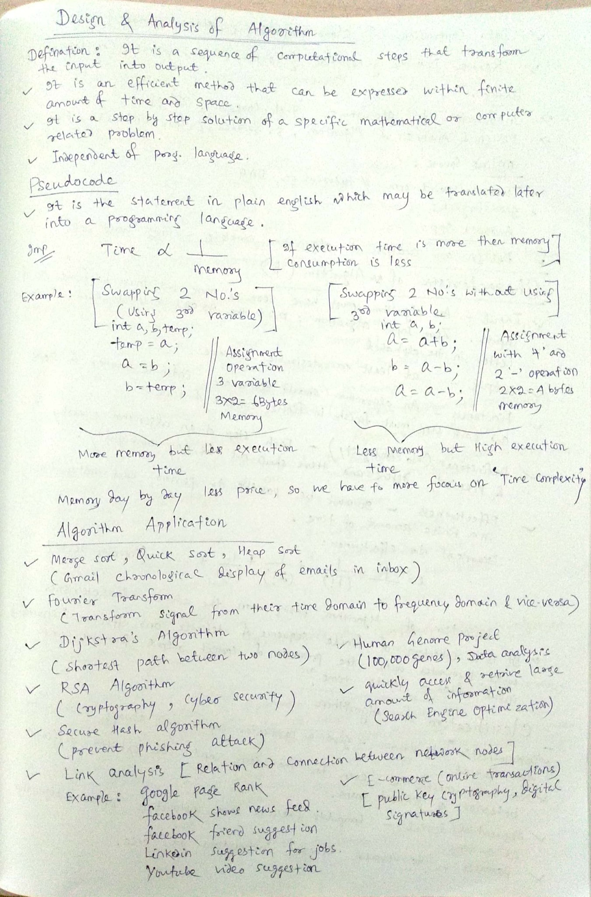

UNIT:1

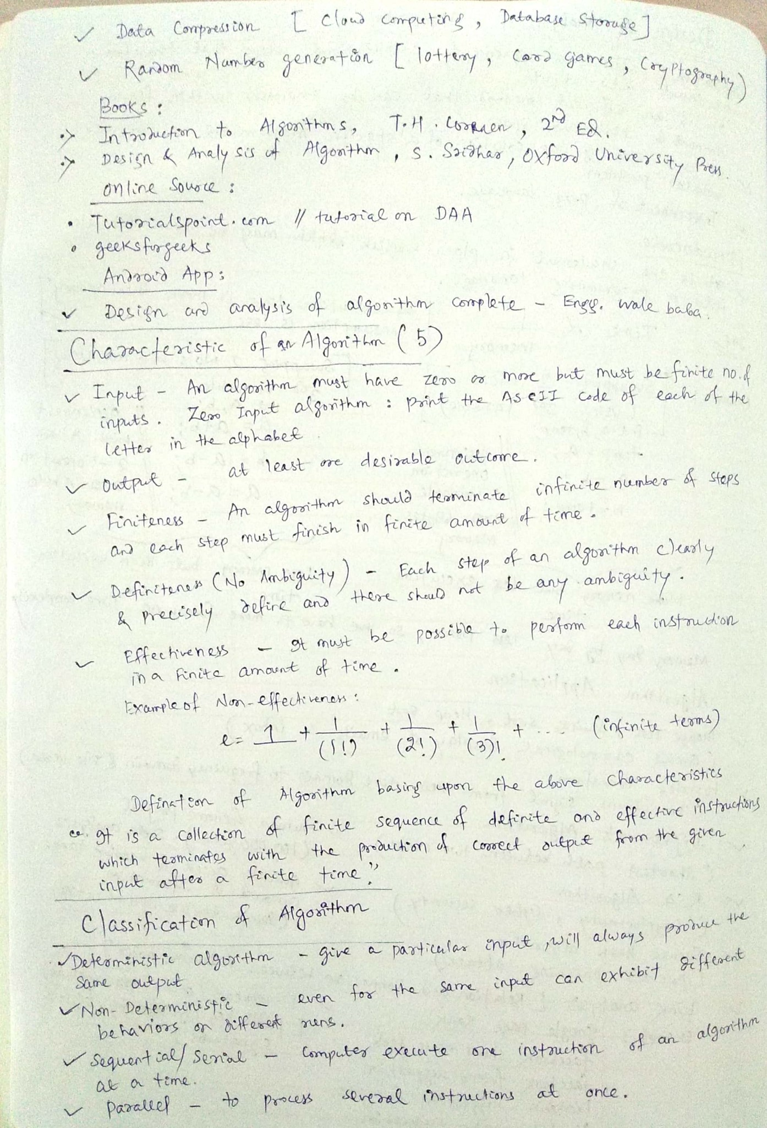

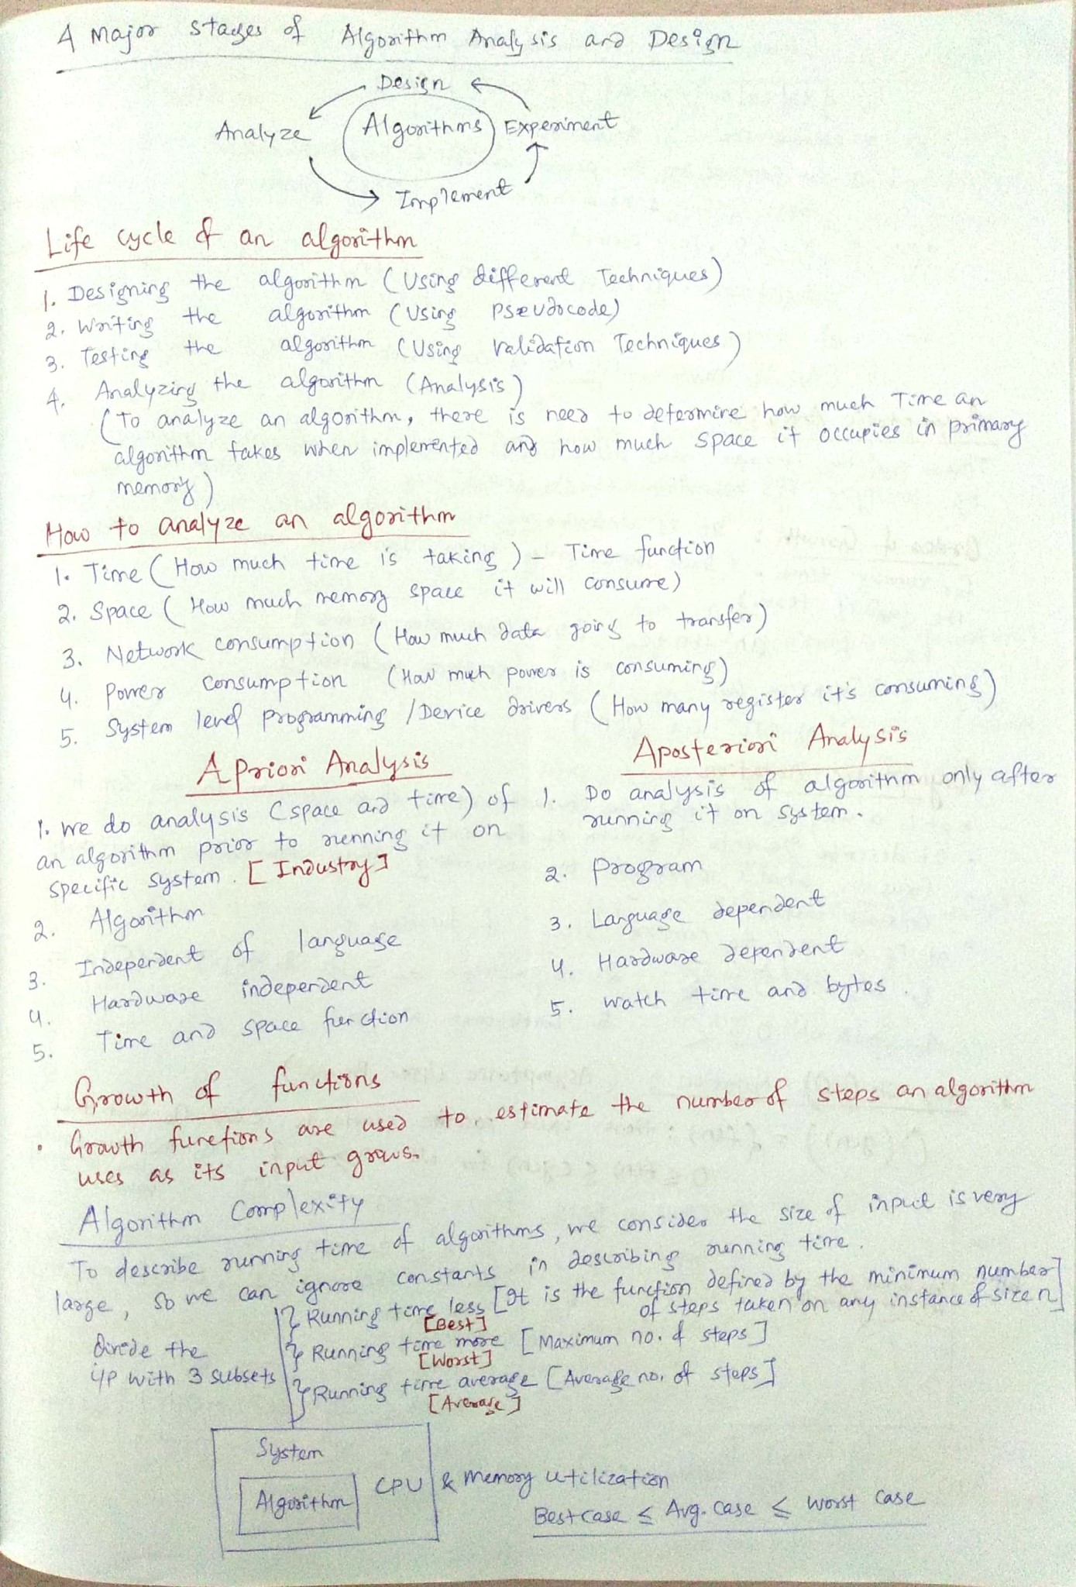

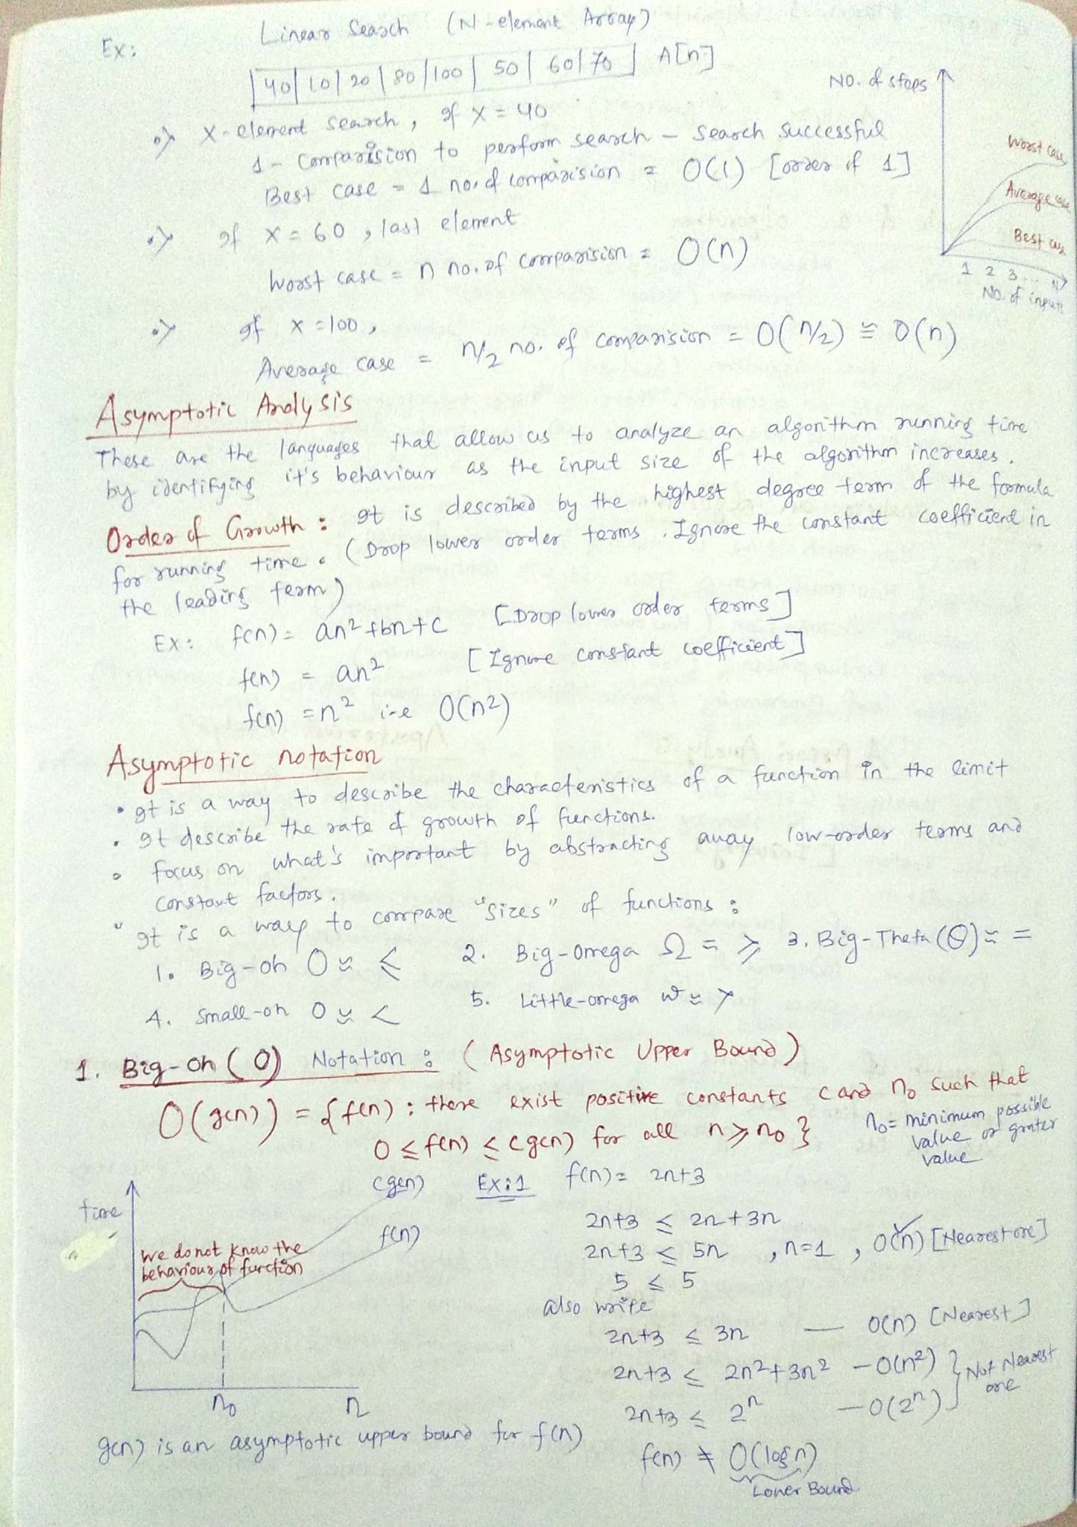

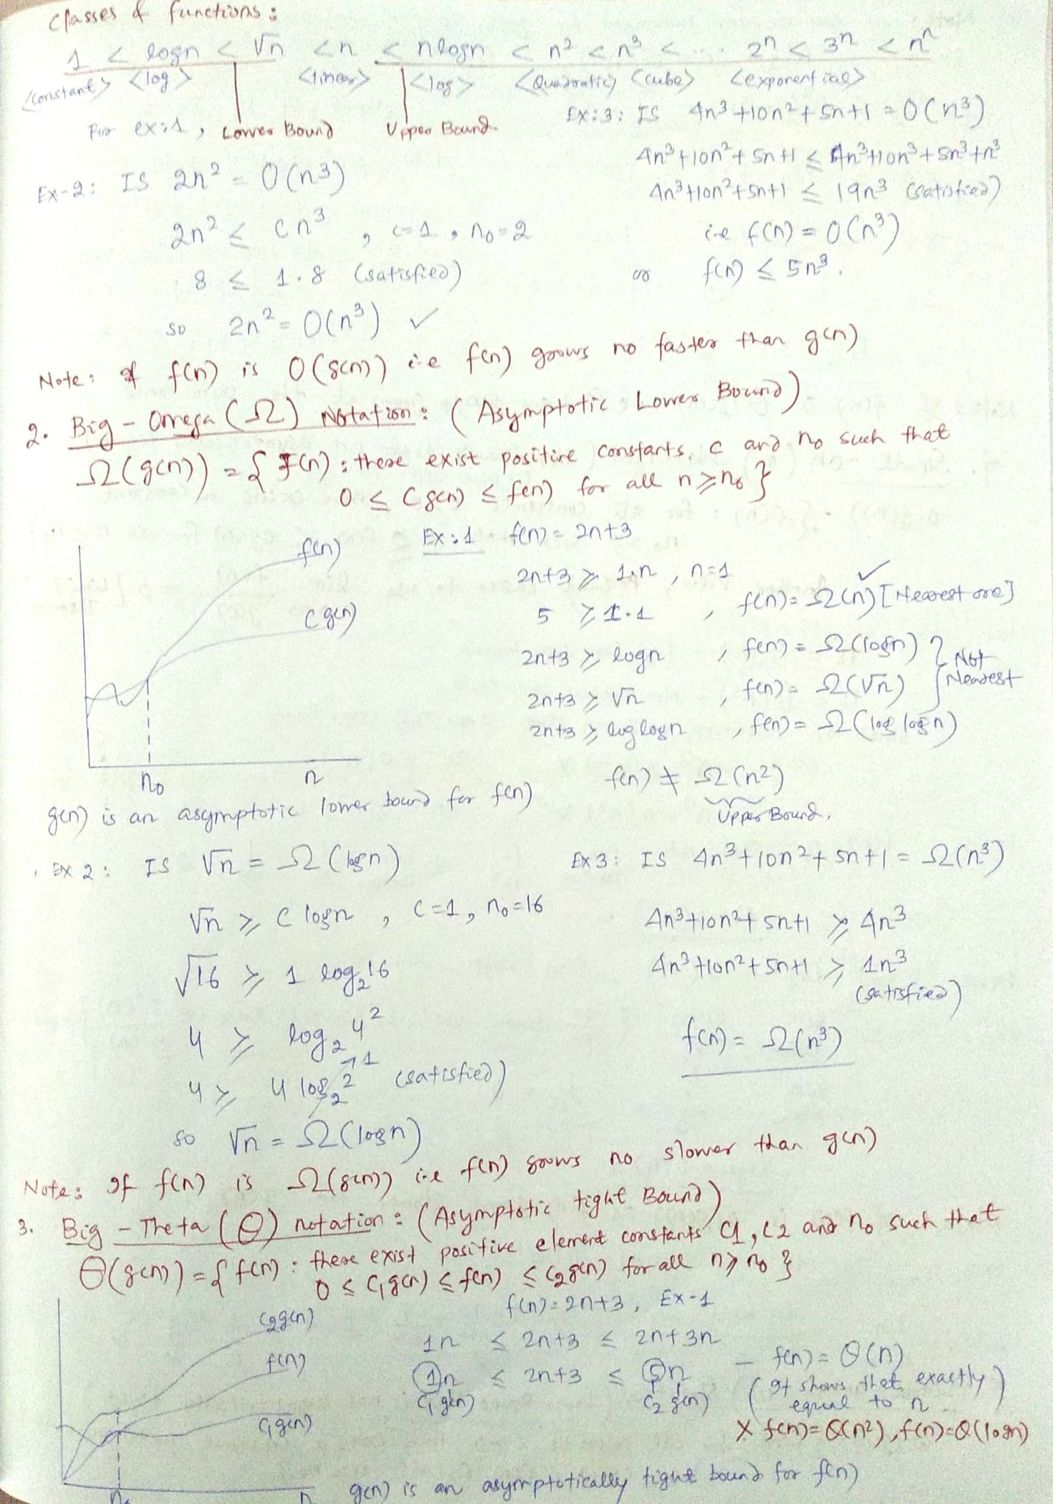

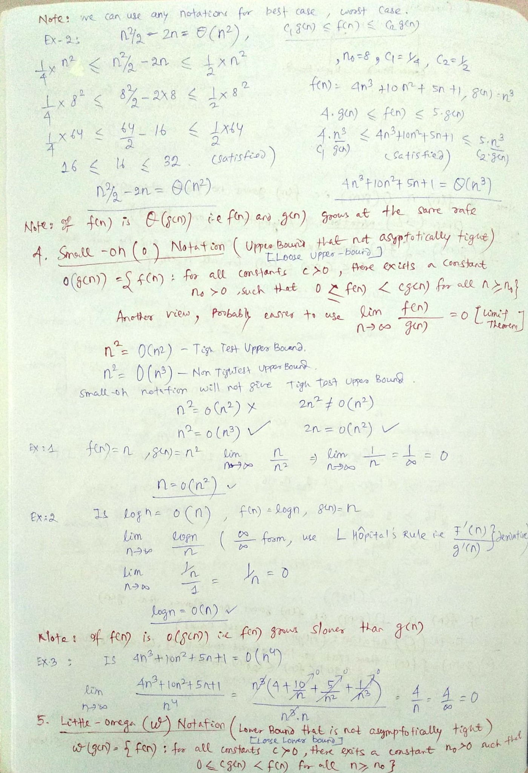

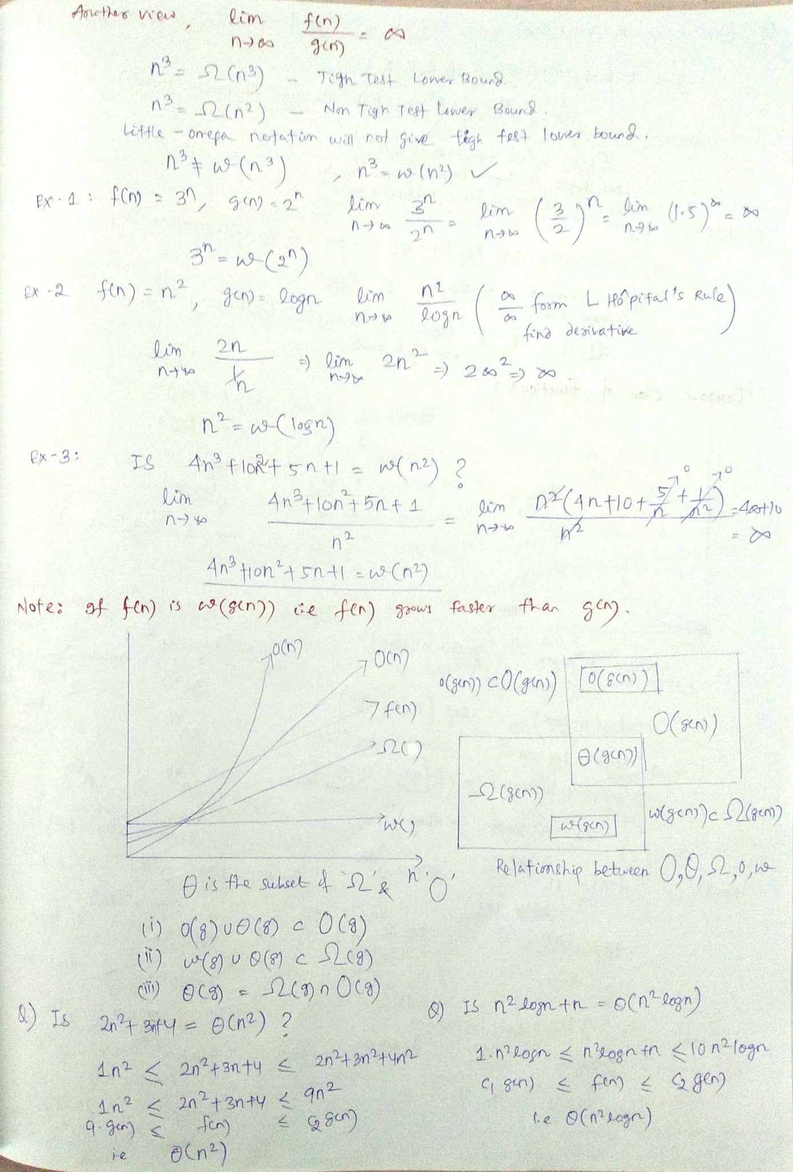

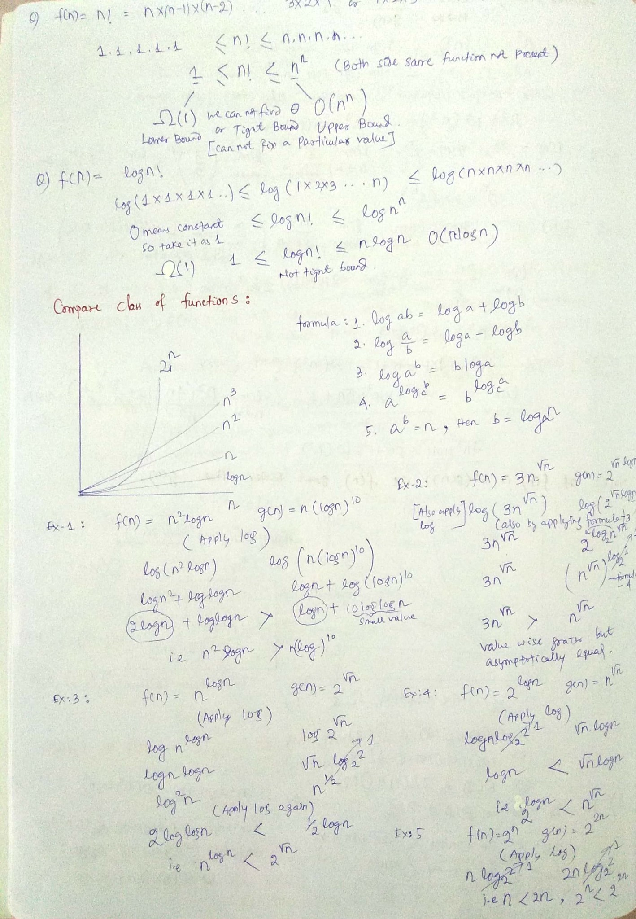

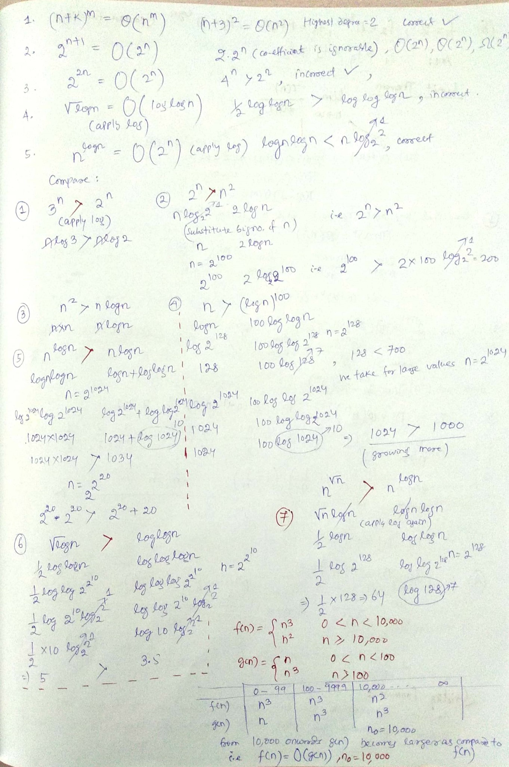

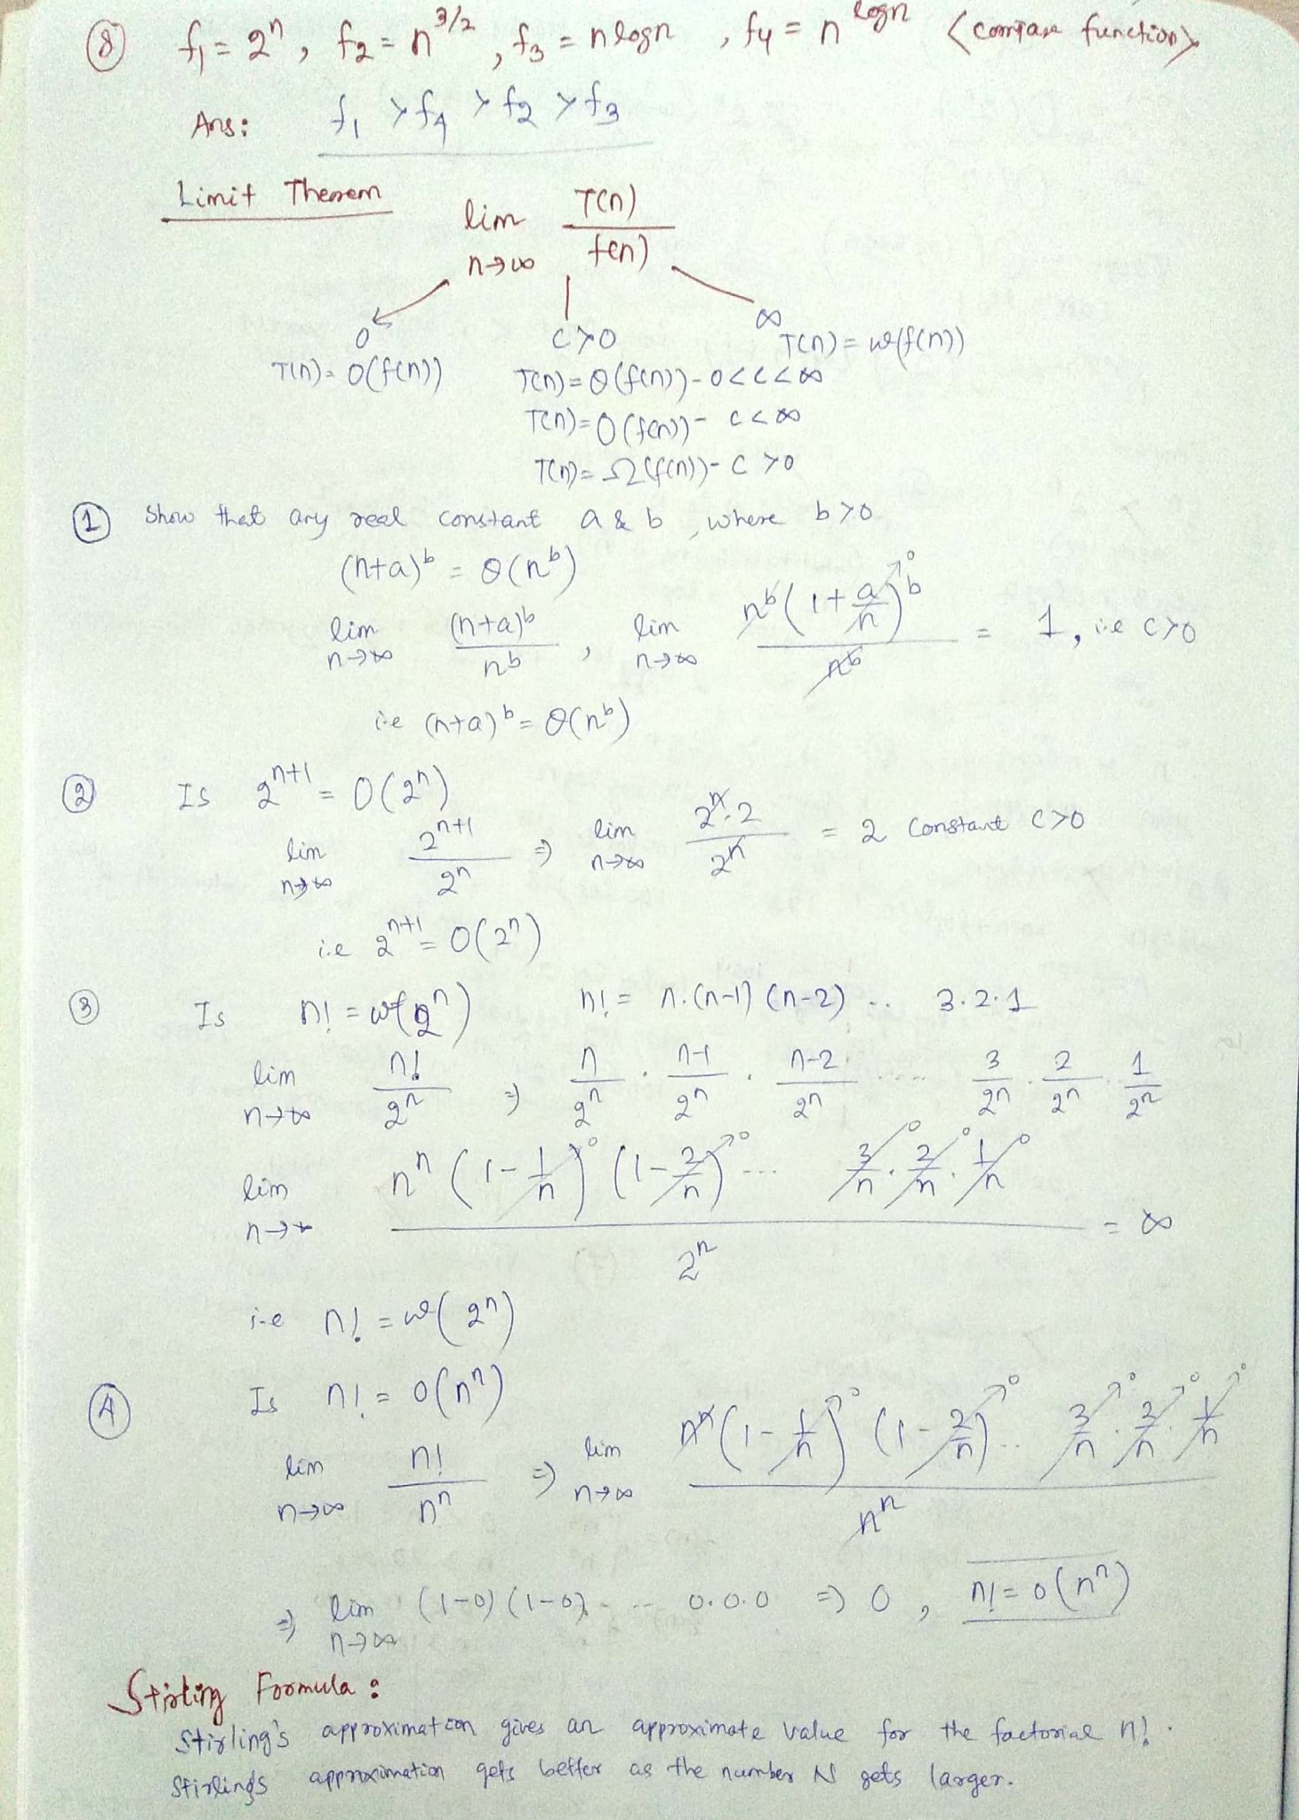

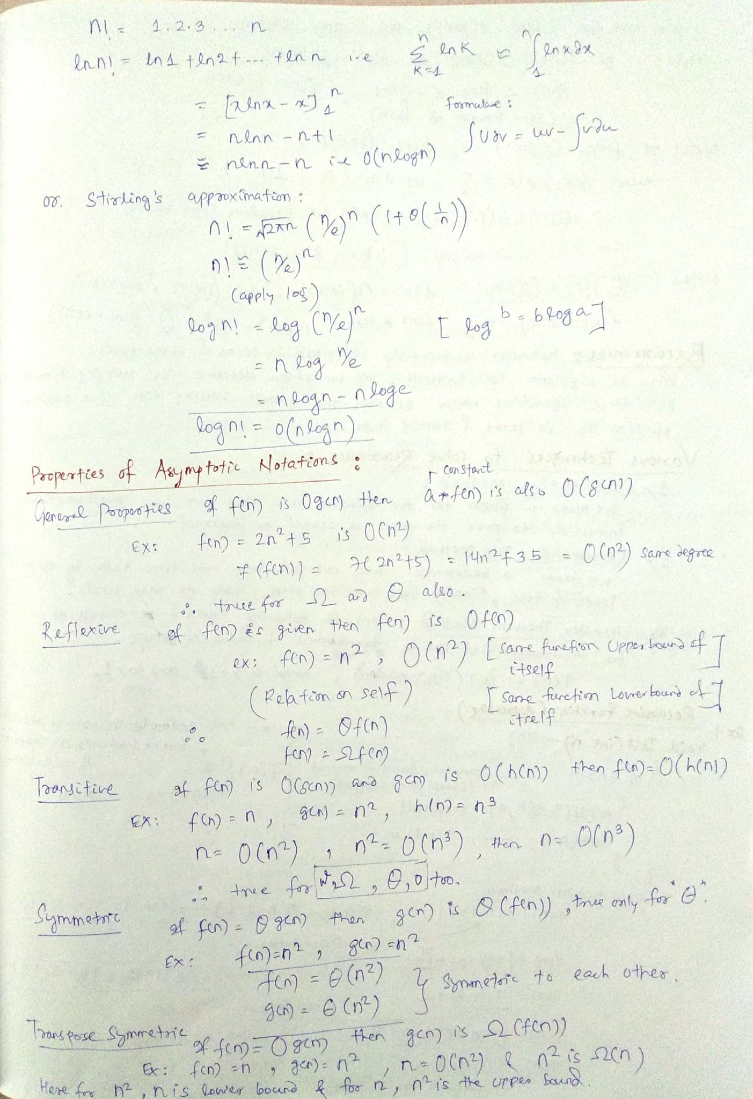

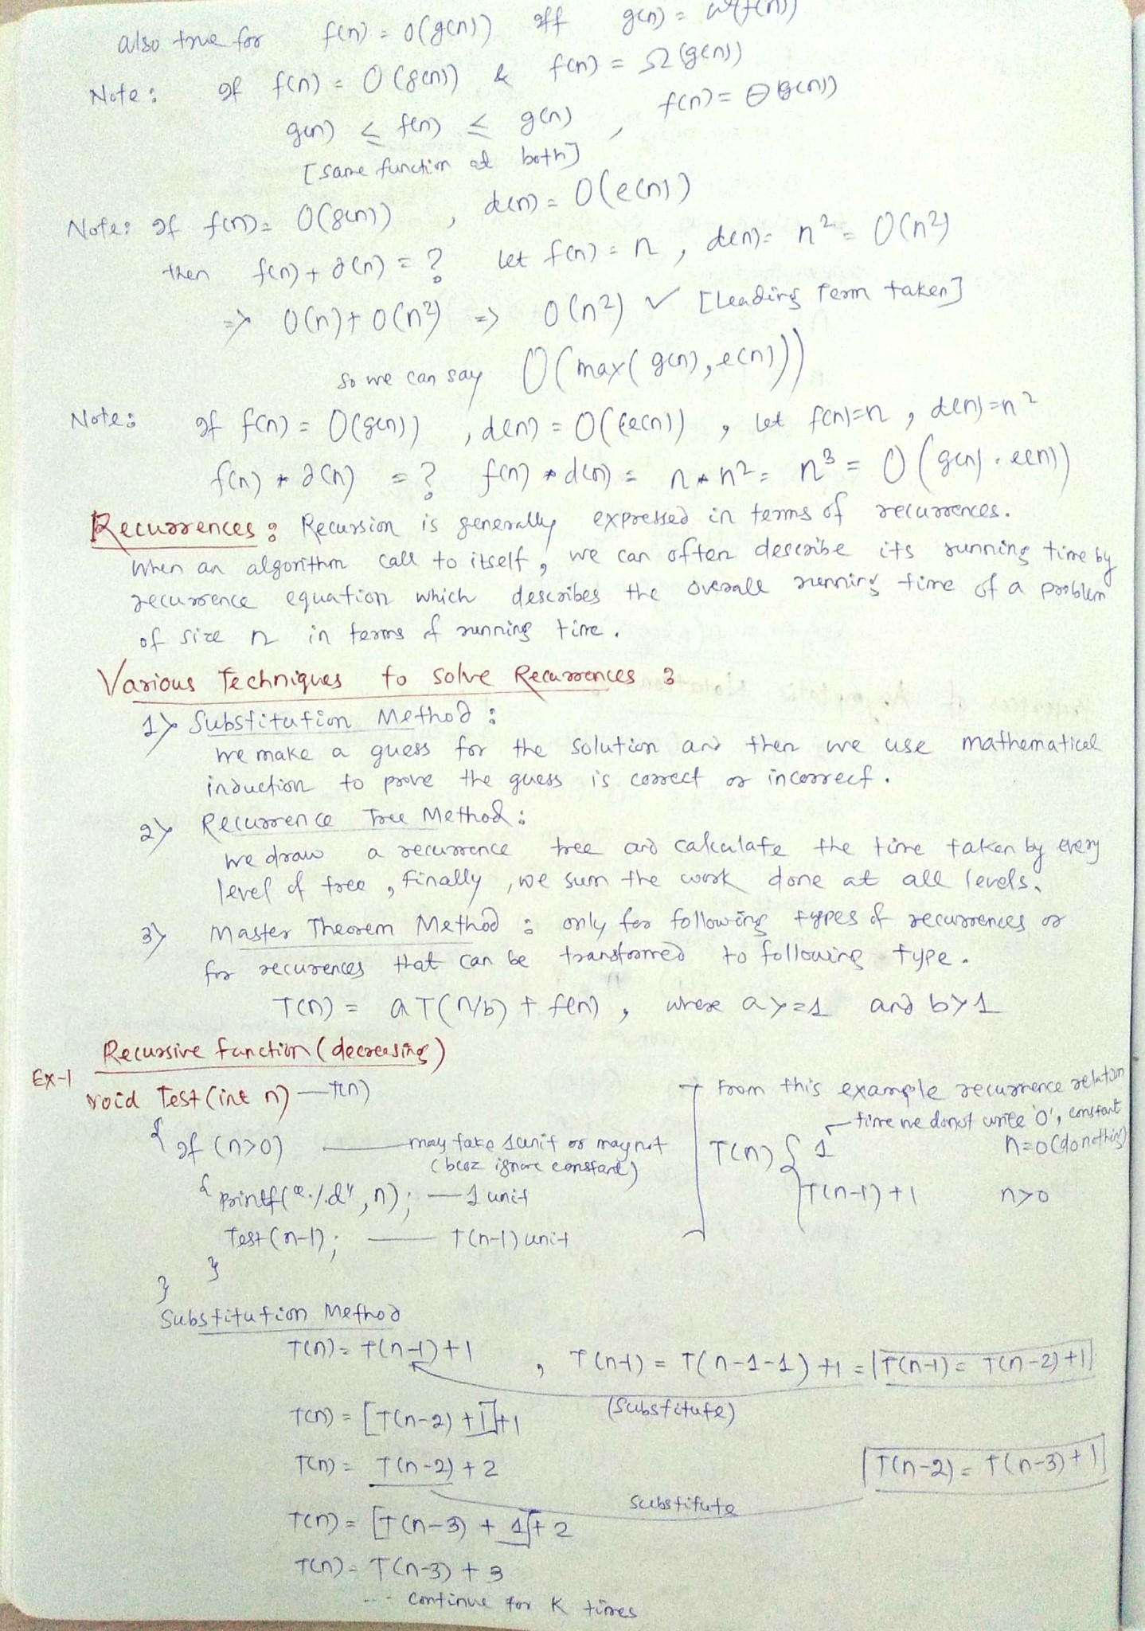

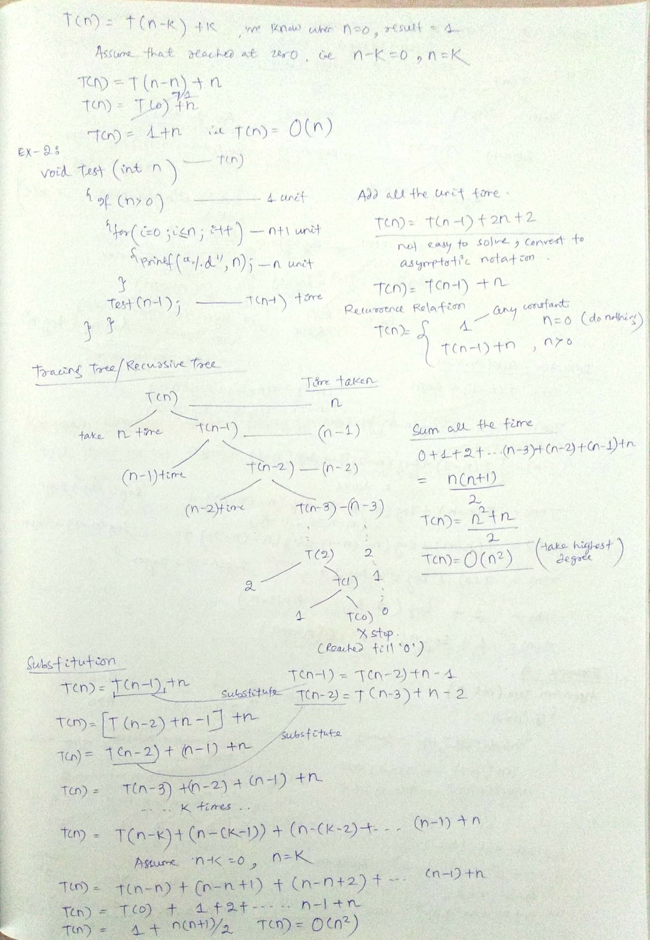

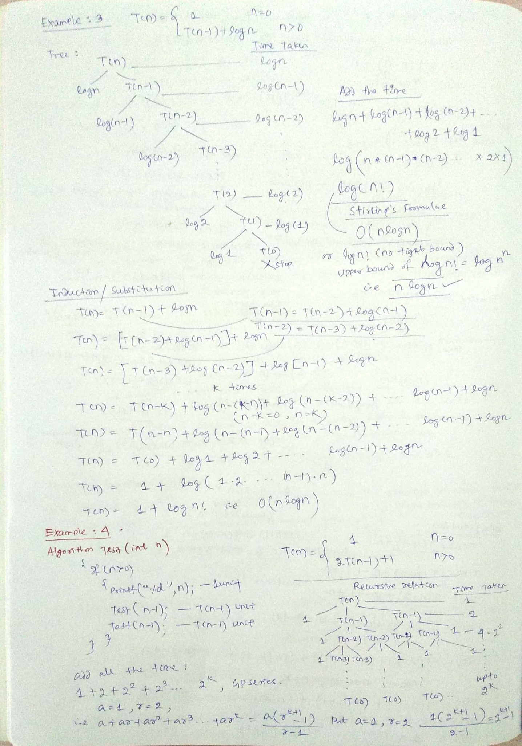

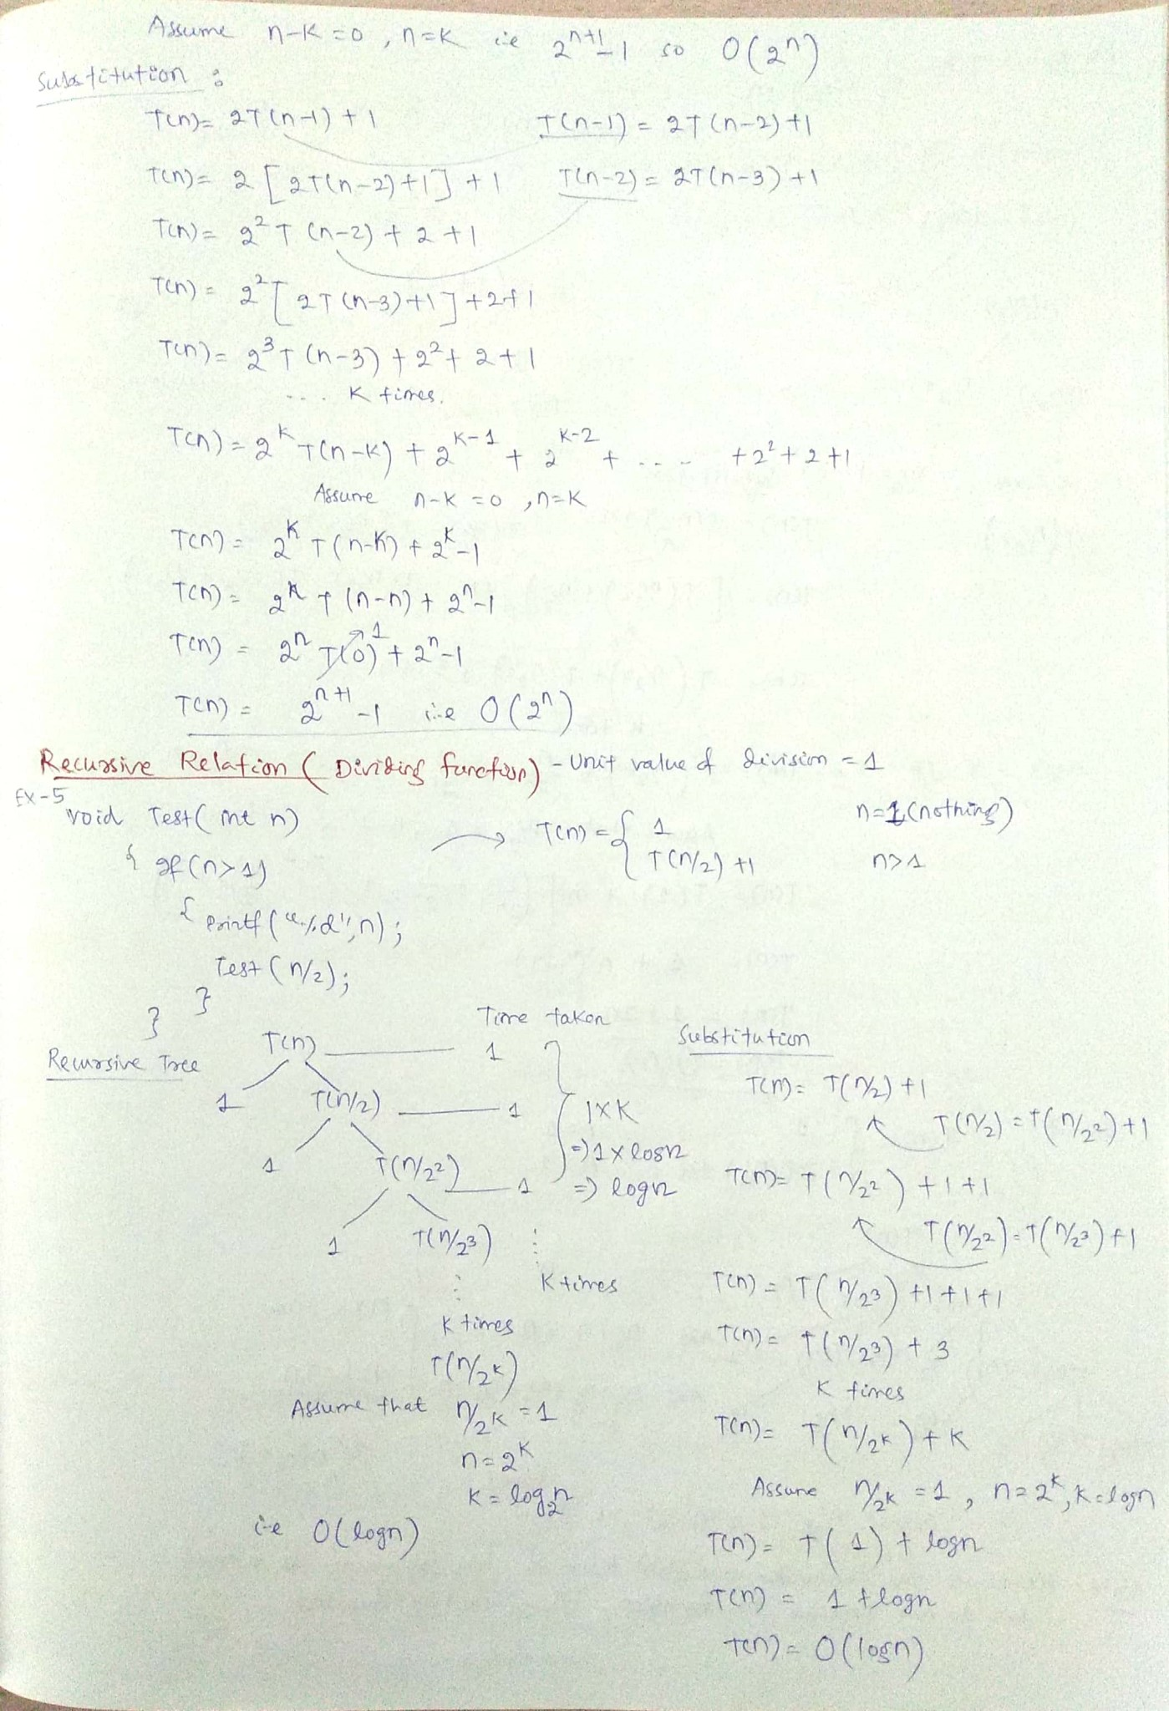

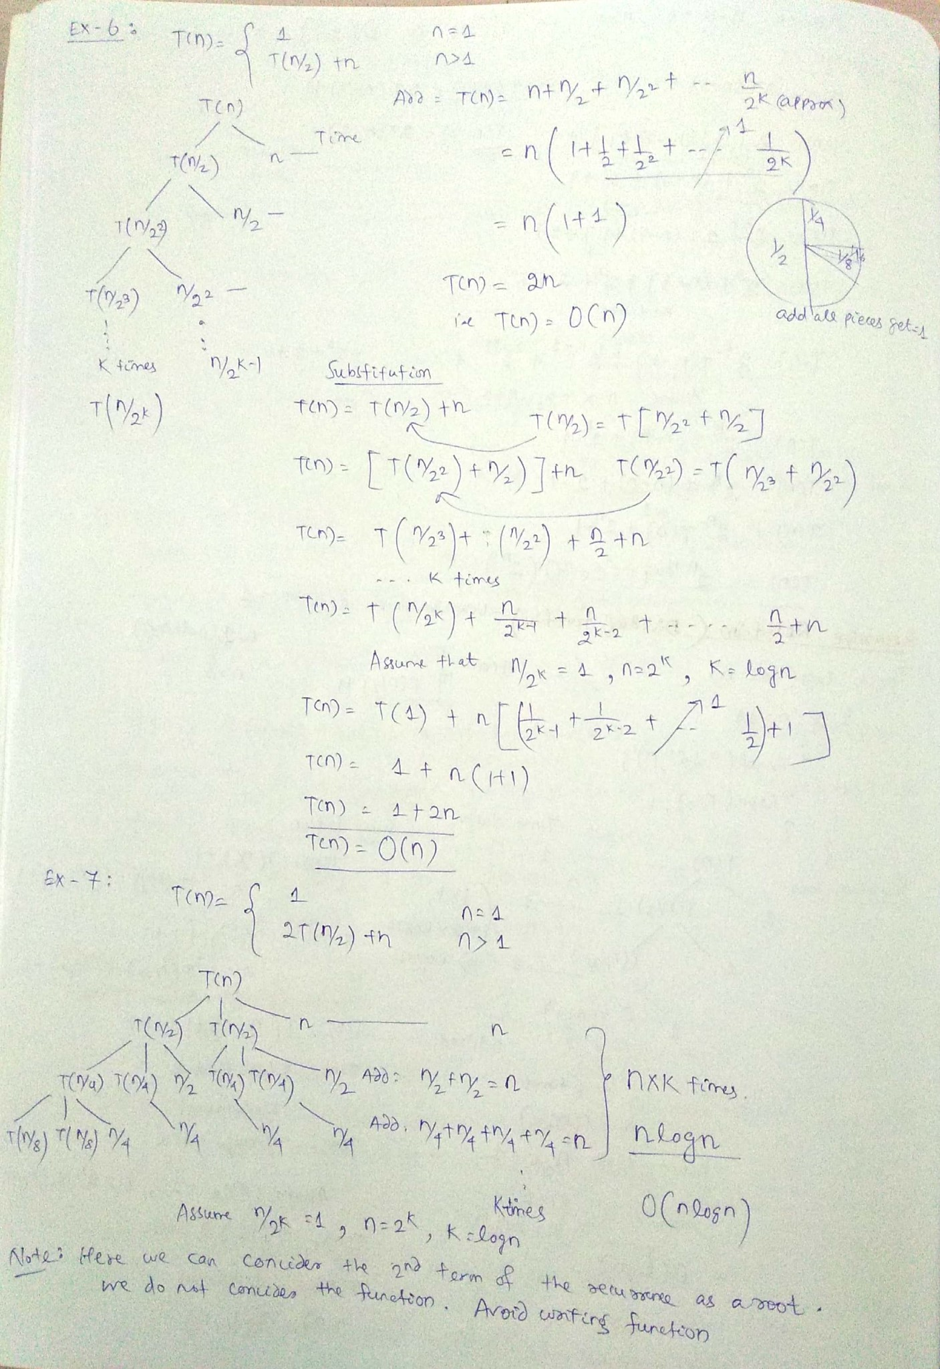

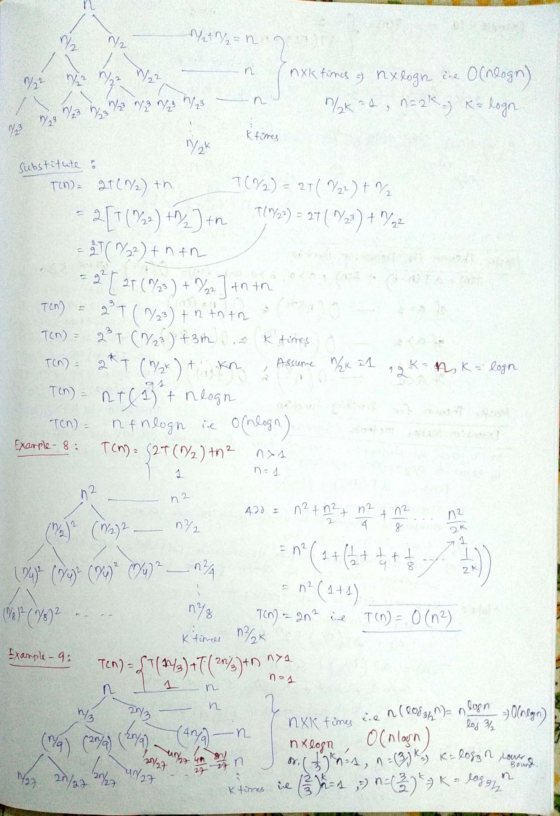

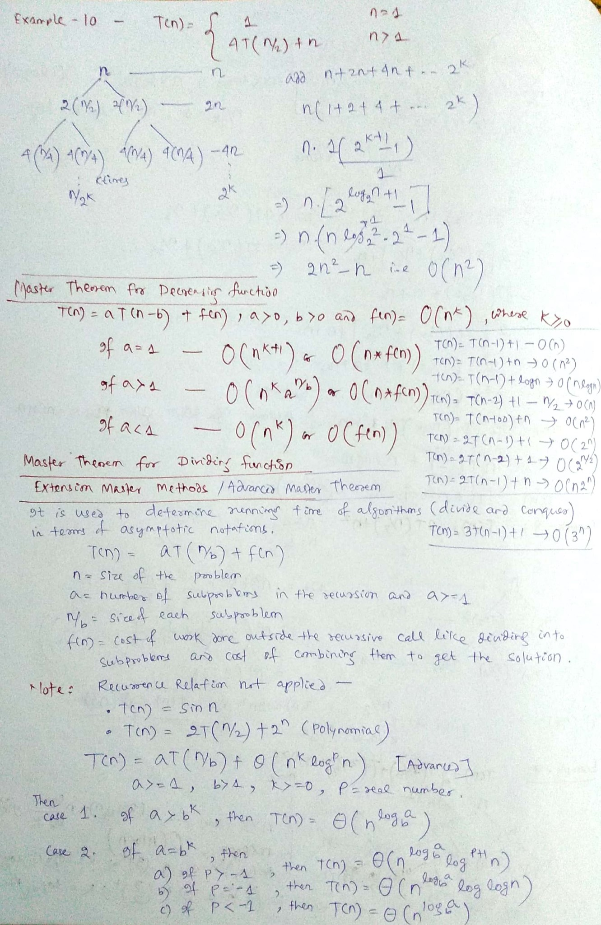

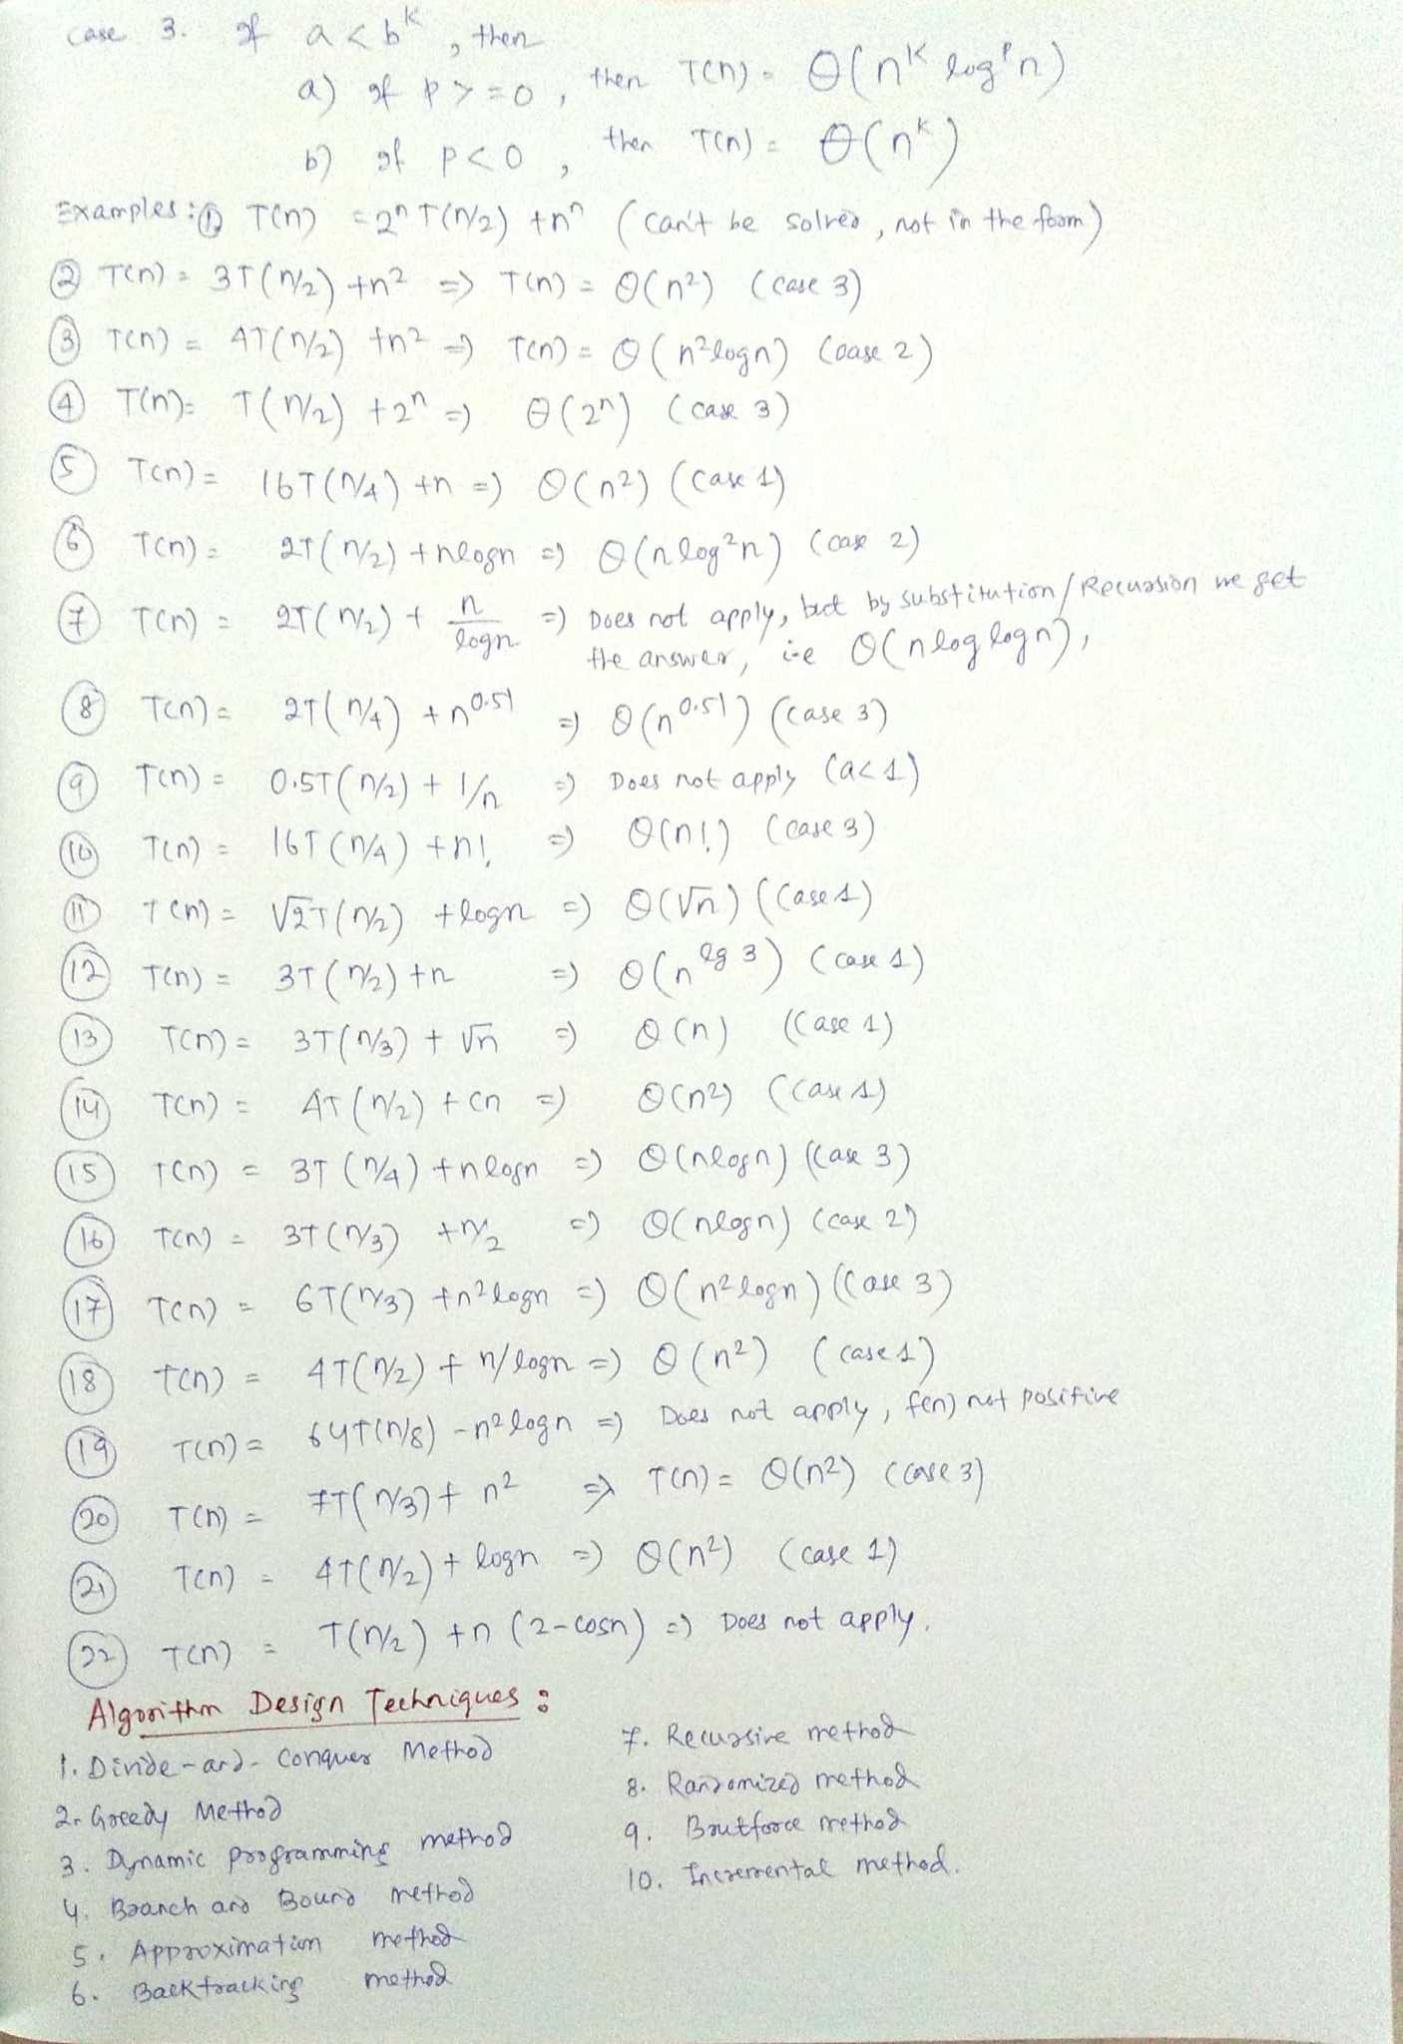

**

# Analysis of Algorithm | Set 5 (Amortized Analysis Introduction)

Amortized Analysis is used for algorithms where an occasional operation is very slow, but most of the other operations are faster. In Amortized Analysis, we analyze a sequence of operations and guarantee a worst case average time which is lower than the worst case time of a particular expensive operation.

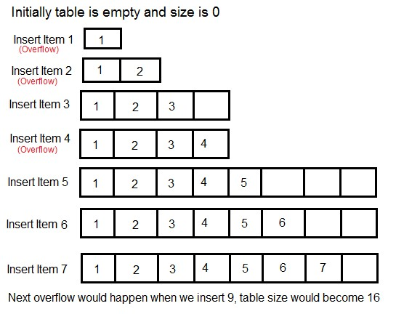

The example data structures whose operations are analyzed using Amortized Analysis are Hash Tables, Disjoint Sets and Splay Trees.

Let us consider an example of a simple hash table insertions. How do we decide table size? There is a trade-off between space and time, if we make hash-table size big, search time becomes fast, but space required becomes high.

The solution to this trade-off problem is to use Dynamic Table (or Arrays). The idea is to increase size of table whenever it becomes full. Following are the steps to follow when table becomes full.

1) Allocate memory for a larger table of size, typically twice the old table. 2) Copy the contents of old table to new table.

3) Free the old table.

If the table has space available, we simply insert new item in available space.

**What is the time complexity of n insertions using the above scheme?**

If we use simple analysis, the worst case cost of an insertion is O(n). Therefore, worst case cost of n inserts is n * O(n) which is O(n2). This analysis gives an upper bound, but not a tight upper bound for n insertions as all insertions don’t take Θ(n) time.

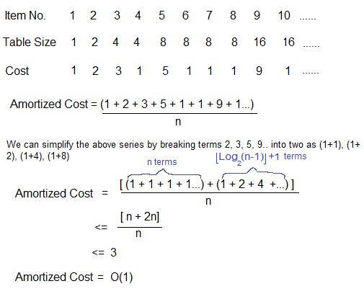

So using Amortized Analysis, we could prove that the Dynamic Table scheme has O(1)

insertion time which is a great result used in hashing.

Also, the concept of dynamic table is

used in

vectors in C++,

ArrayList in Java

.

Following are few important notes.

**1)**

Amortized cost of a sequence of operations can be seen as expenses of a salaried

person. The average monthly expense of the person is less than or equal to the salary, but

the person can spend more money in a particular month by buying a car or something. In

other months, he or she saves money for the expensive month.

**2)**

The above Amortized Analysis done for Dynamic Array example is called

**Aggr**

**egate**

**Method**

.

There are two more powerful ways to do Amortized analysis called

**Accounting**

**Method**

and

**P**

**otential Method**

.

We will be discussing the other two methods in separate

posts.

**3)**

The amortized analysis doesn’t involve probability. There is also another different notion

of average case running time where algorithms use randomization to make them faster and

expected running time is faster than the worst case running time. These algorithms are

analyzed using Randomized Analysis. Examples of these algorithms are Randomized Quick

Sort, Quick Select and Hashing. We will soon be covering Randomized analysis in a different

post.

**Sources:**

Berkeley Lecture 35: Amortized Analysis

MIT Lecture 13: Amortized Algorithms, Table Doubling, Potential Method

http://www.cs.cornell.edu/courses/cs3110/2011sp/lectures/lec20-

amortized/amortized.htm

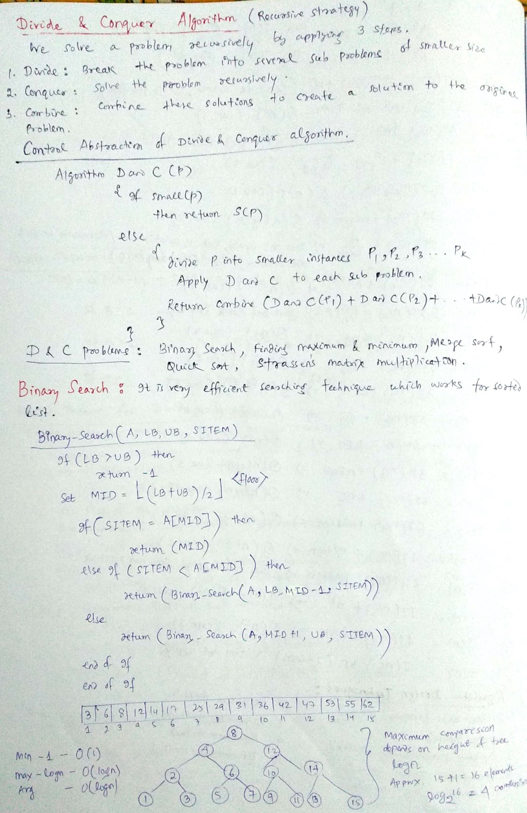

UNIT: 2

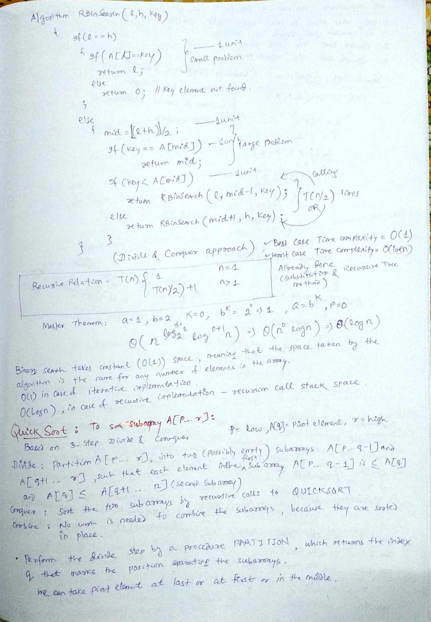

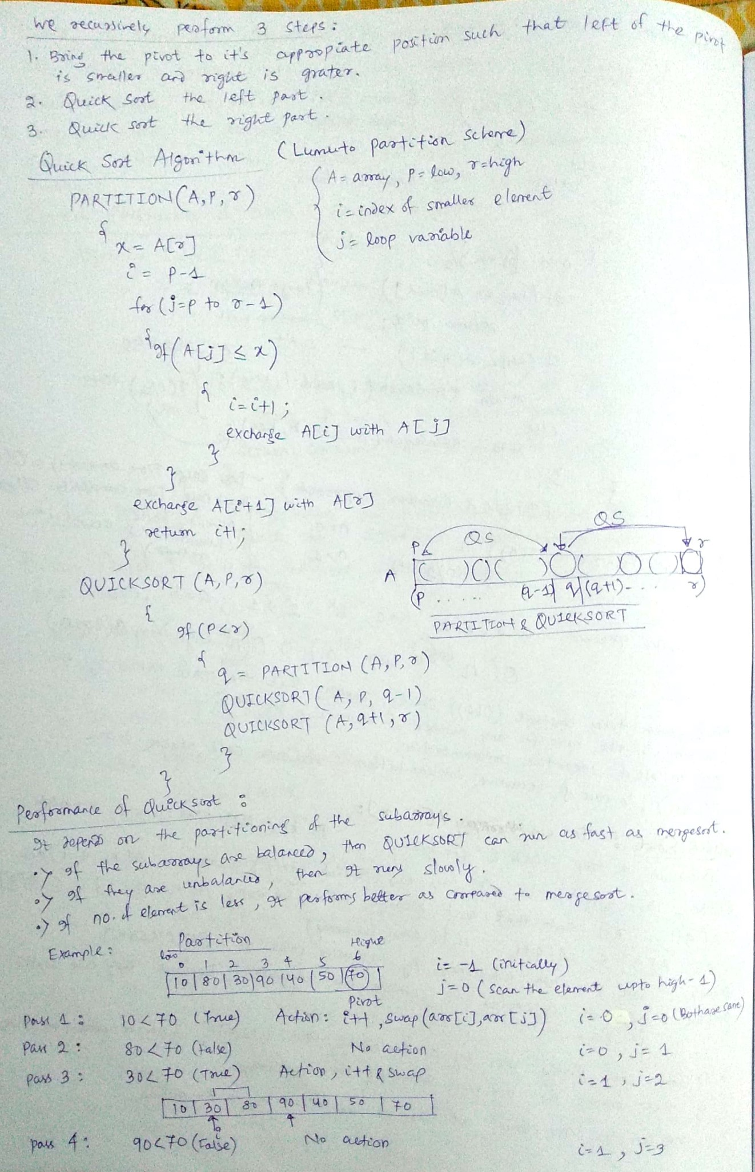

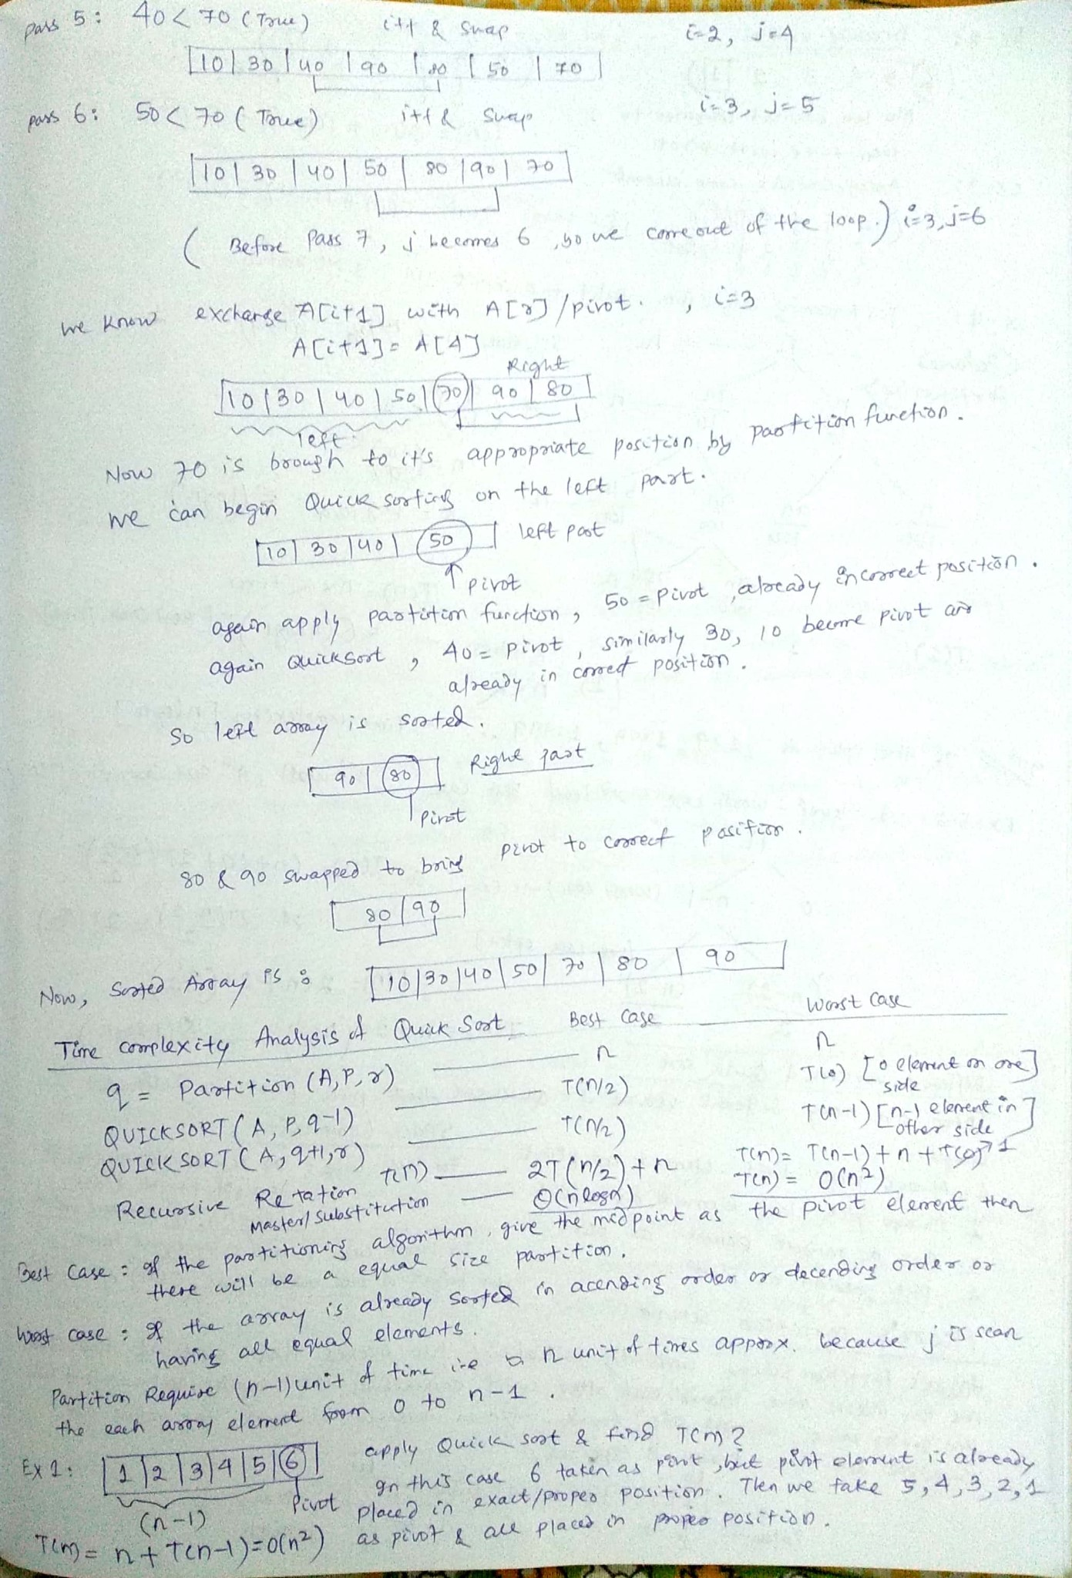

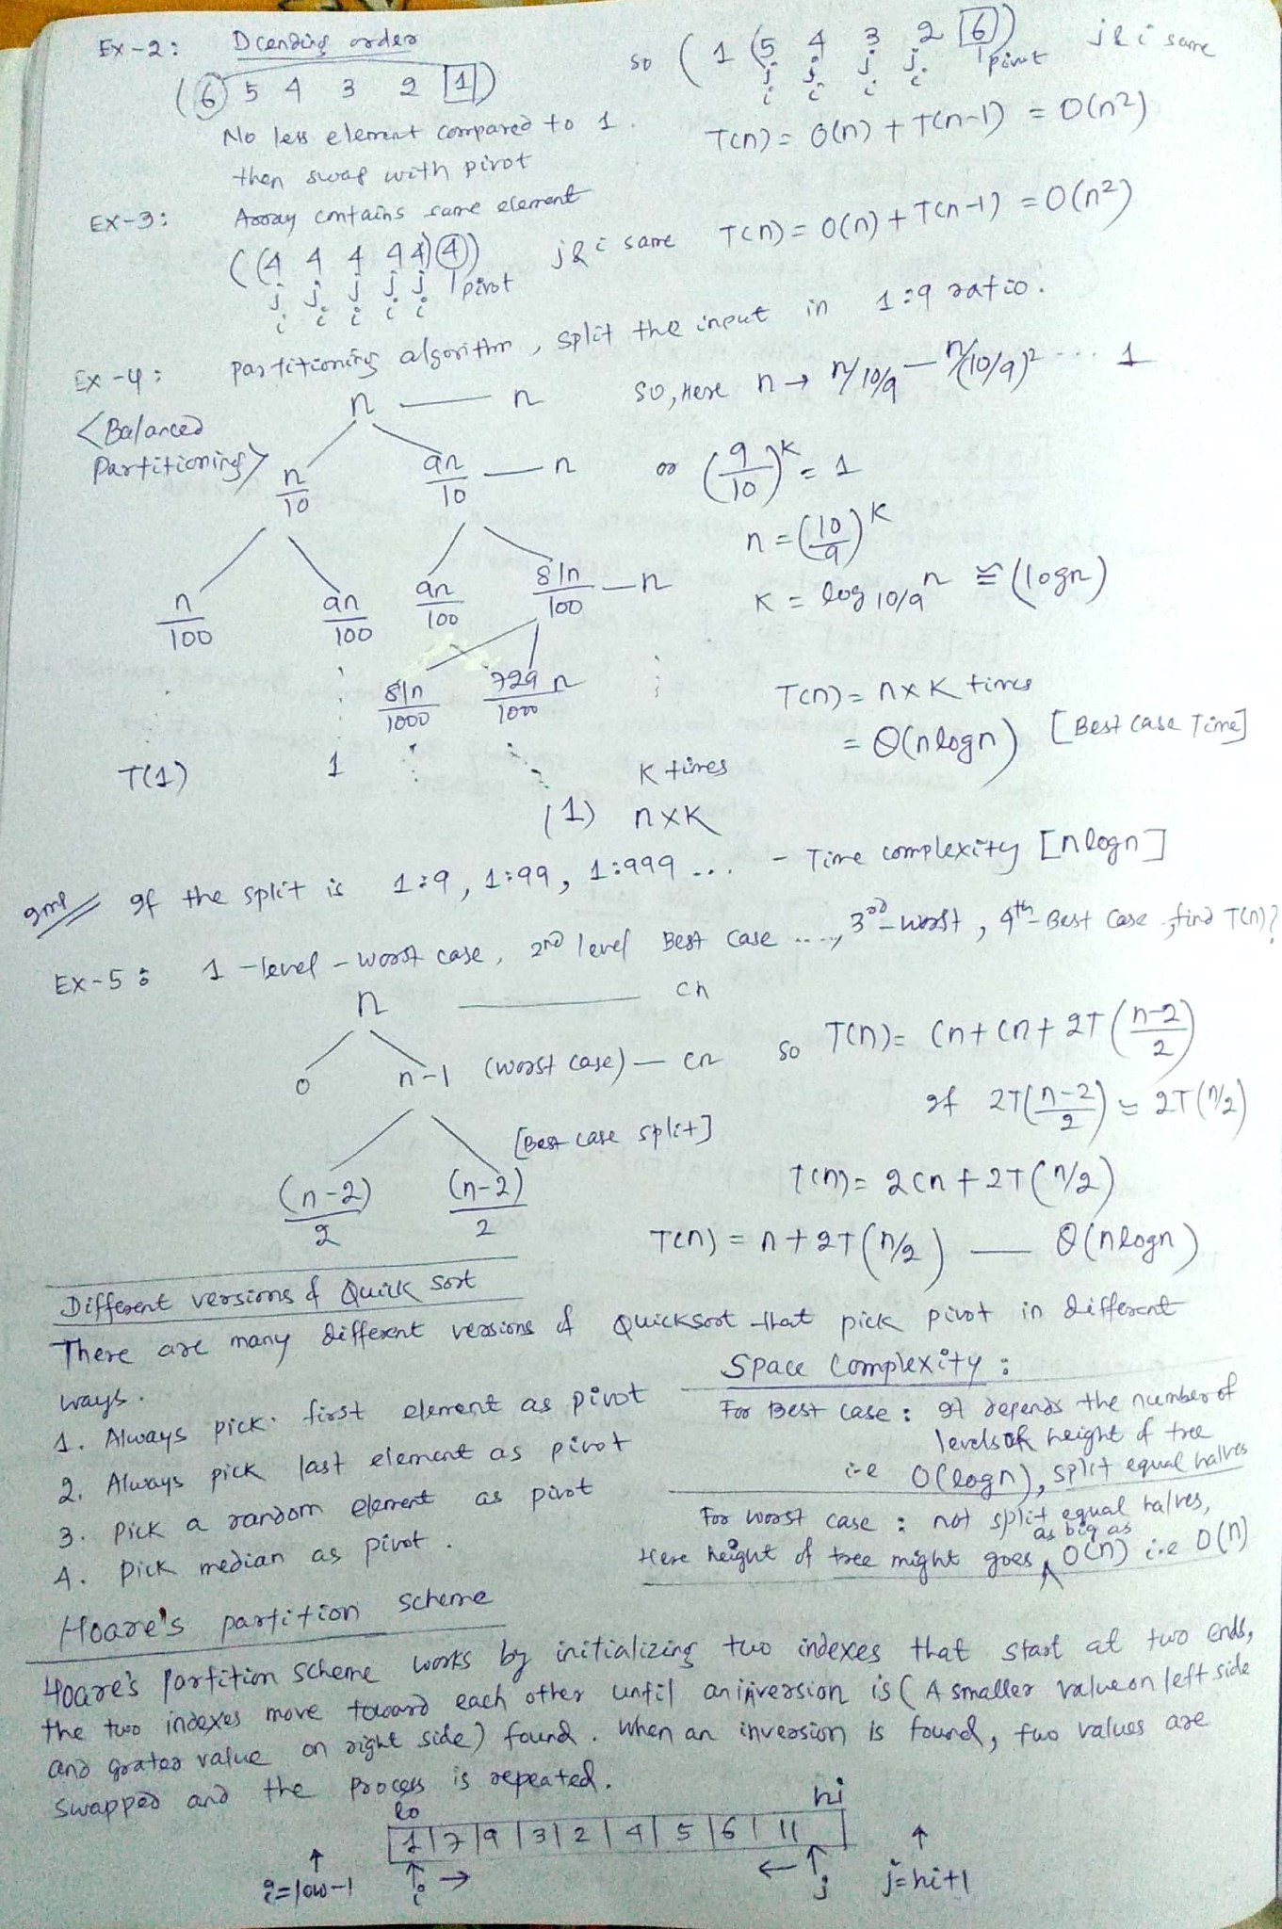

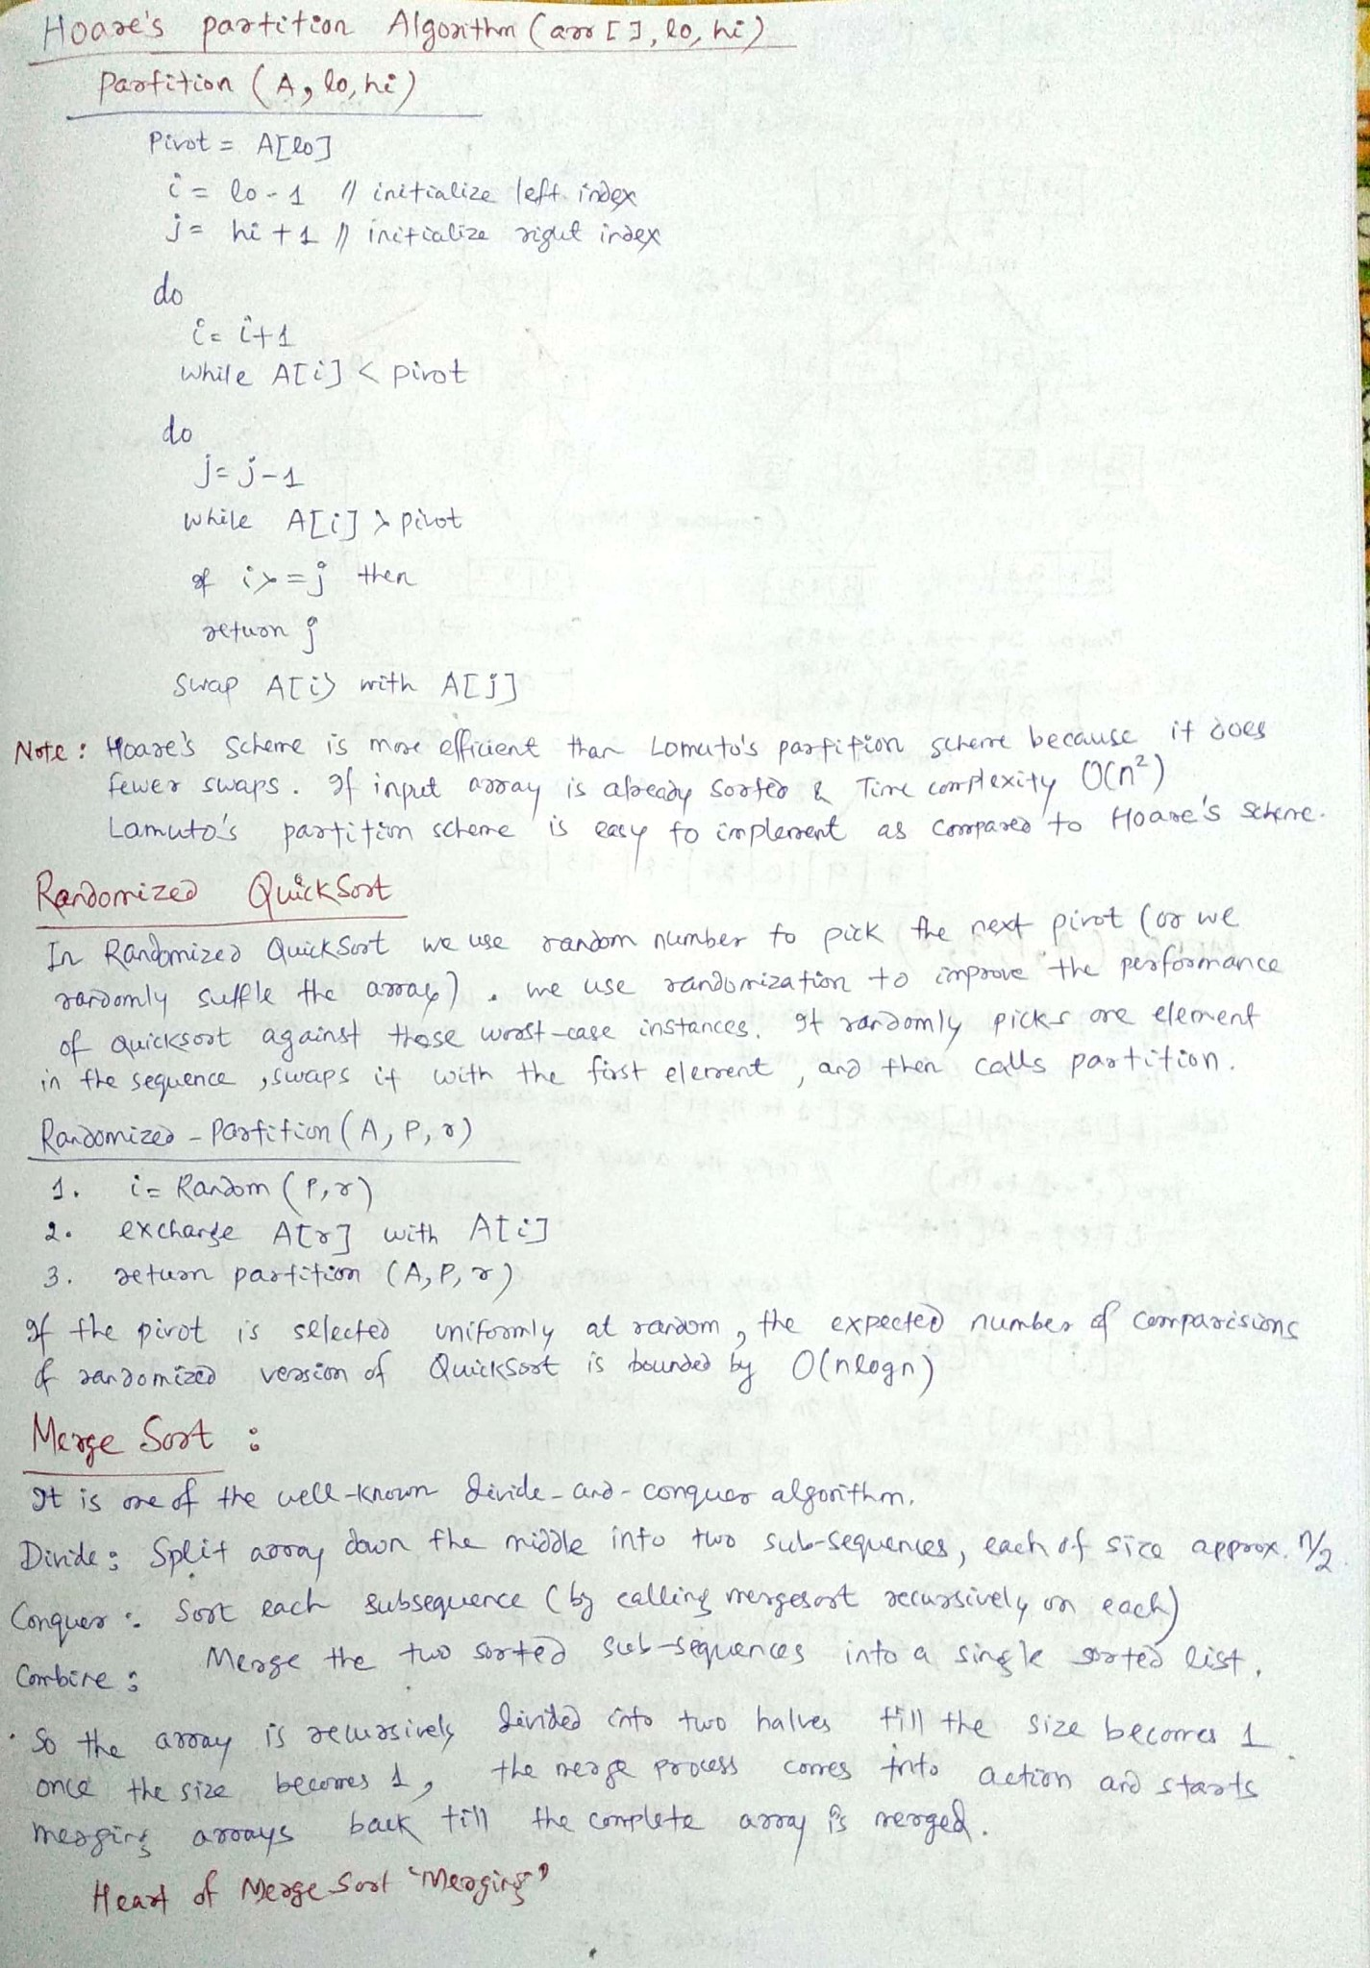

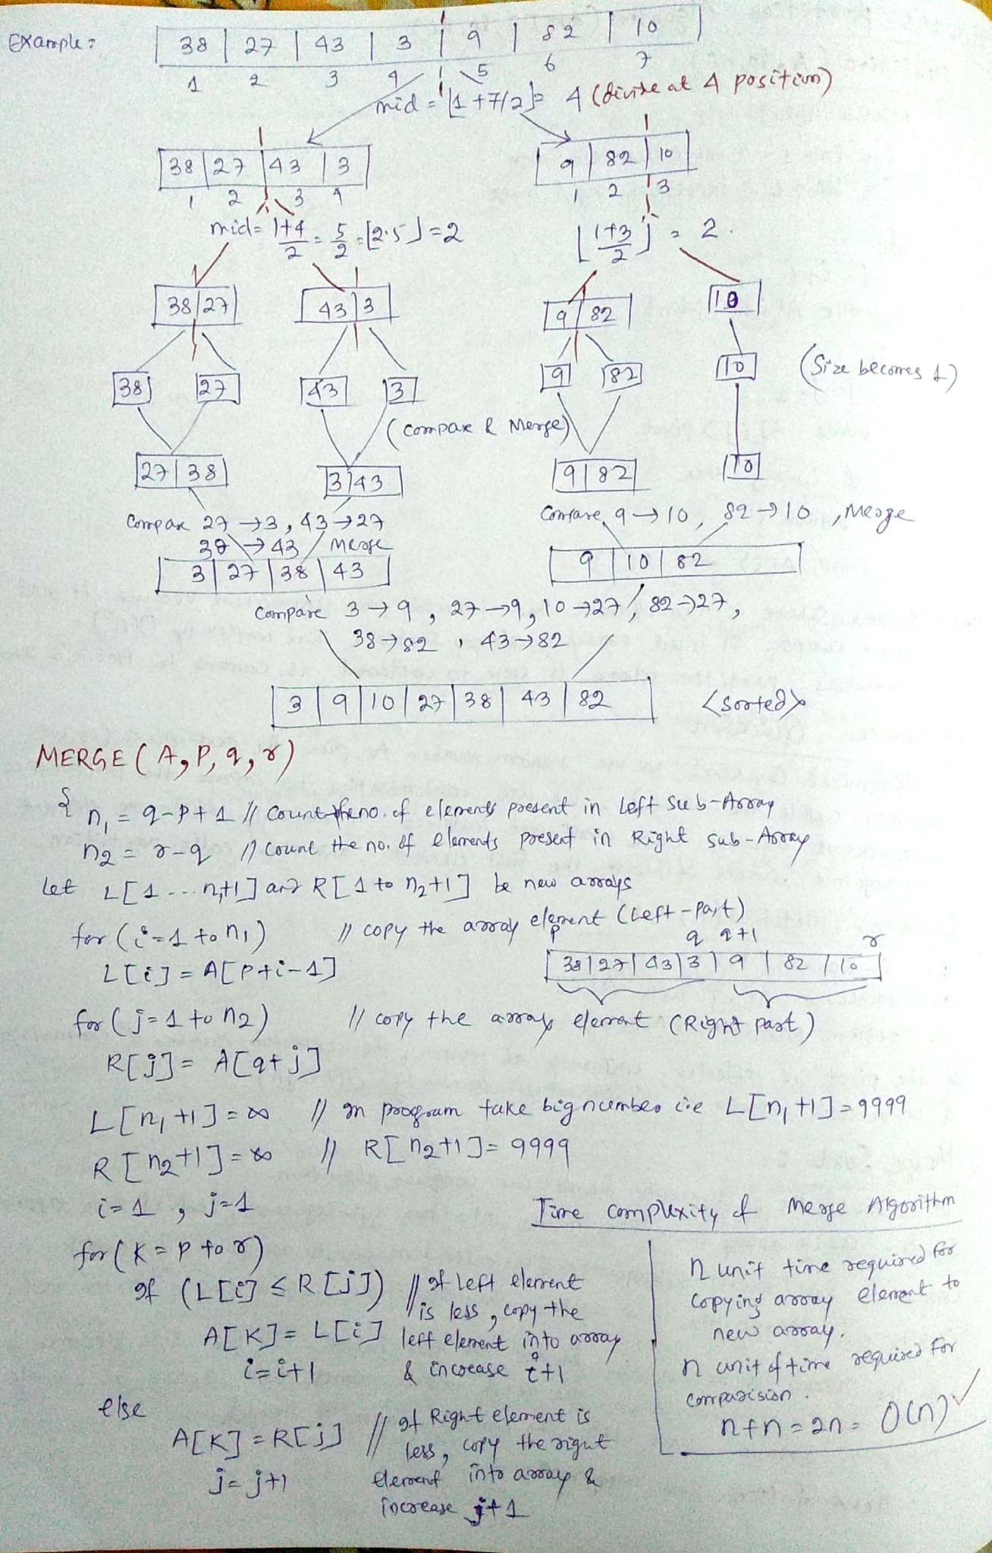

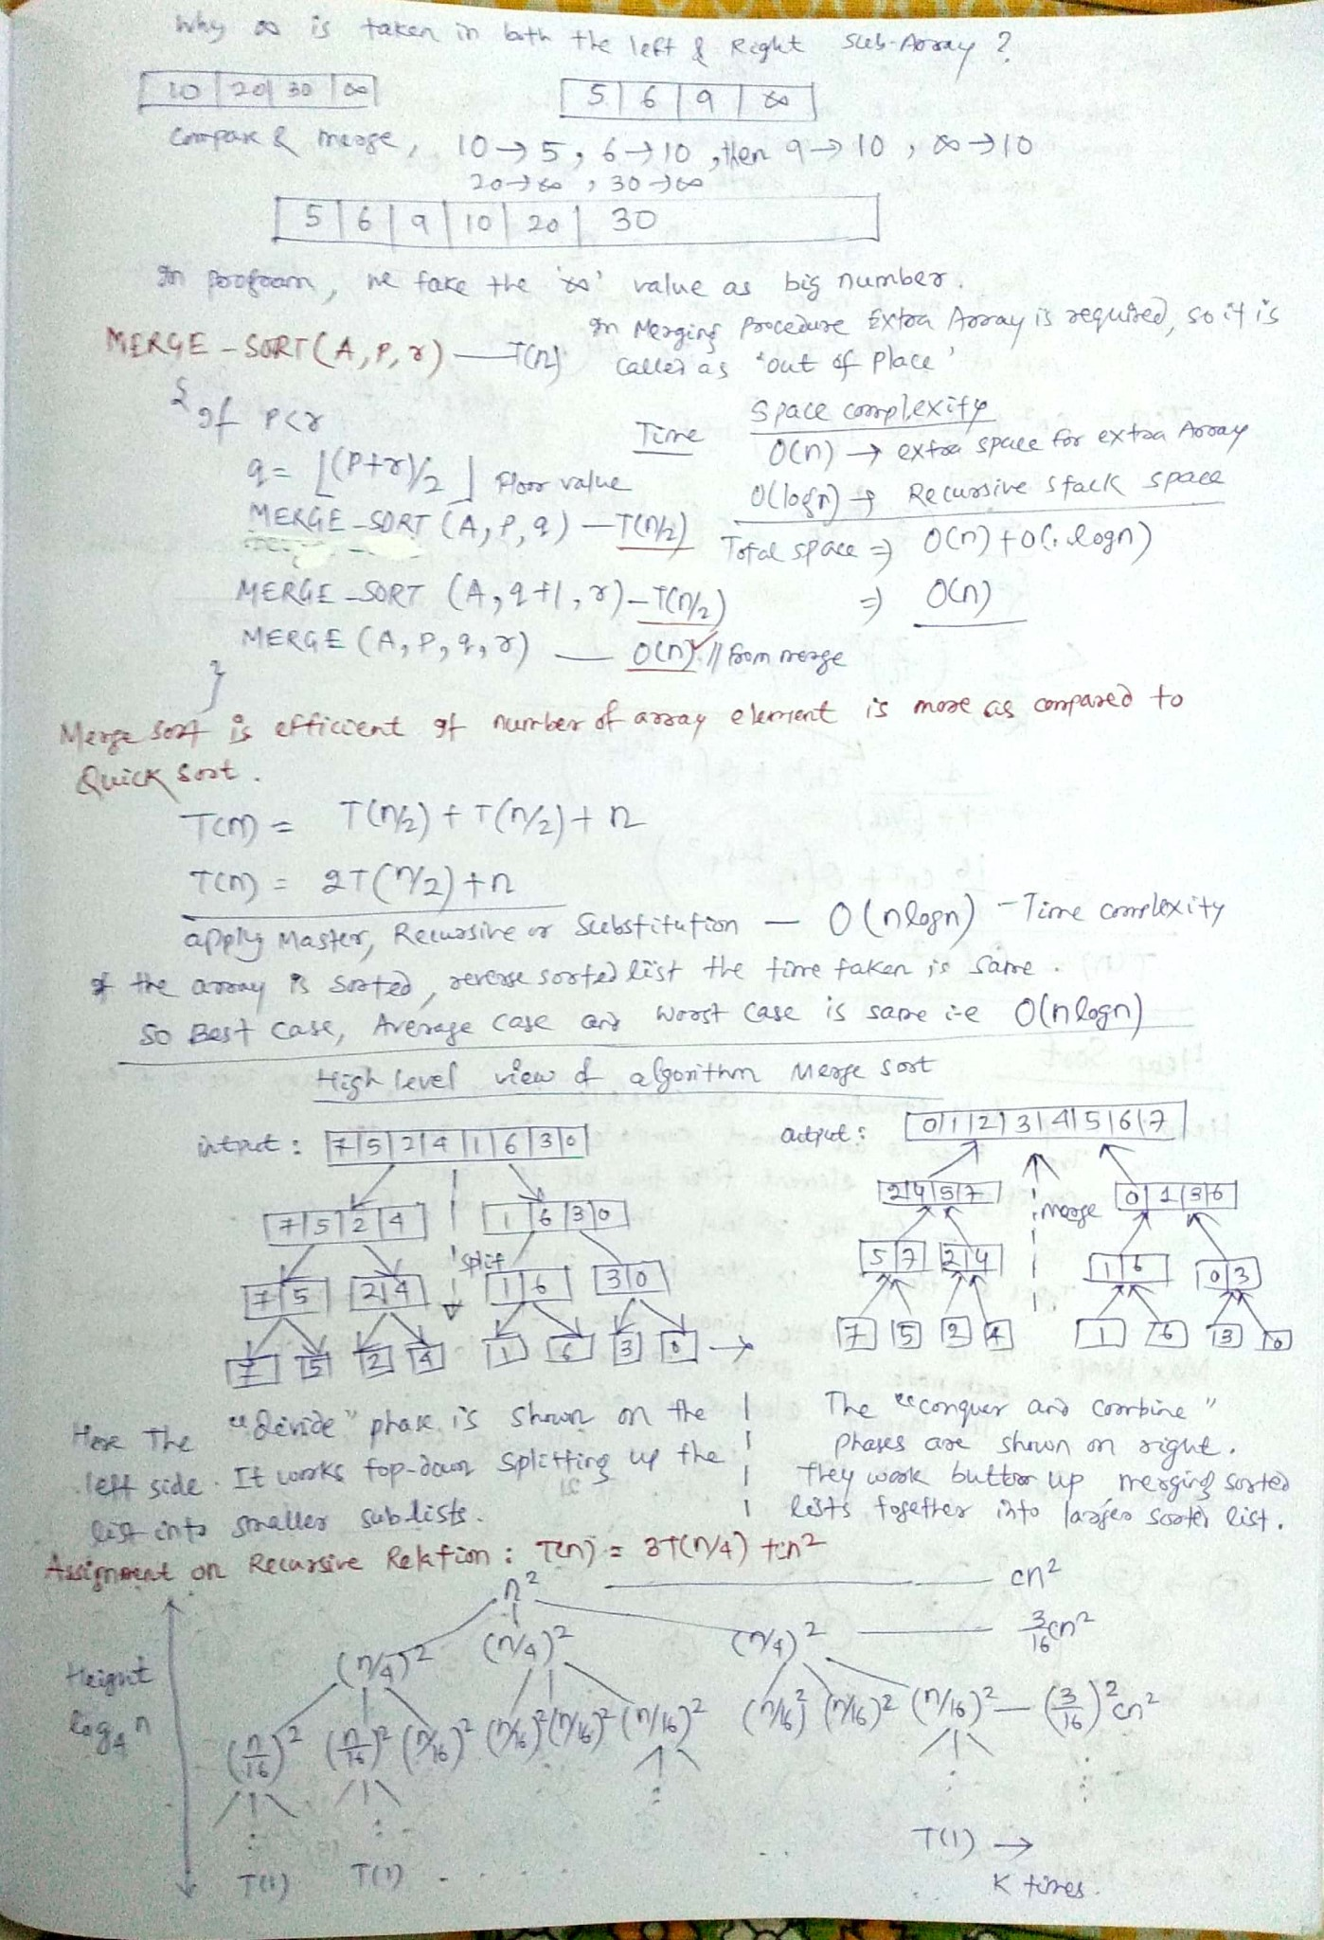

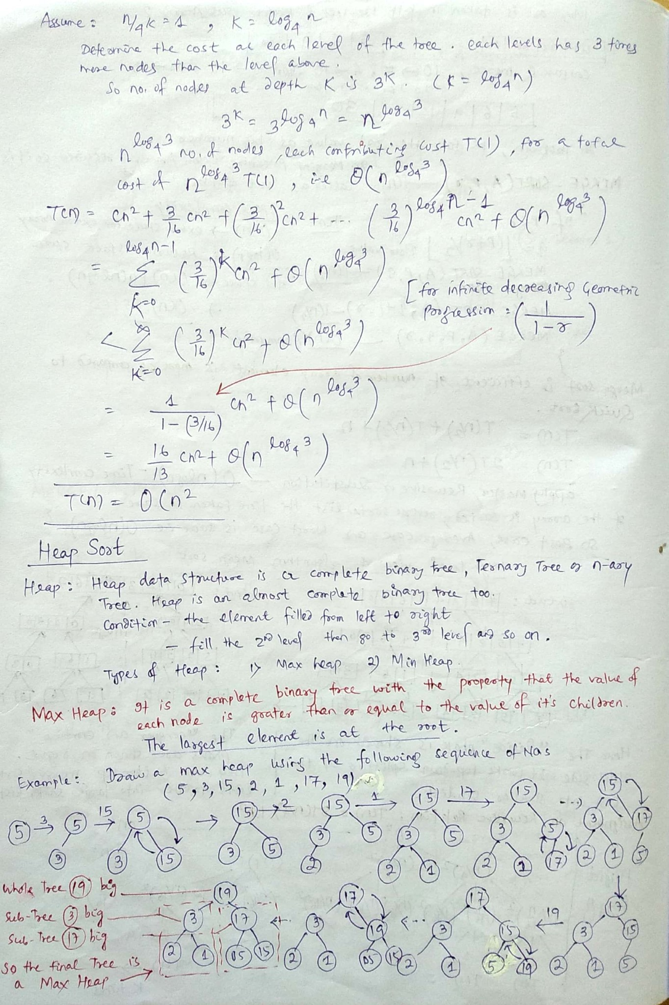

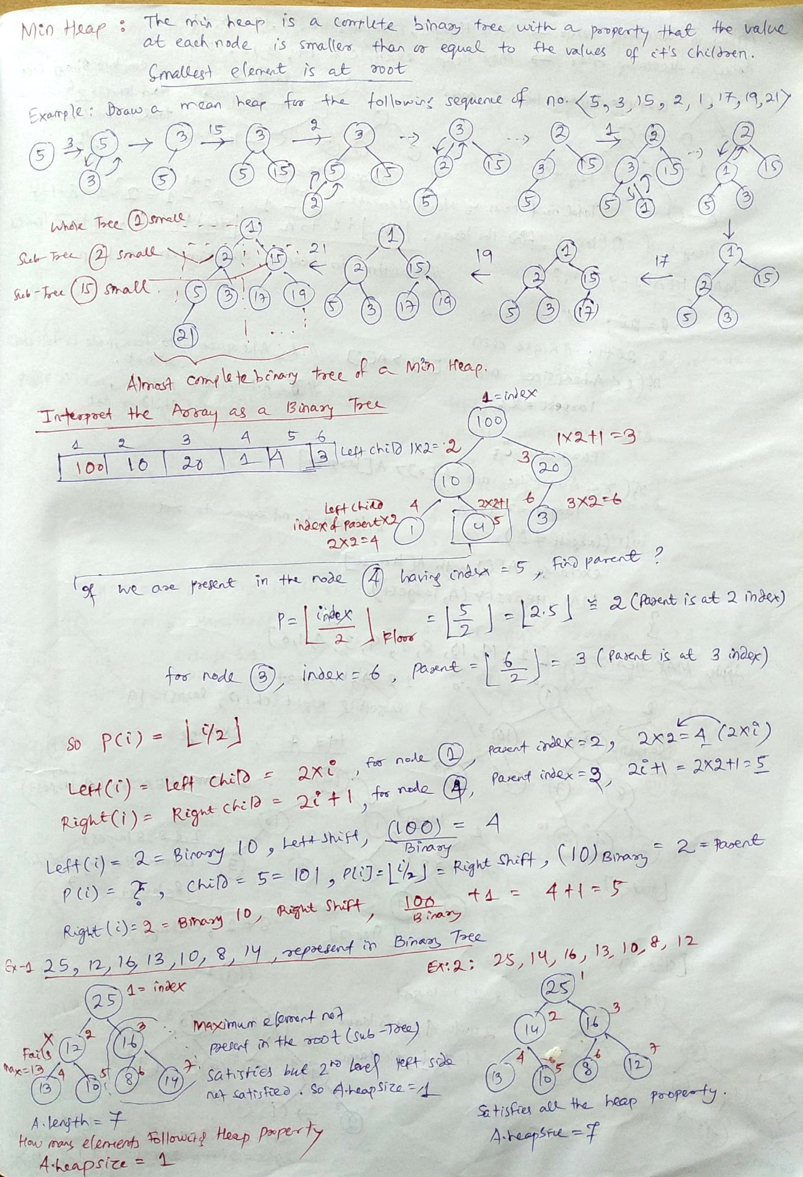

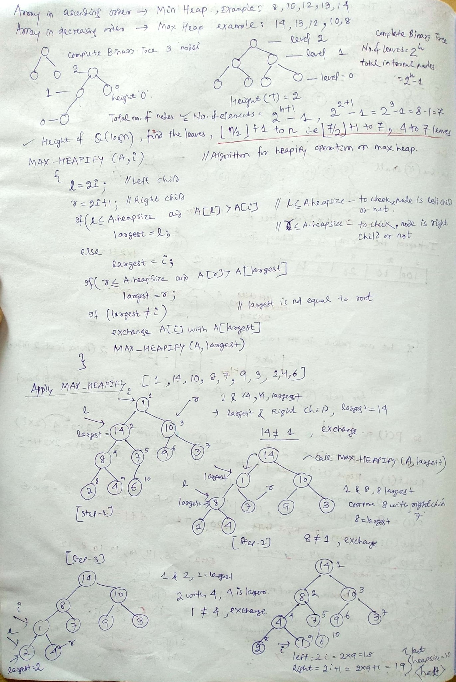

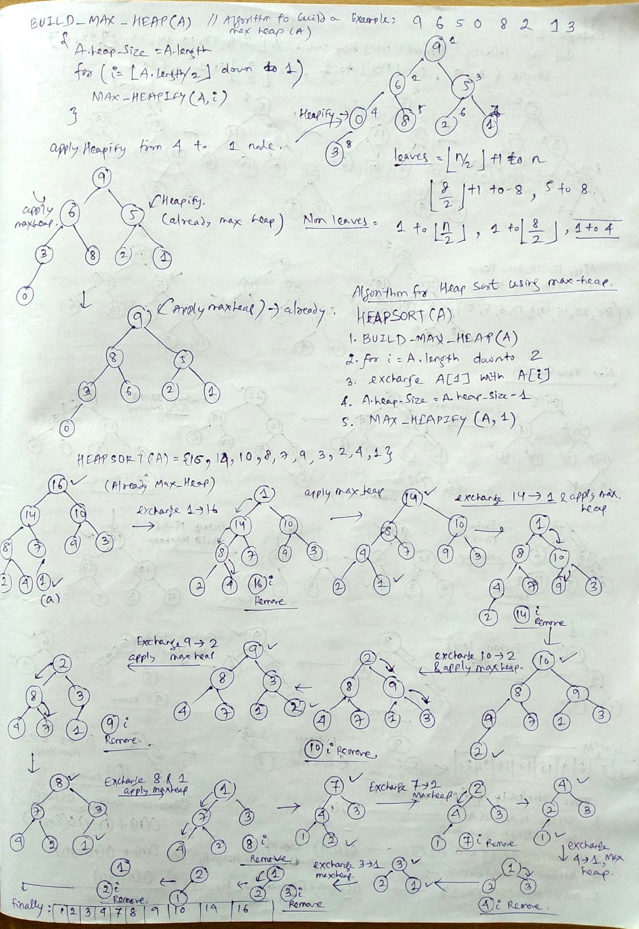

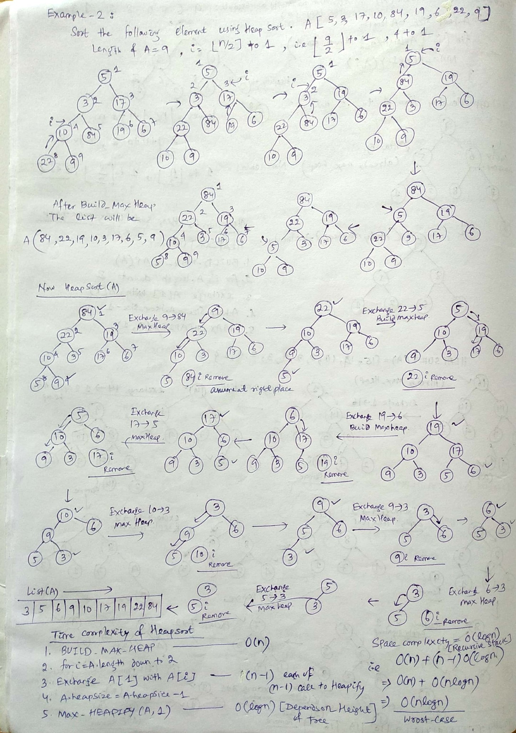

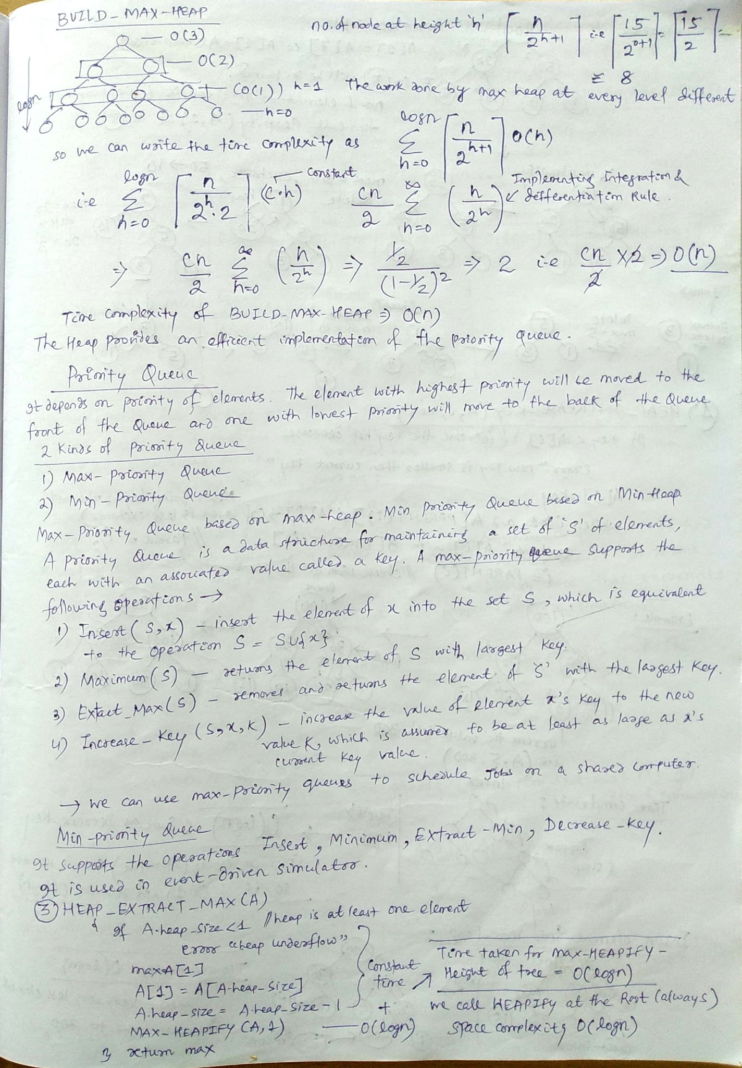

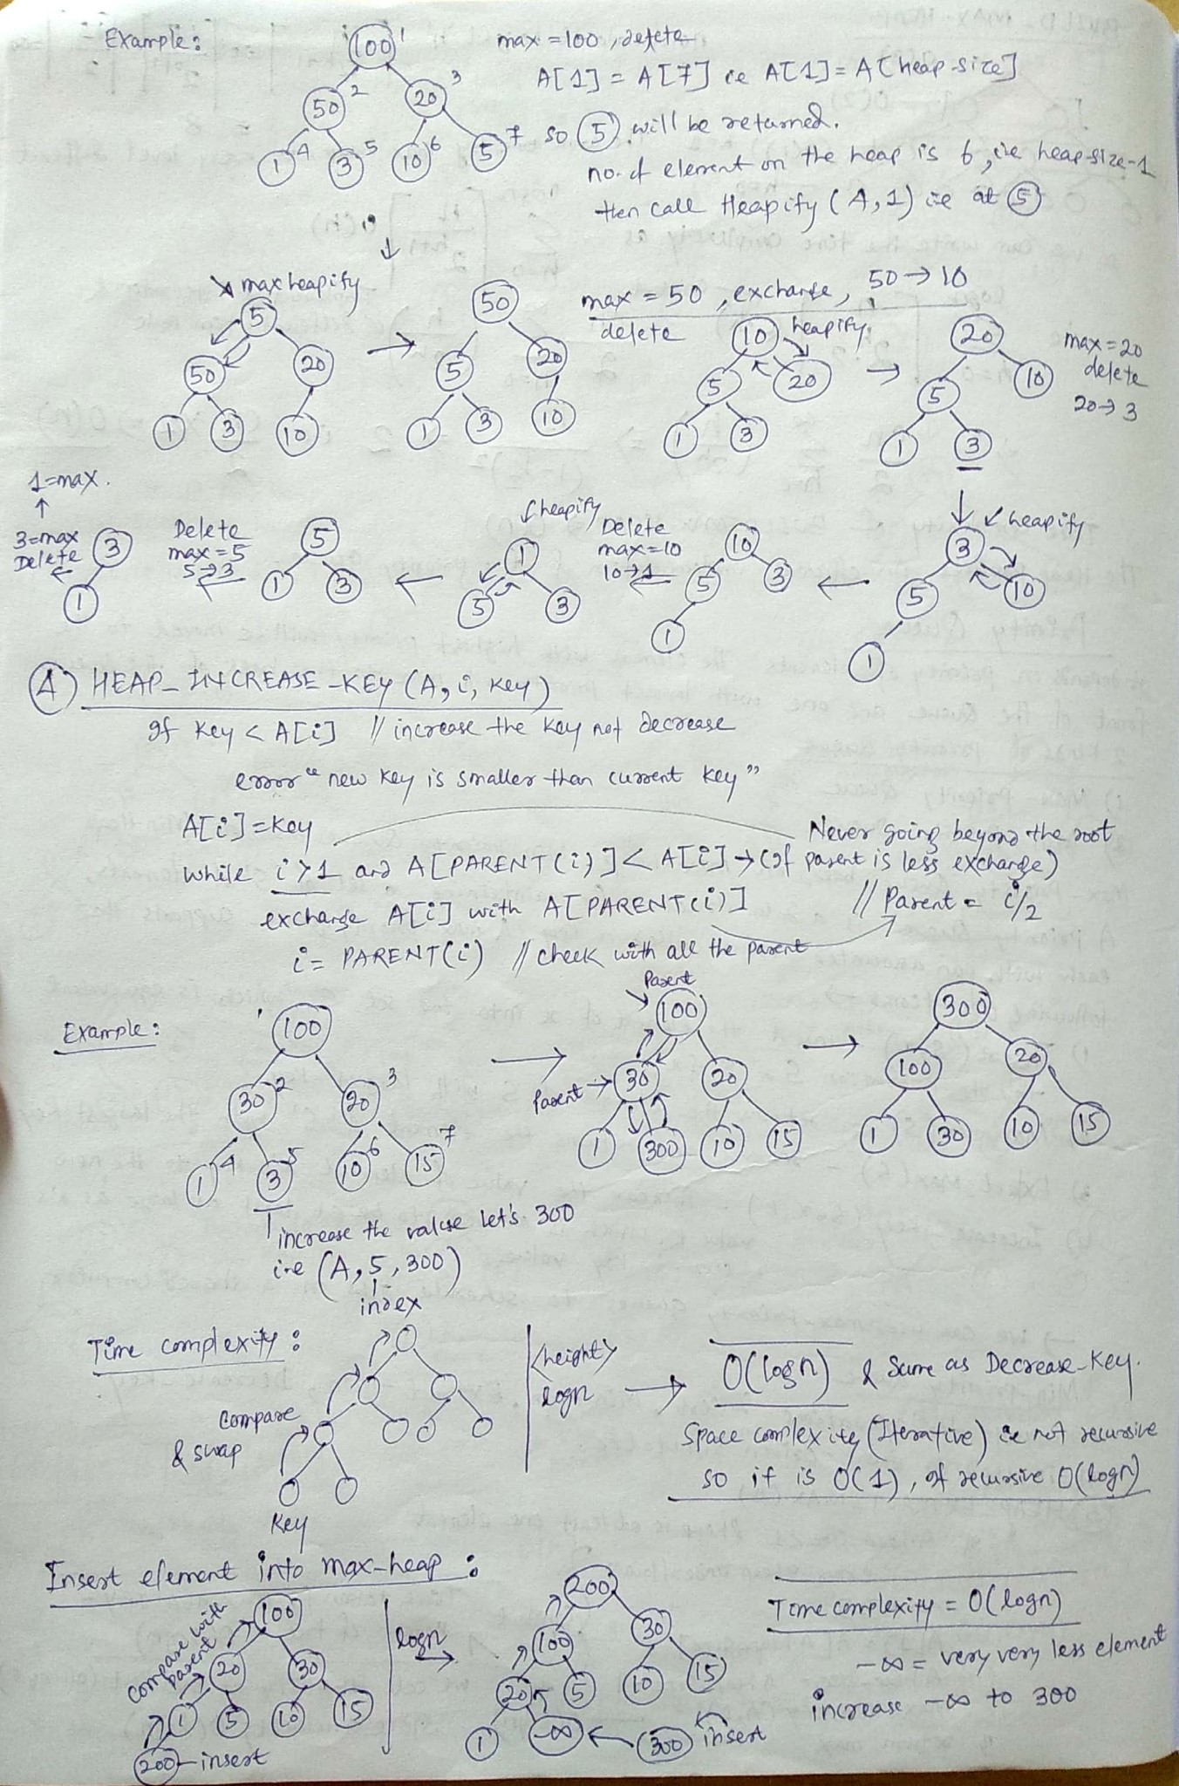

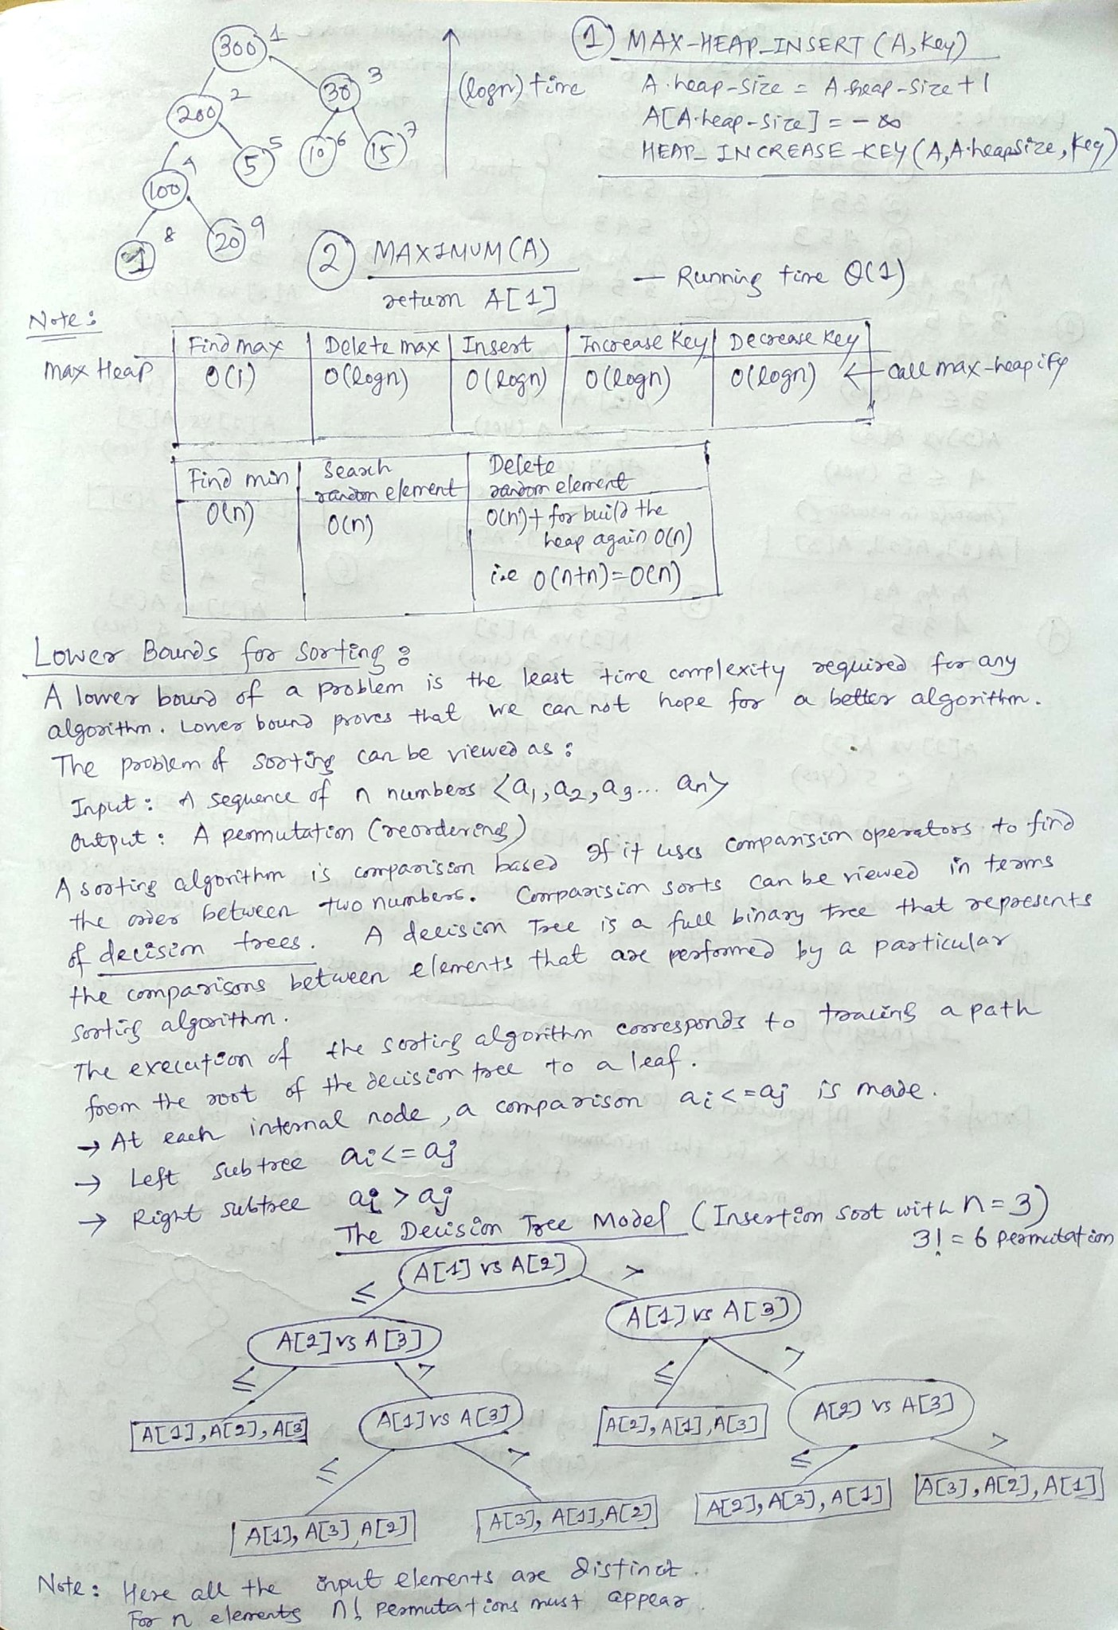

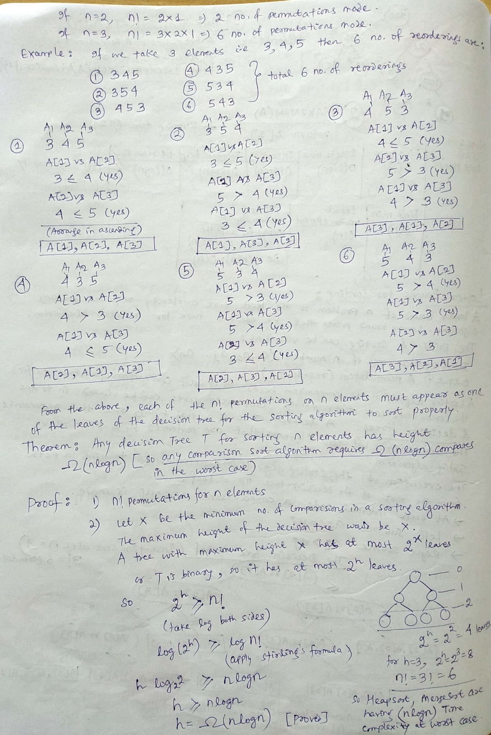

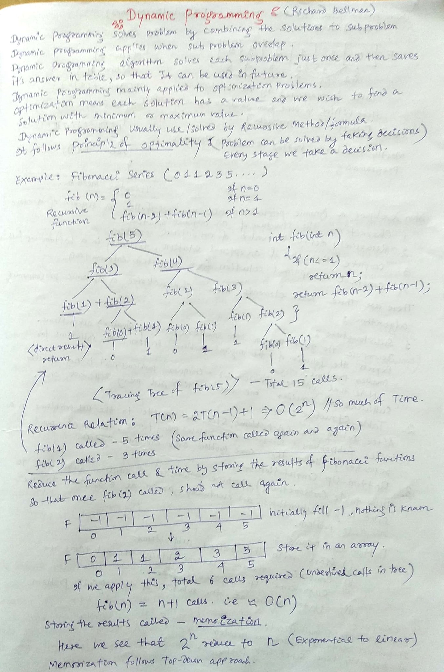

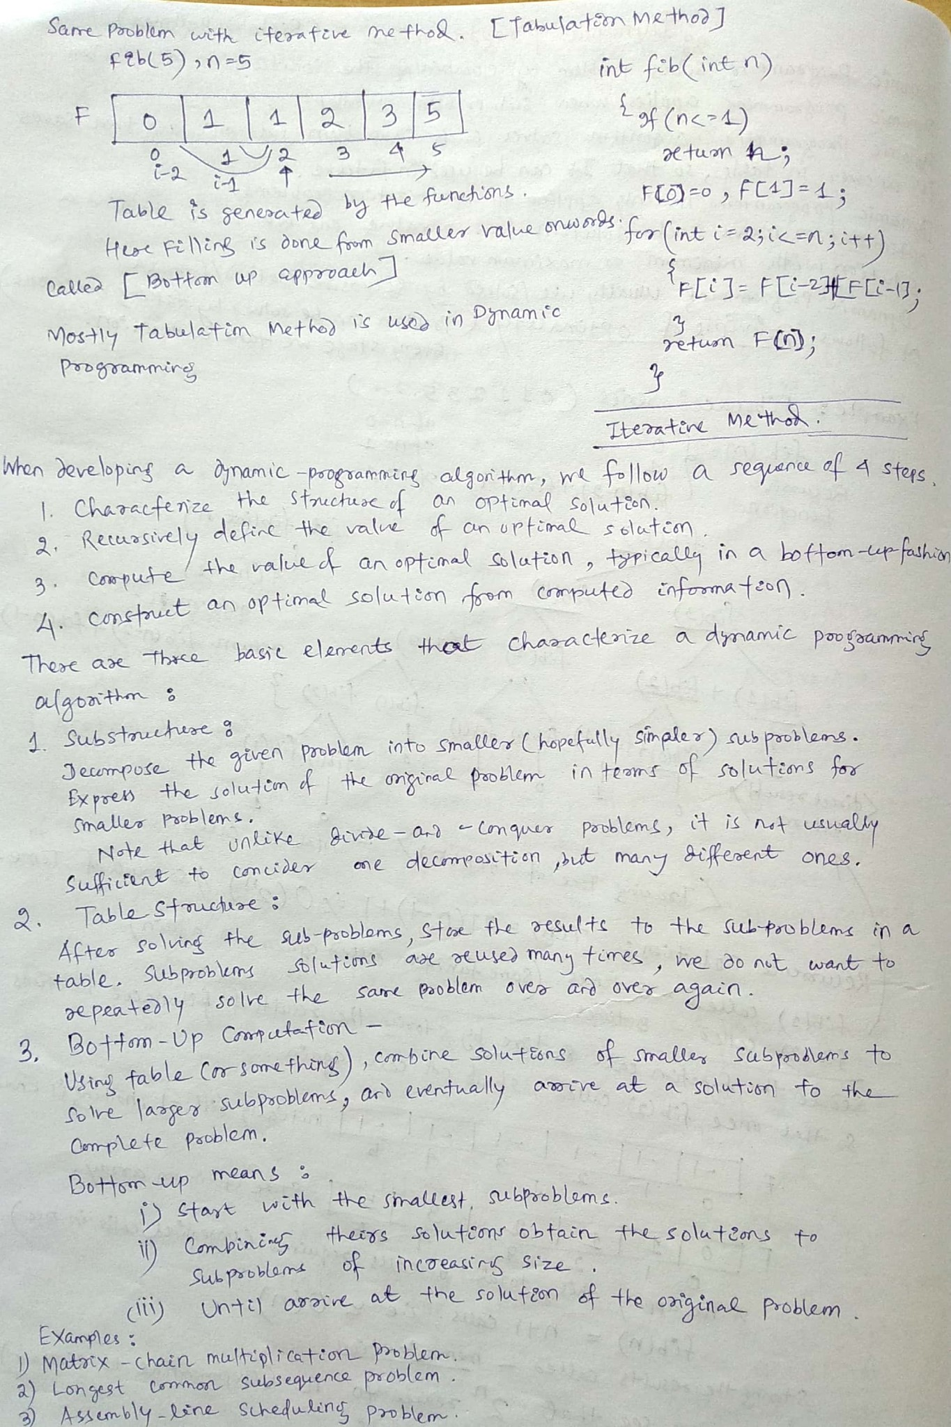

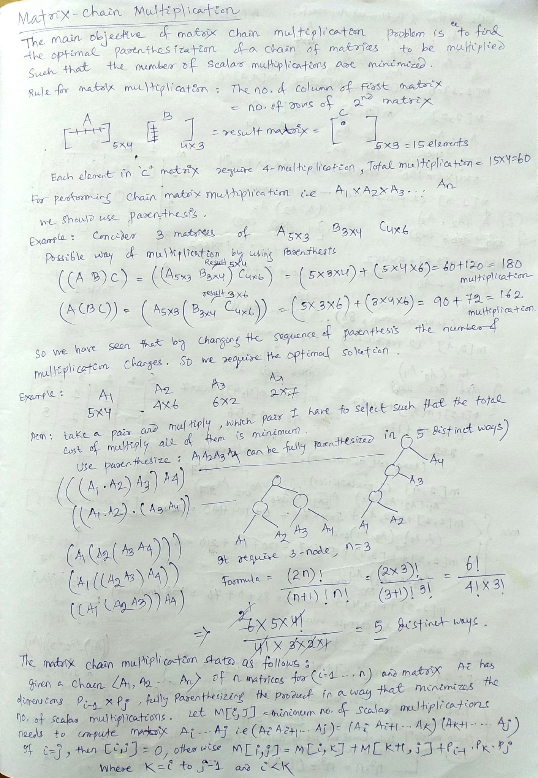

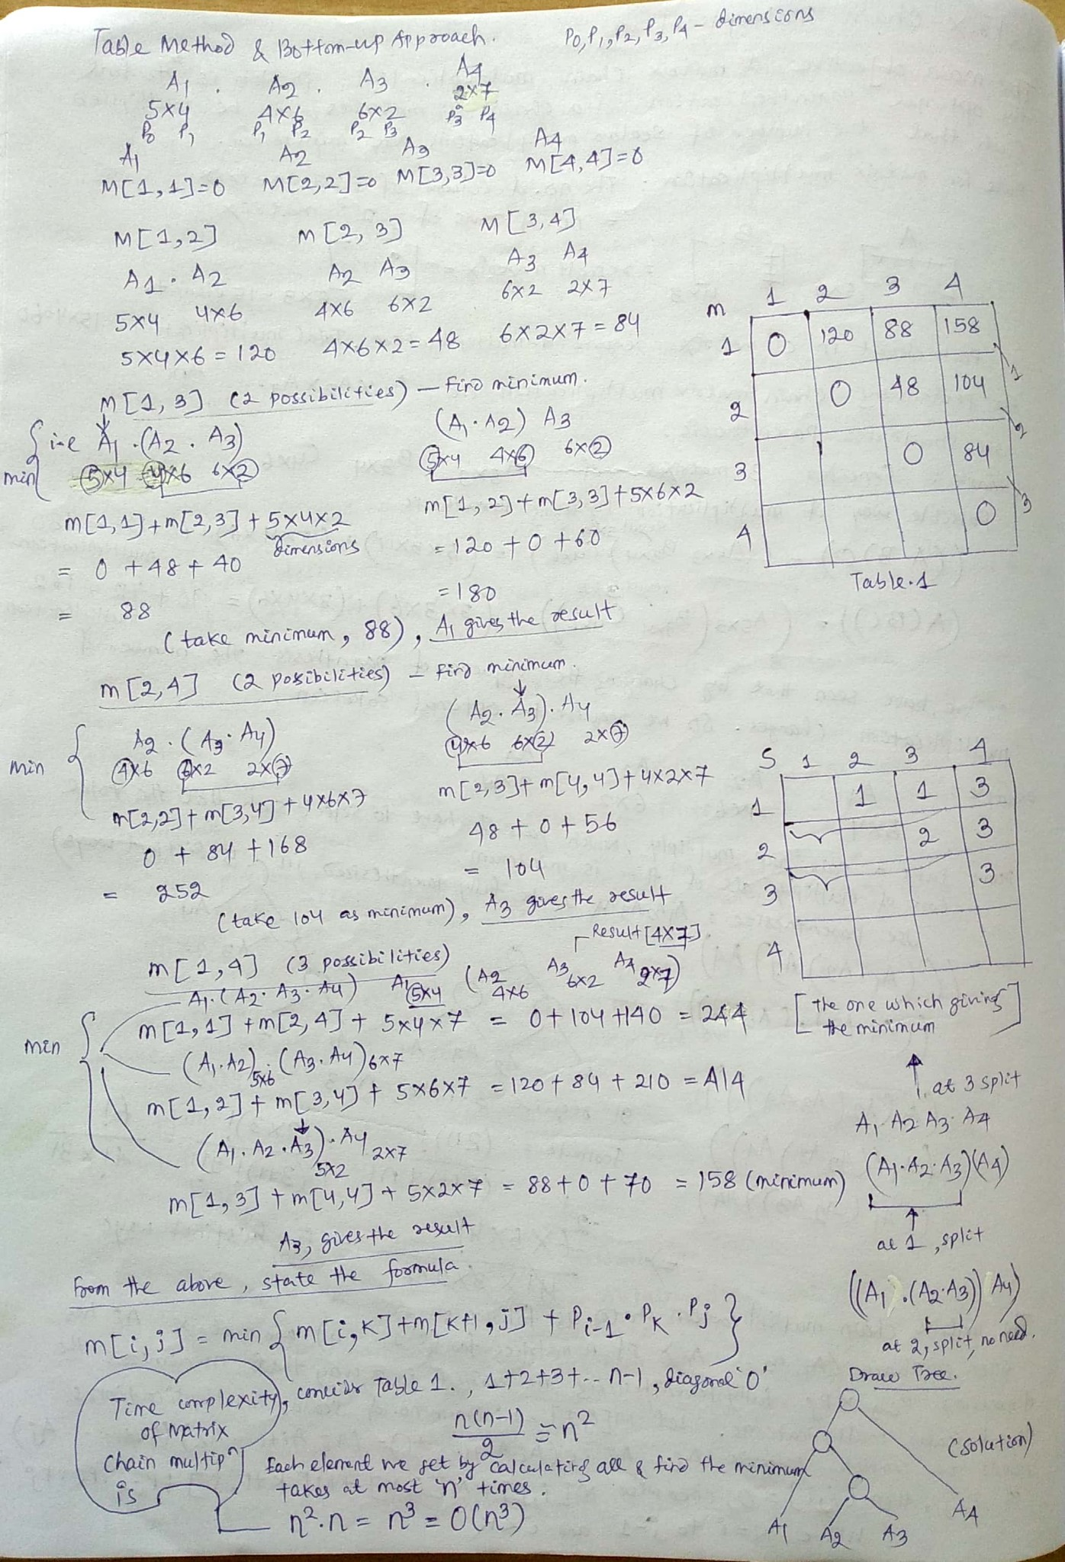

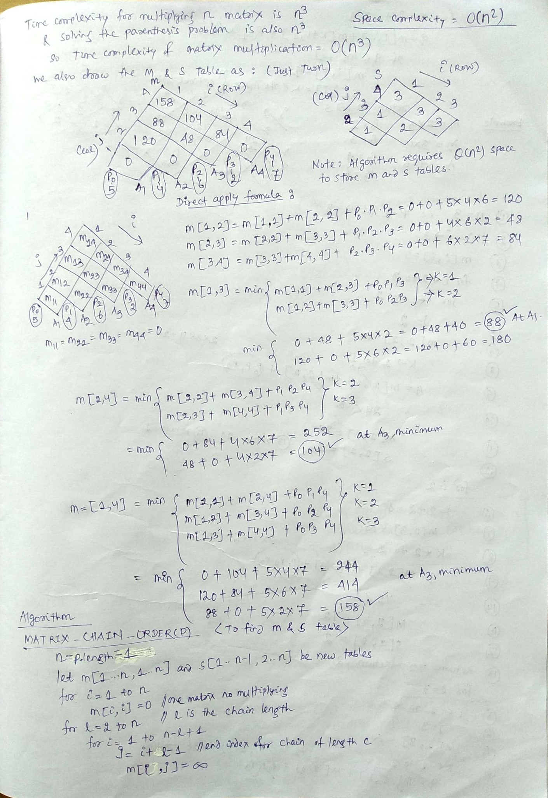

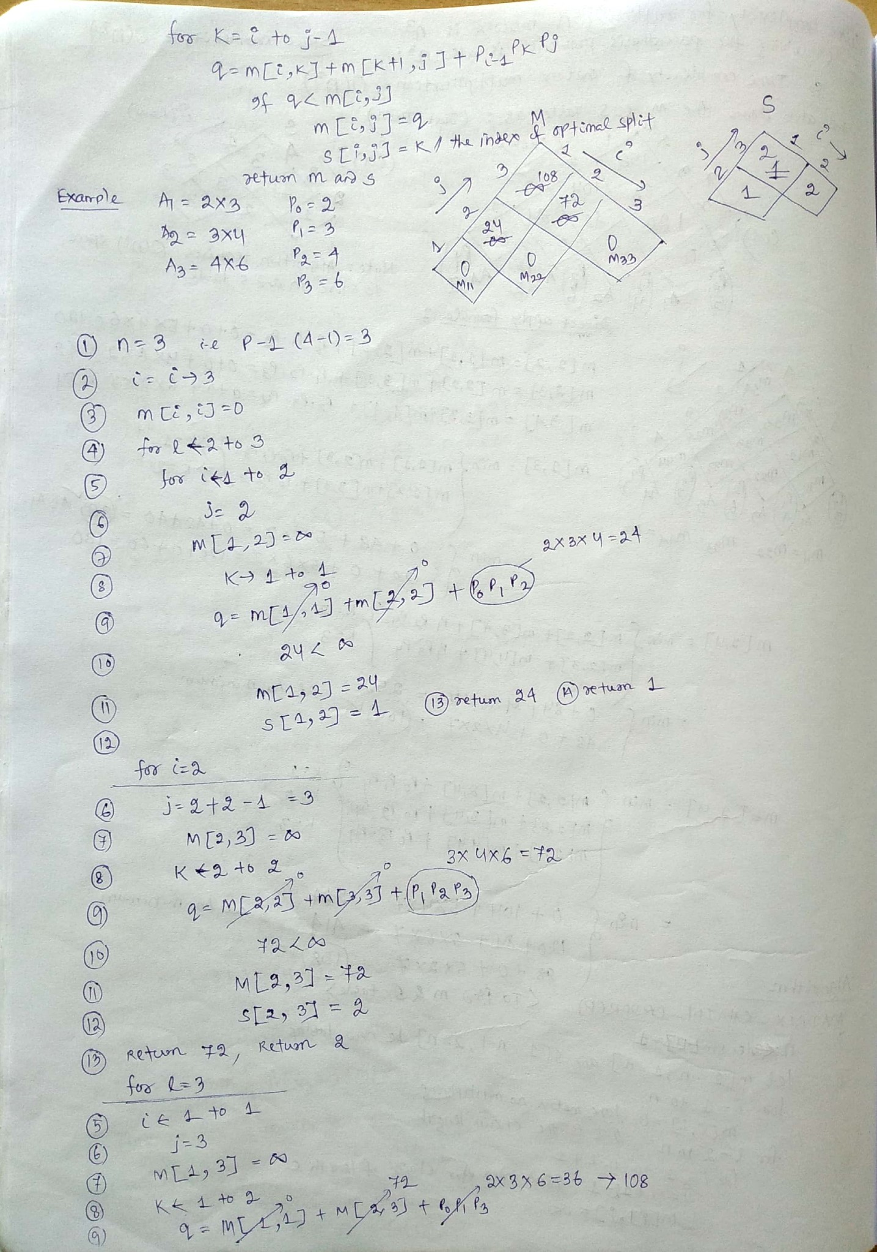

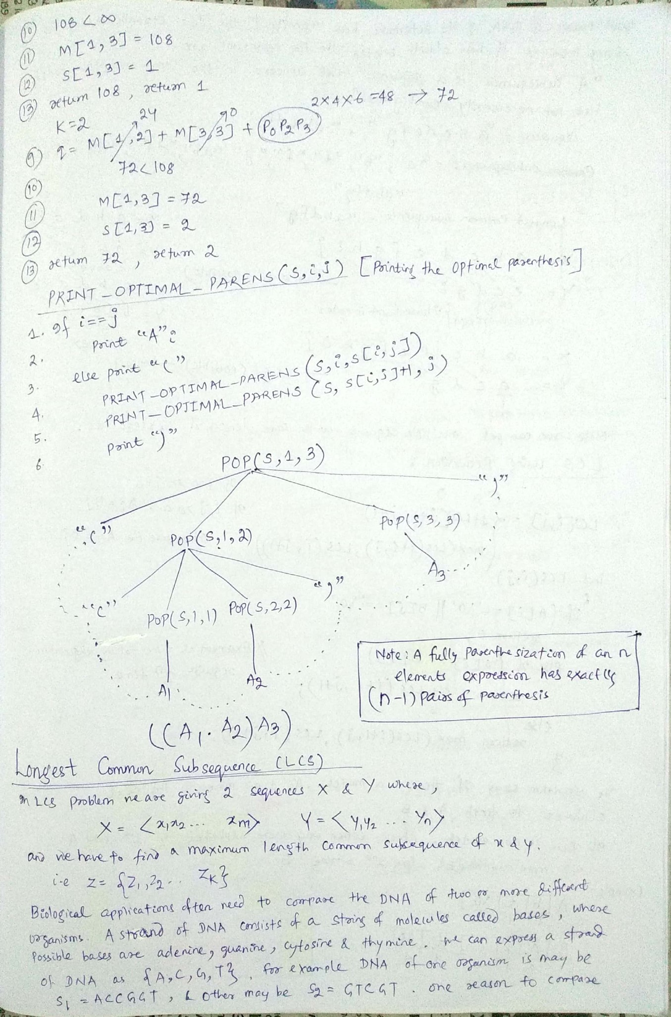

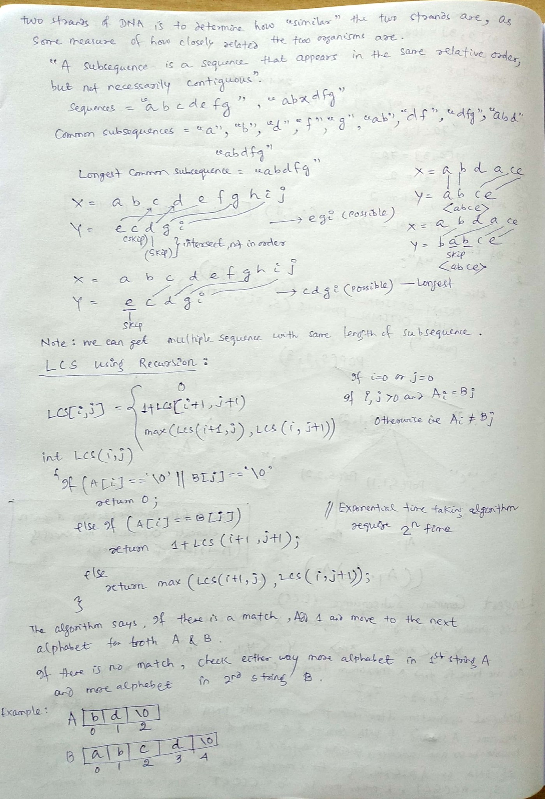

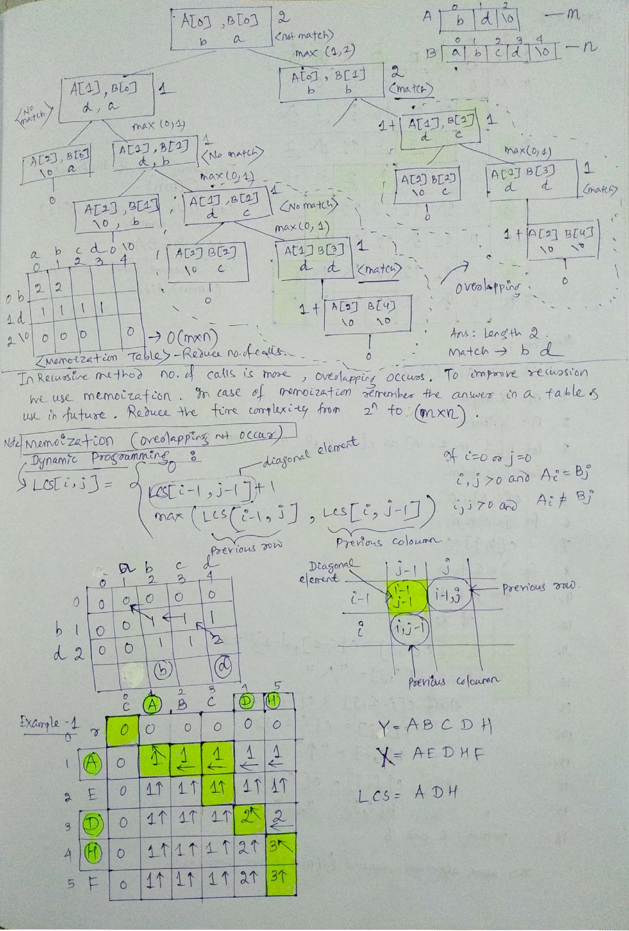

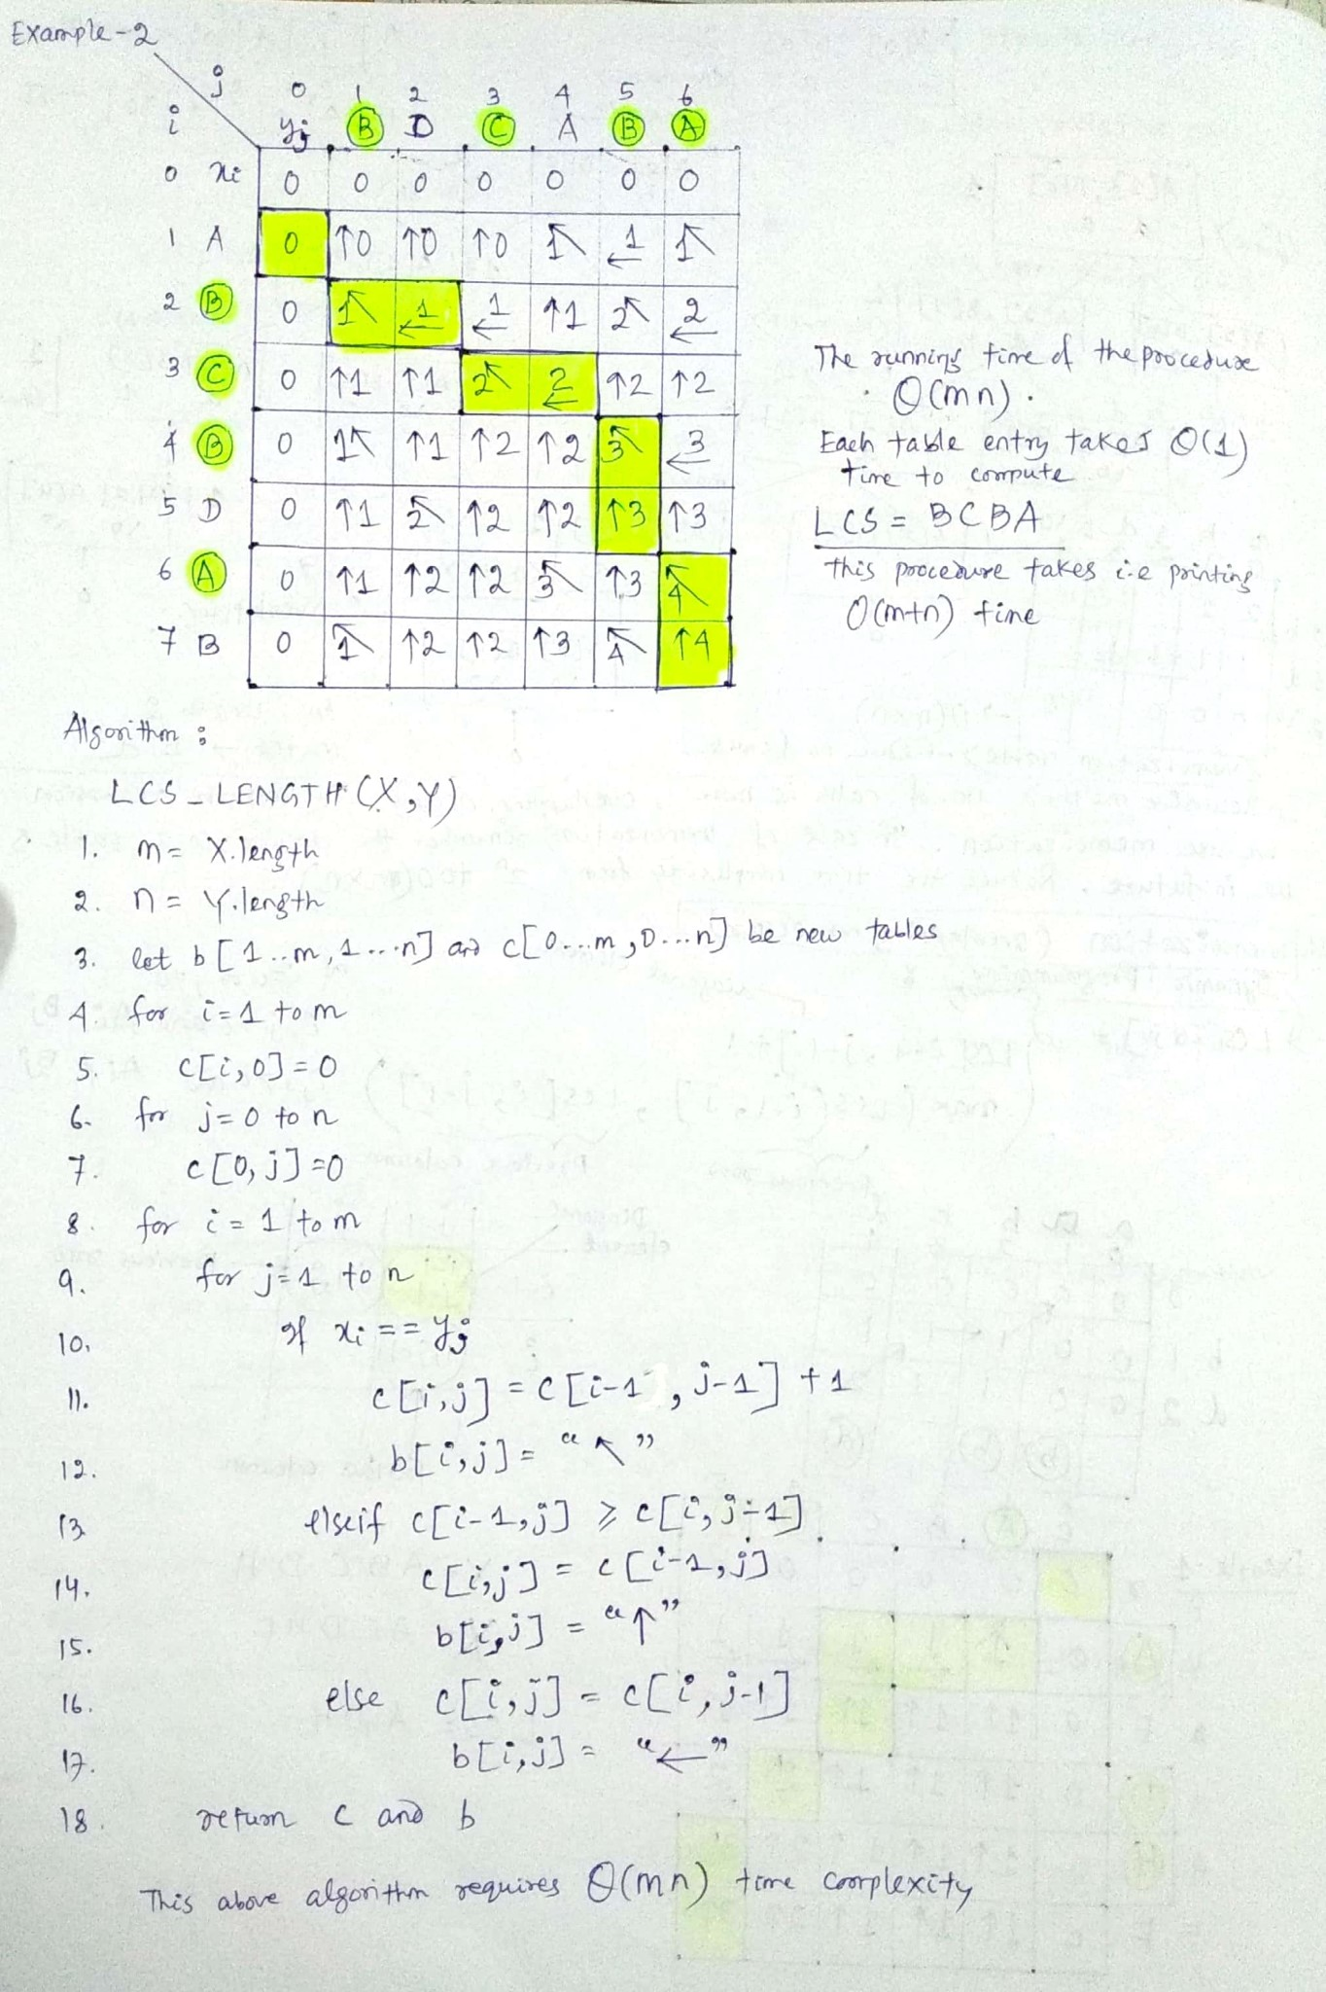

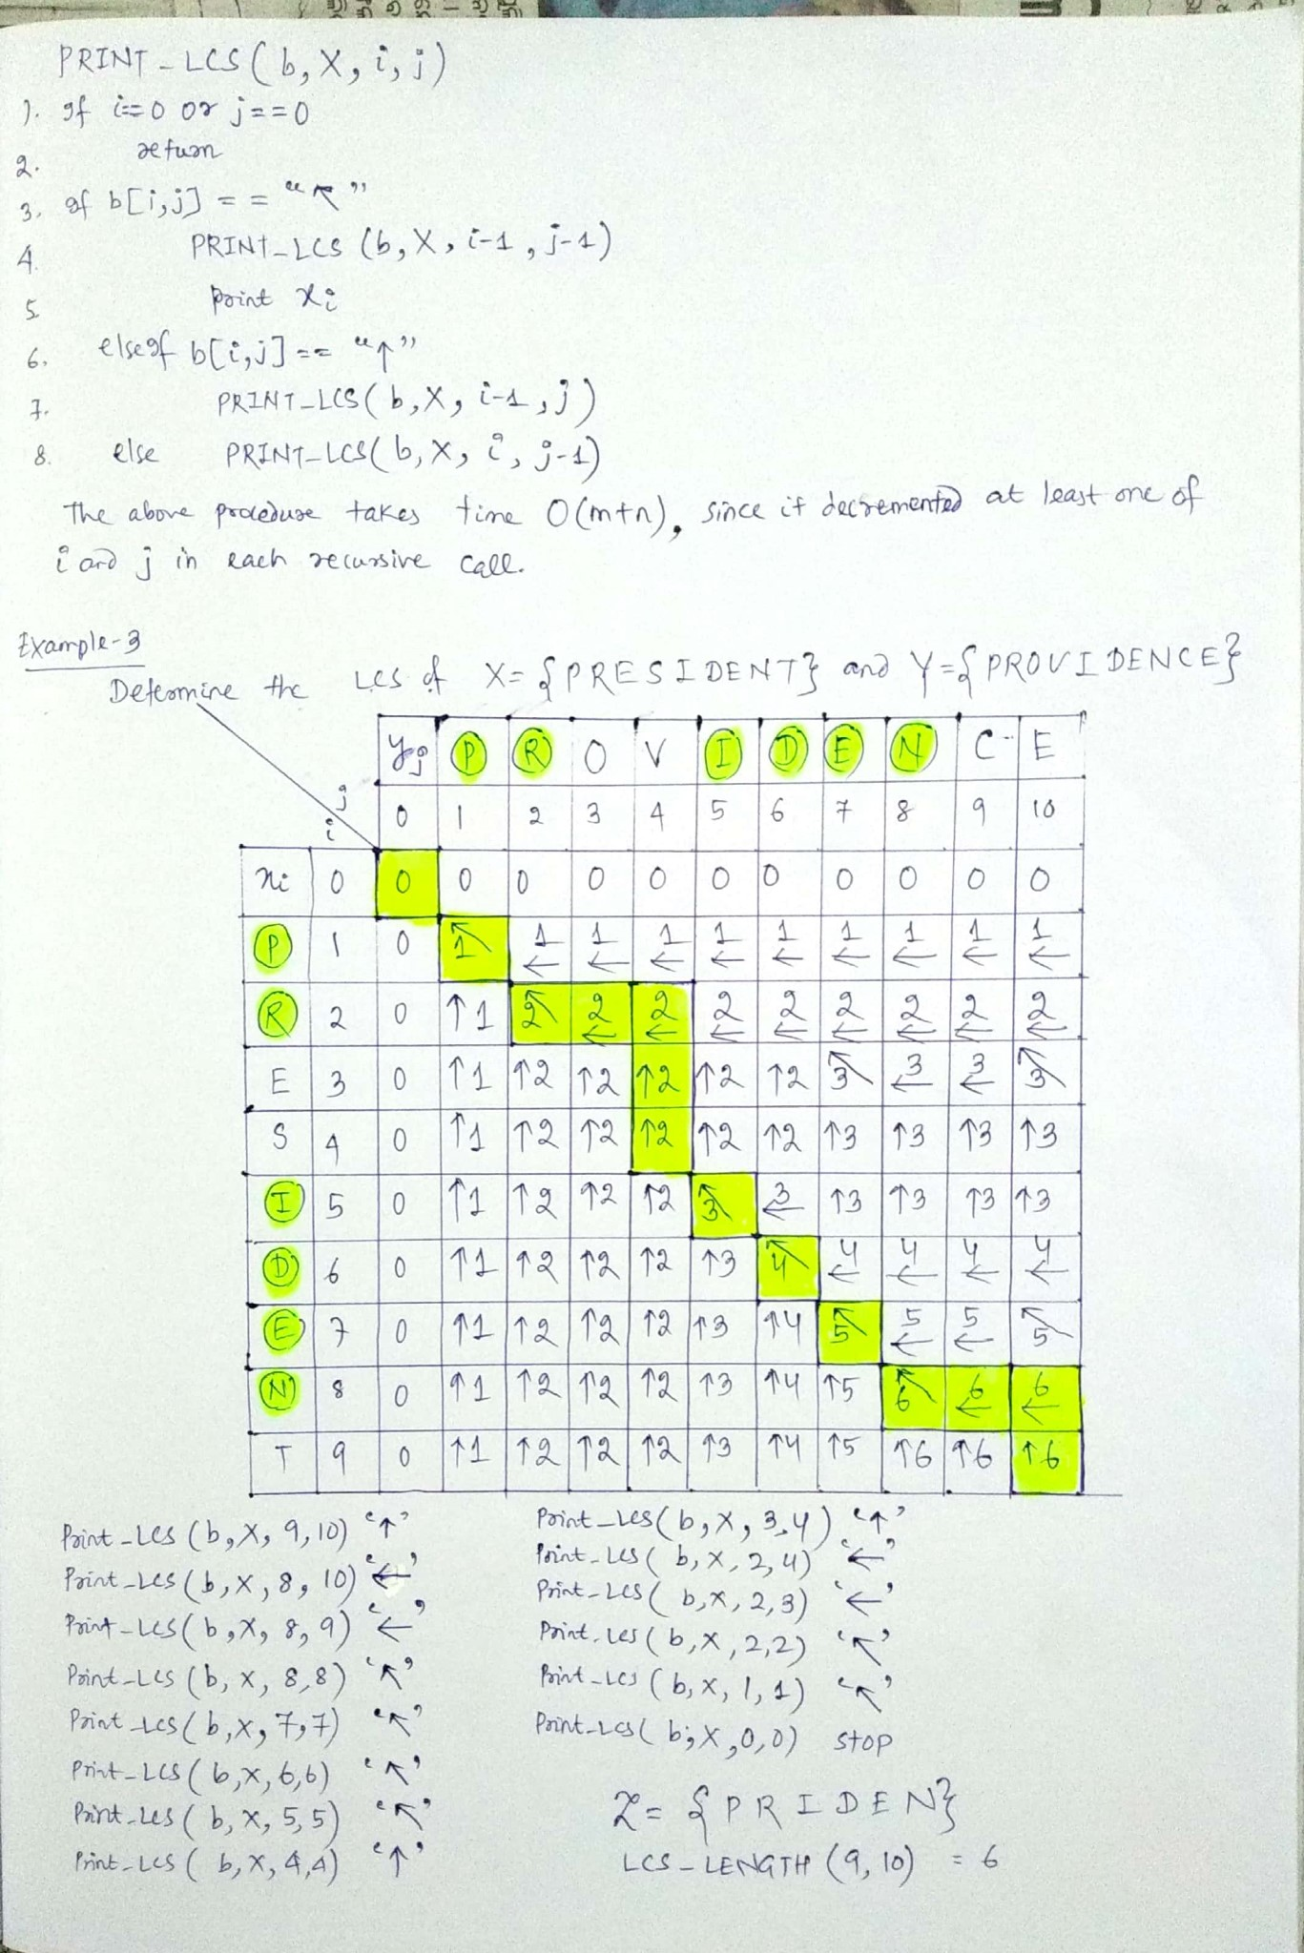

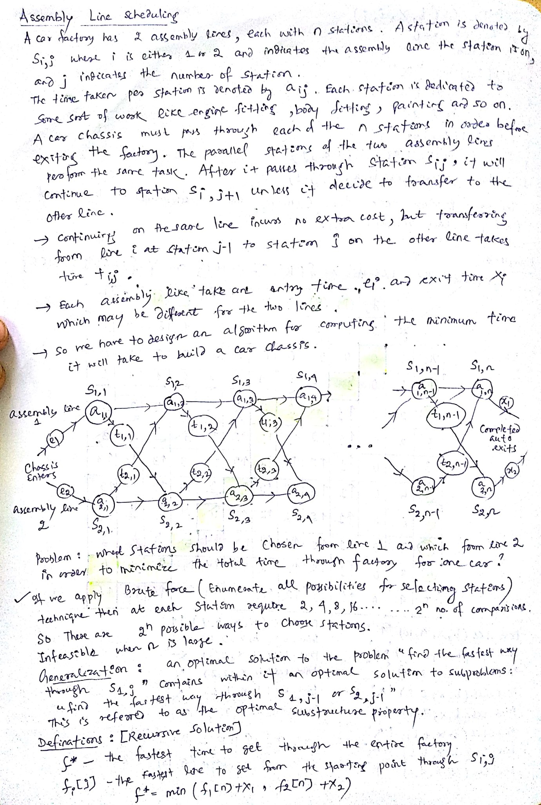

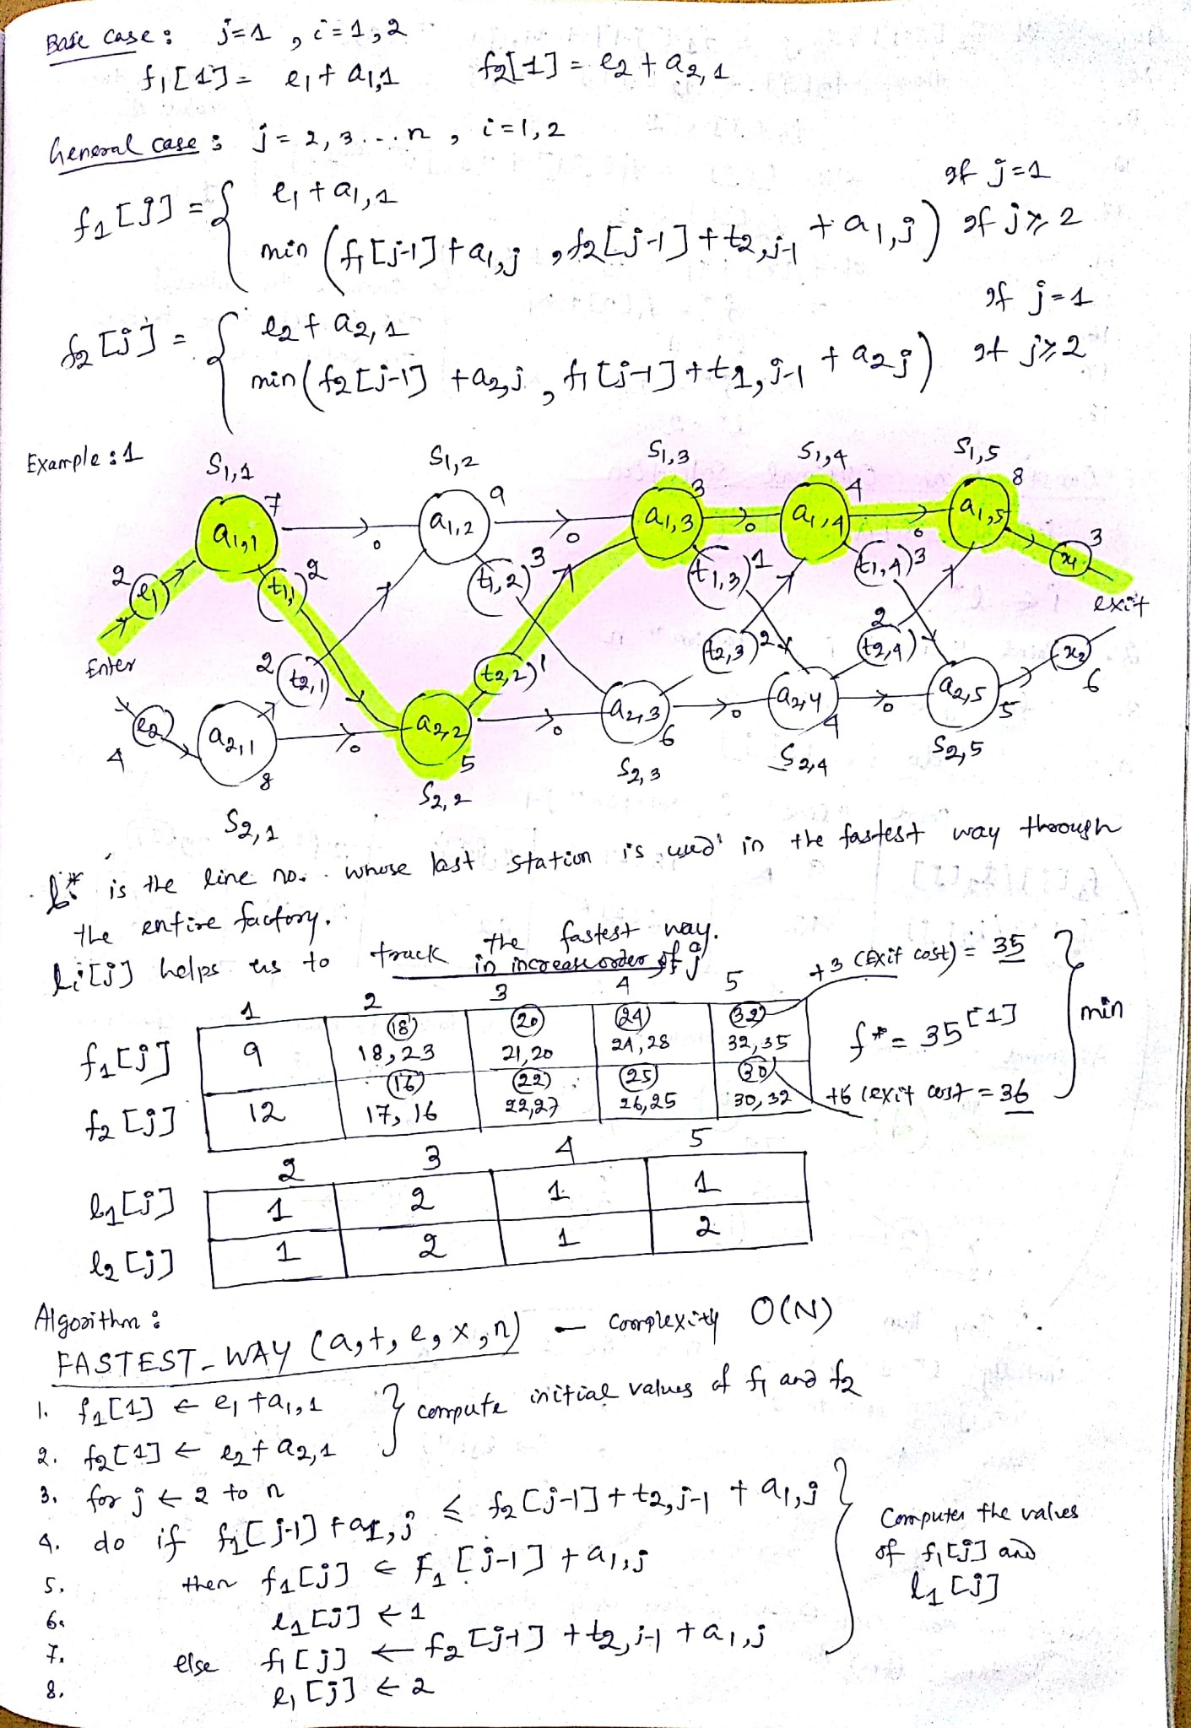

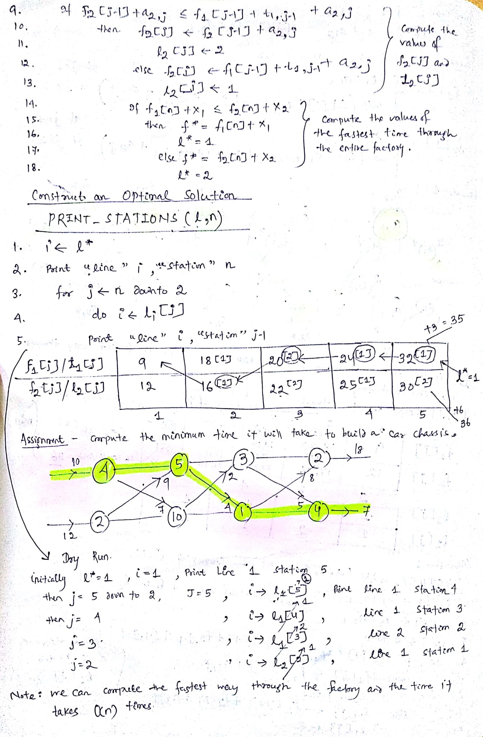

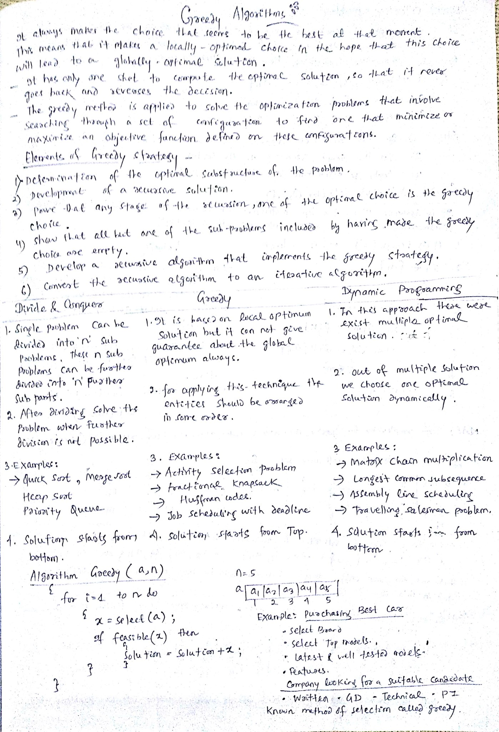

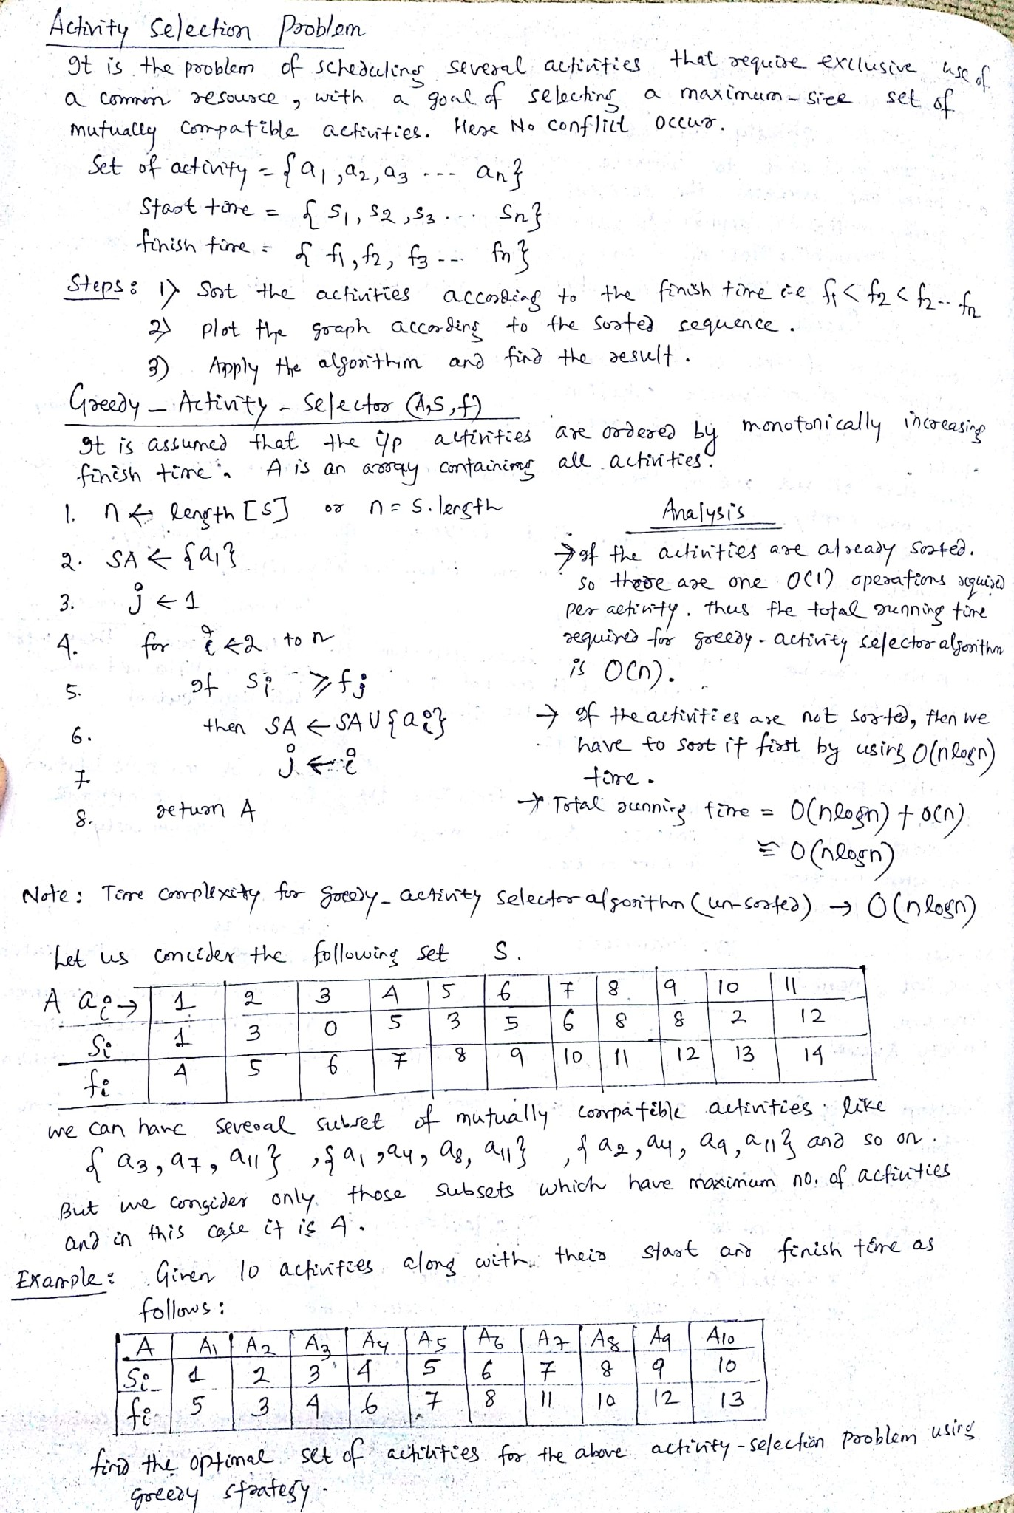

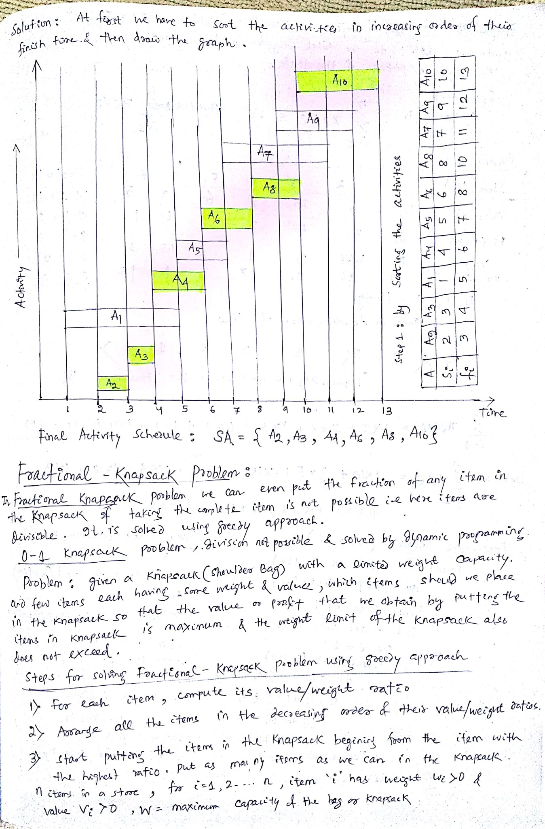

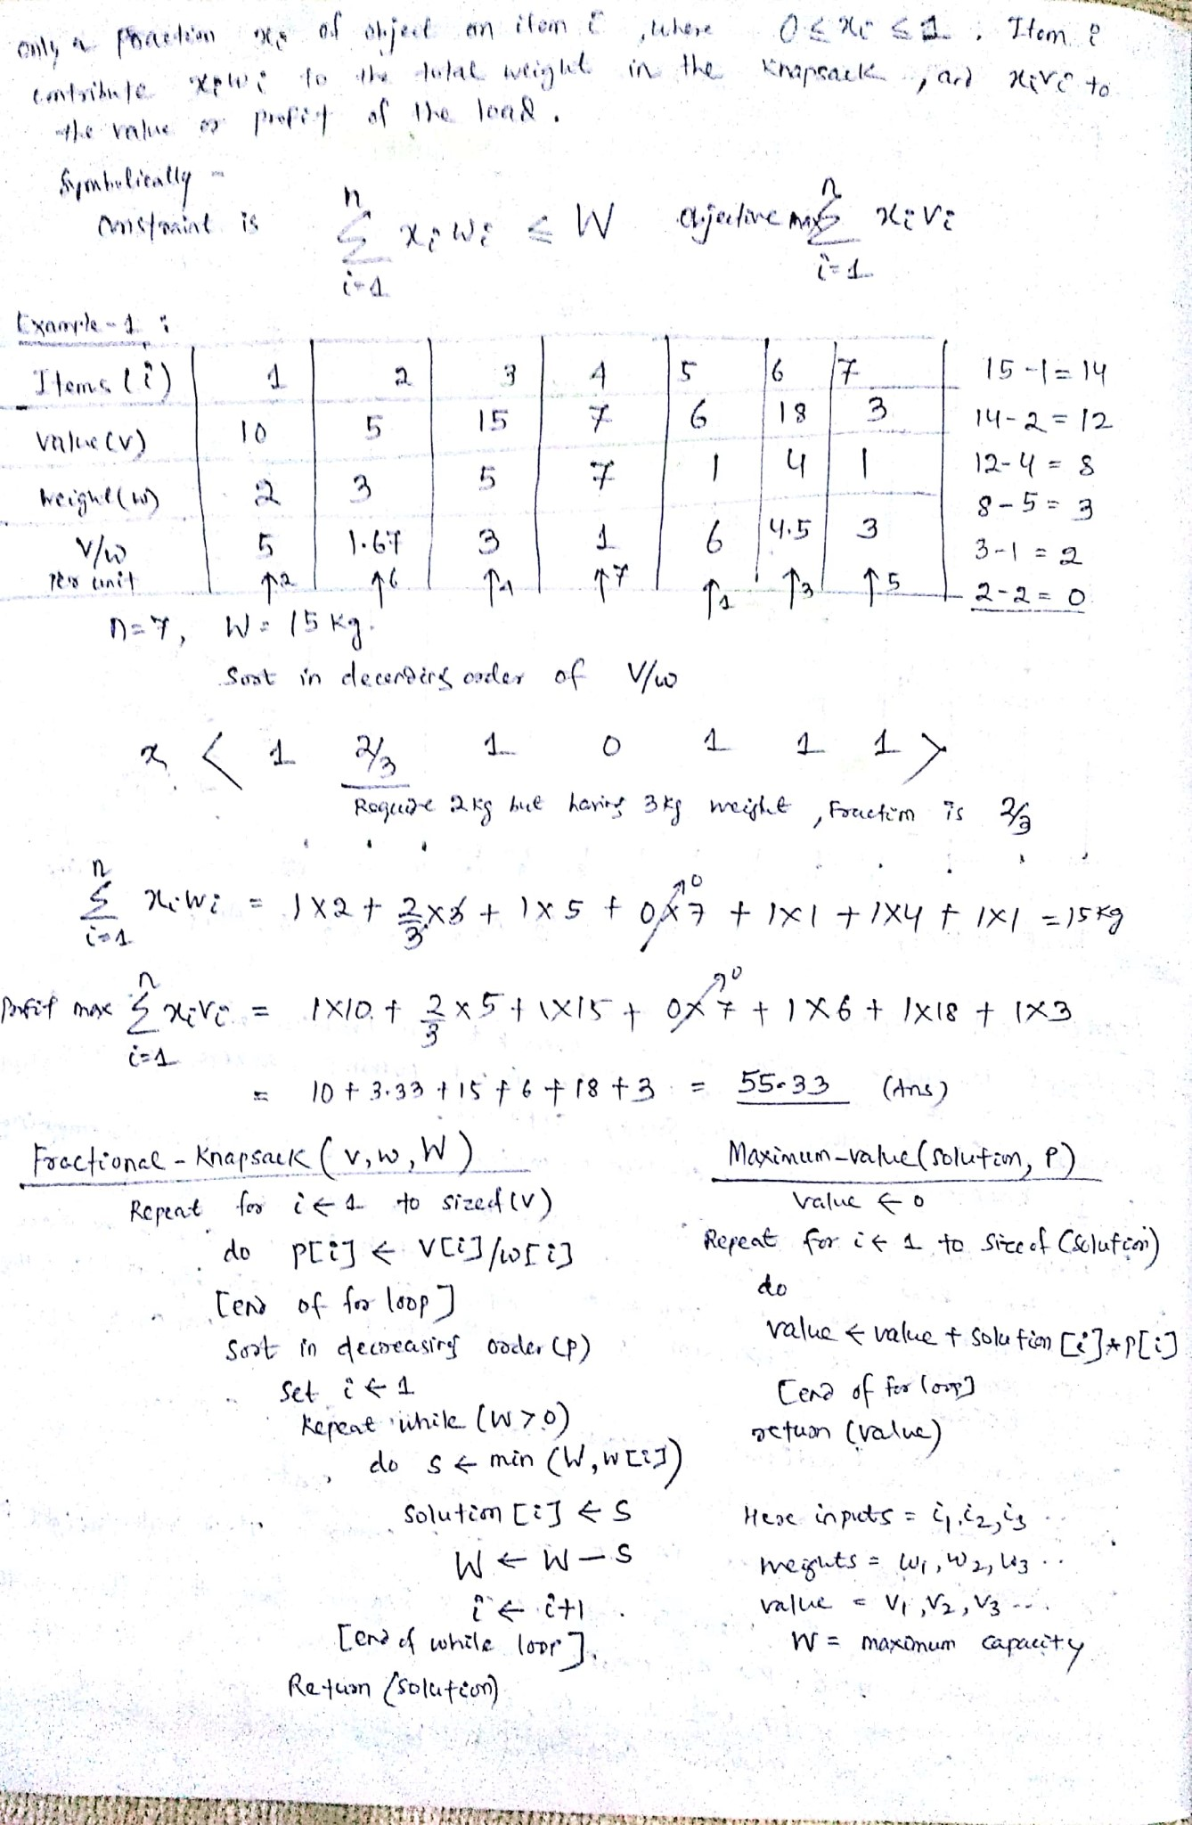

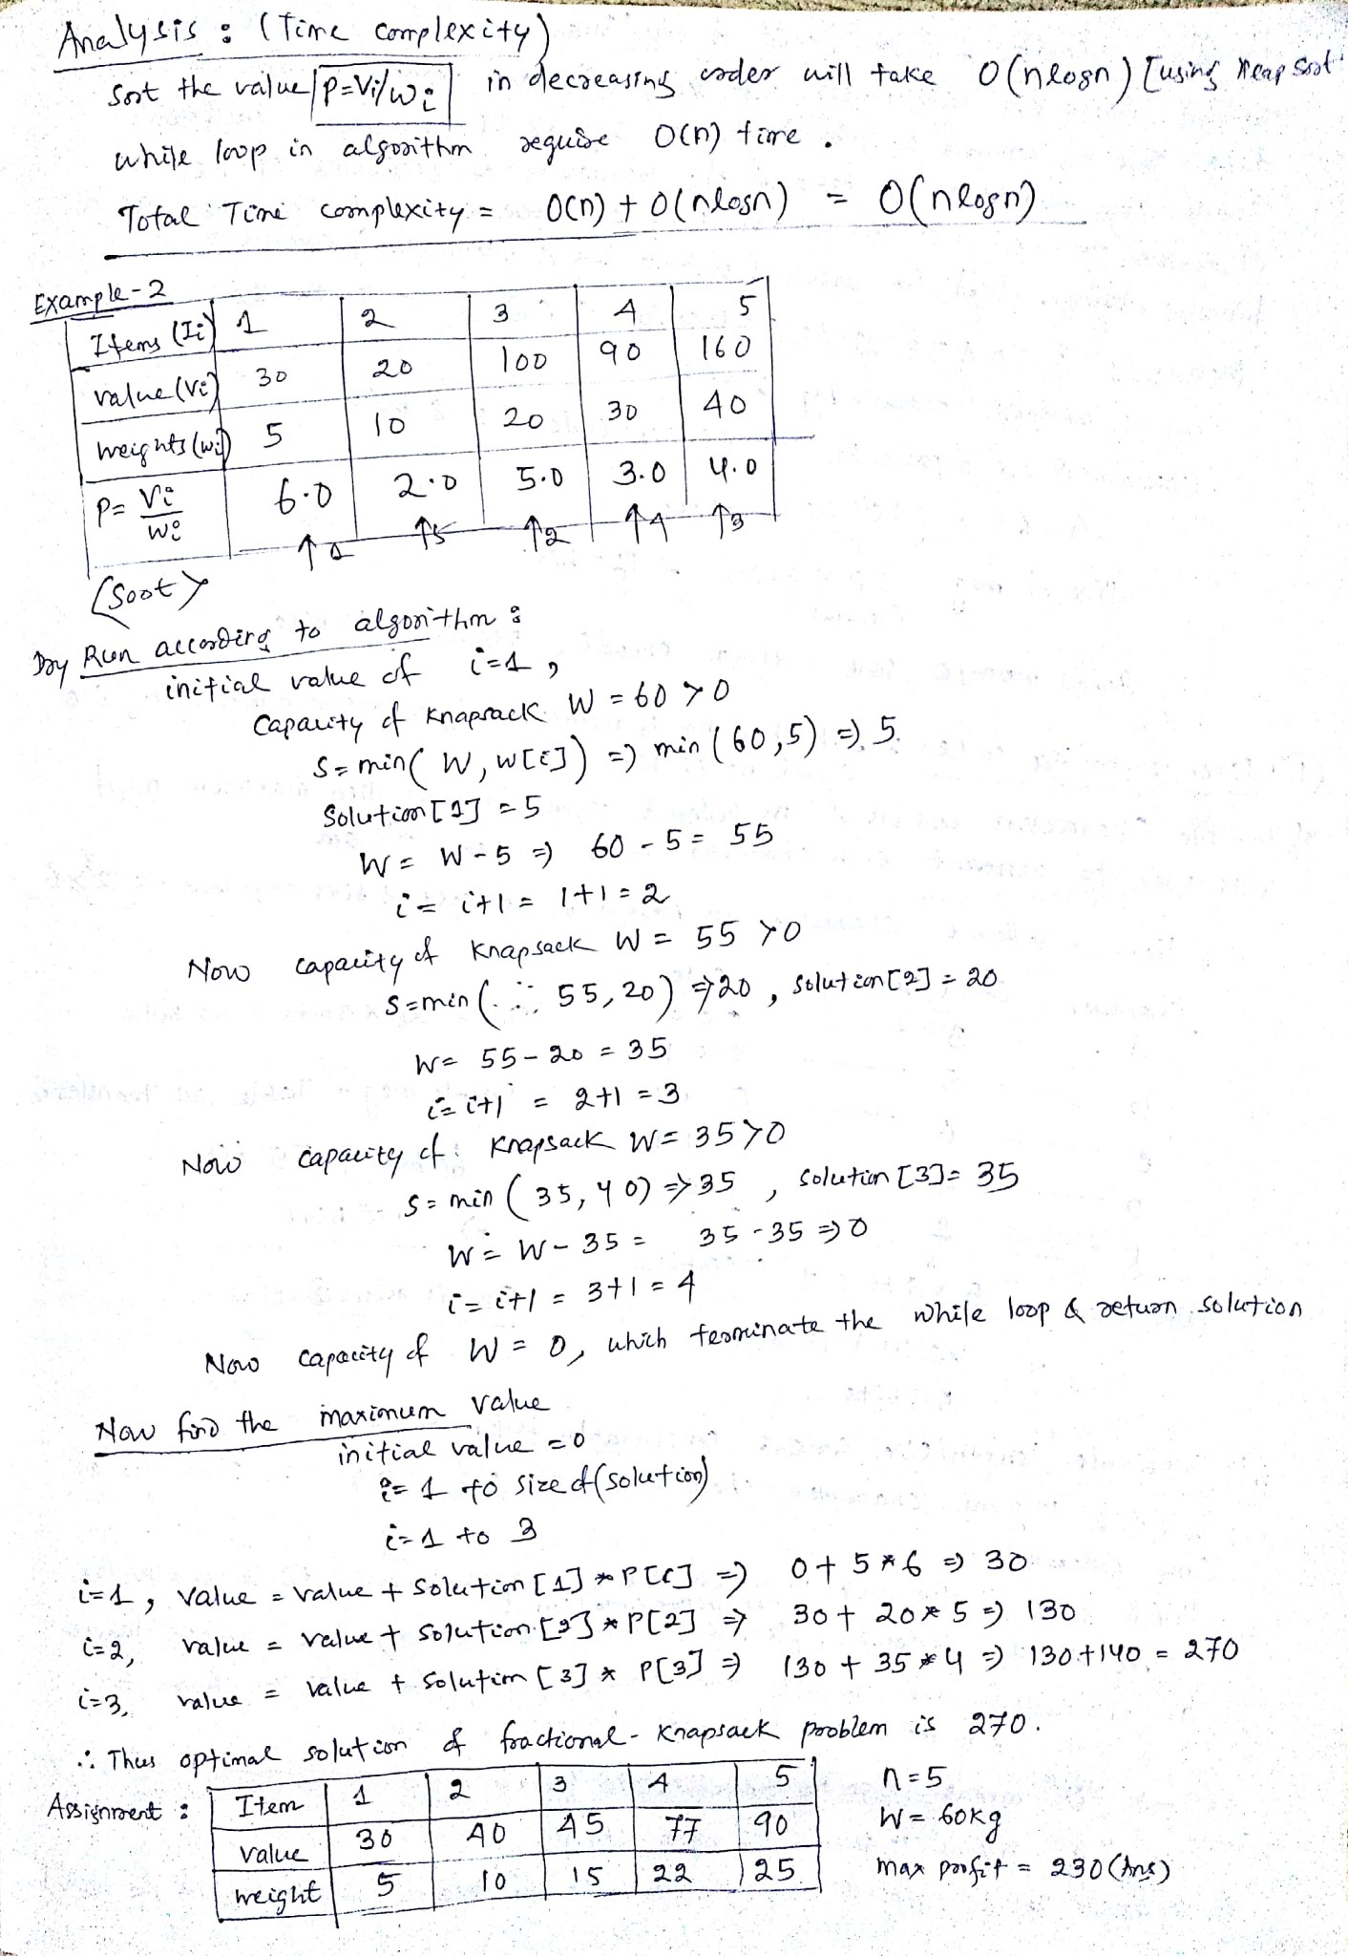

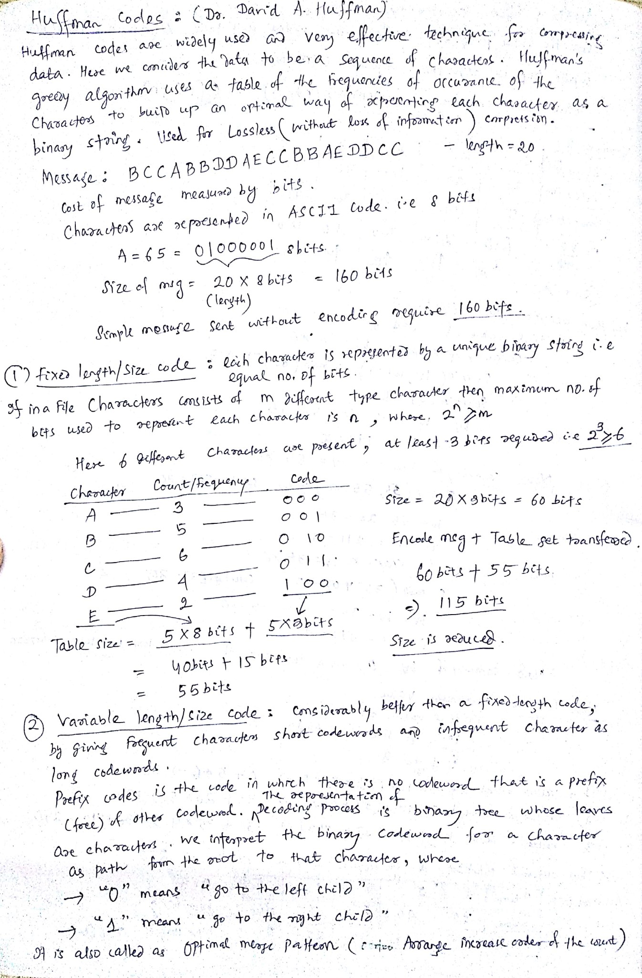

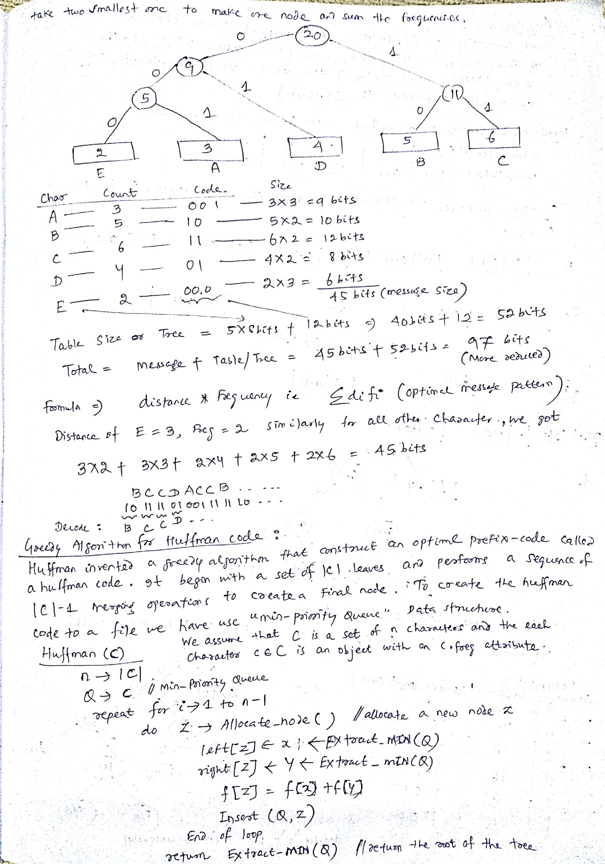

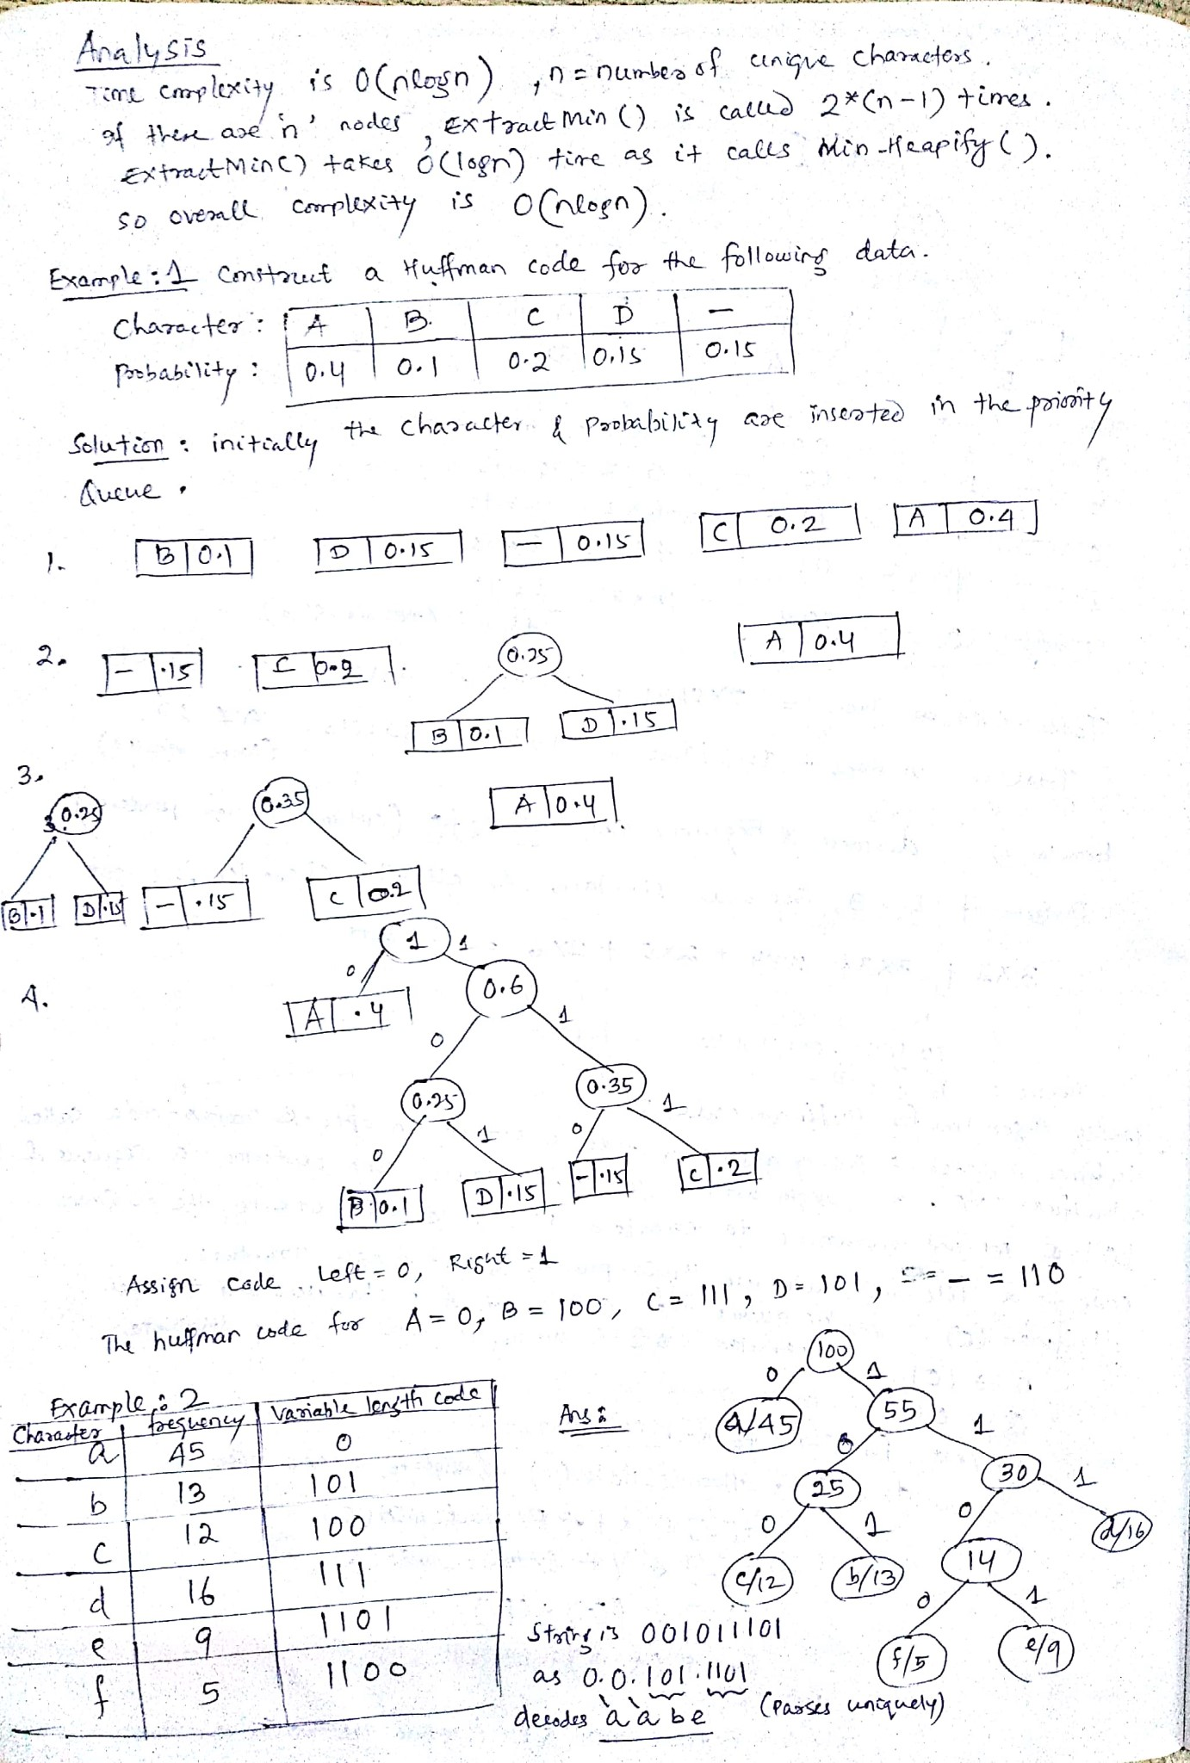

UNIT: 3

## Disjoint Set Data Structure

In computing, a **disjoint-set data structure**, also called a **union–find data structure** or **merge–** **find set**, is a data structure that keeps track of a set of elements partitioned into a number of disjoint (non overlapping) subsets.

It supports the following useful operations:

* *Find*: Determine which subset a particular element is in. *Find* typically returns an item from this set that serves as its "representative"; by comparing the result of two *Find* operations, one can determine whether two elements are in the same subset.
* *Union*: Join two subsets into a single subset.
* *Make Set*, which makes a set containing only a given element (a singleton). **Applications:**
* partitioning of a set
* implementing Kruskal's algorithm to find the minimum spanning tree of a graph.
* Determine the connected components of an undirected graph. **Disjoint Set Operations, Linked list Representation**
* A disjoint-set is a collection S={S1, S2,…, S*k*} of distinct dynamic sets.
* Each set is identified by a member of the set, called *representative*. **Disjoint set operations**
* MAKE-SET(*x*): create a new set with only *x*. Assume *x* is not already in some other set.
* UNION(*x*,*y*): combine the two sets containing *x* and *y* into one new set. A new representative is selected.
* FIND-SET(*x*): return the representative of the set containing *x*.

Application: Determine the connected components of an undirected graph.

### Linked list Representation

• Each set as a linked-list, with head and tail, and each node contains value, next node pointer and back-to-representative pointer.

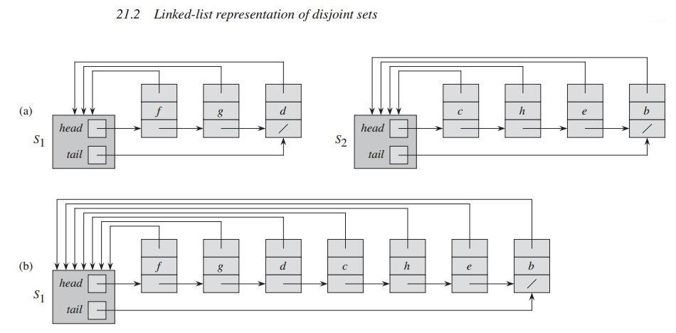

Figure 21.2 (a) Linked-list representations of two sets. Set S1 contains members d, f , and g, with representative f , and set S2 contains members b, c, e, and h, with representative c. Each object in the list contains a set member, a pointer to the next object in the list, and a pointer back to the set object. Each set object has pointers head and tail to the first and last objects, respectively. (b) The result of UNION(g, e), which appends the linked list containing e to the linked list containing g. The representative of the resulting set is f . The set object for e’s list, S2, is destroyed.

The total time spent in all UNION operations is thus O(n lg n). Each MAKESET and FIND-SET operation takes O(1) time, and there are O(m) of them. The total time for the entire sequence is thus O(m + n lg n).

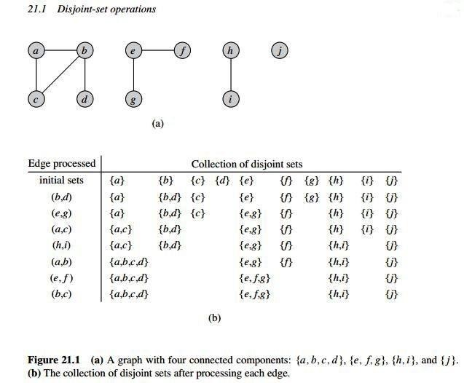

CONNECTED-COMPONENTS(G)

1. for each vertex vV[G]
2. MAKE-SET(v)
3. for each edge (u,v) E[G]
4. if FIND-SET(u) ≠ FIND-SET(v)
5. then UNION(u,v) SAME-COMPONENT(*u*,*v*)
6. if FIND-SET(u)=FIND-SET(v)
7. then return TRUE
8. else return FALSE

The procedure CONNECTED-COMPONENTS initially places each vertex in its own set. Then, for each edge (u,v), it unites the sets containing u and v. By Exercise 21.1-2, after processing all the edges, two vertices are in the same connected component if and only if the corresponding objects are in the same set. Thus, CONNECTEDCOMPONENTS computes sets in such a way that the procedure SAME-COMPONENT can determine whether two vertices are in the same connected component. Figure 21.1(b) illustrates how CONNECTEDCOMPONENTS compute the disjoint sets.

### Disjoint Forests

In a faster implementation of disjoint sets, we represent sets by rooted trees, with each node containing one member and each tree representing one set. In a disjointset forest, illustrated in Figure 21.4(a), each member points only to its parent. The root of each tree contains the representative and is its own parent. As we shall see, although the straightforward algorithms that use this representation are no faster than ones that use the linked-list representation, by introducing two heuristics—―union by rank‖ and ―path compression‖—we can achieve an asymptotically optimal disjoint-set data structure.

#### Union by Rank & Path Compression

* **Union by Rank:** Each node is associated with a rank, which is the upper bound on the height of the node (i.e., the height of subtree rooted at the node), then when UNION, let the root with smaller rank point to the root with larger rank.

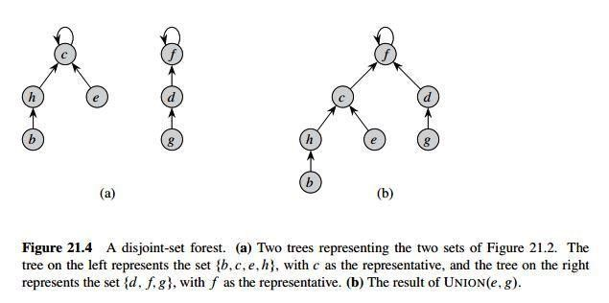

* **Path Compression:** used in FIND-SET(*x*) operation, make each node in the path from *x* to the root directly point to the root. Thus reduce the tree height.

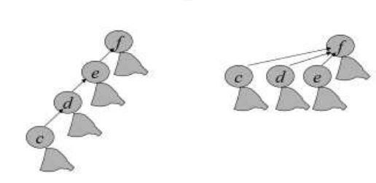

#### Pseudocode for disjoint-set forests

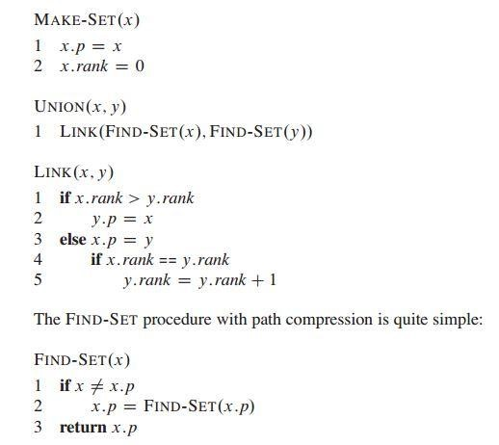

To implement a disjoint-set forest with the union-by-rank heuristic, we must keep track of ranks. With each node x, we maintain the integer value x.rank, which is an upper bound on the height of x. When MAKE-SET creates a singleton set, the single node in the corresponding tree has an initial rank of 0. Each FIND-SET operation leaves all ranks unchanged. The UNION operation has two cases, depending on whether the roots of the trees have equal rank. If the roots have unequal rank, we make the root with higher rank the parent of the root with lower rank, but the ranks themselves remain unchanged. If, instead, the roots have equal ranks, we arbitrarily choose one of the roots as the parent and increment its rank.

Let us put this method into pseudocode. We designate the parent of node x by x.p. The LINK procedure, a subroutine called by UNION, takes pointers to two roots as inputs.The FIND-SET procedure is a twopass method: as it recurses, it makes one pass up the find path to find the root, and as the recursion unwinds, it makes a second pass back down the find path to update each node to point directly to the root. Each call of FIND-SET(x) returns x.p in line 3. If x is the root, then FIND-SET skips line 2 and instead returns x.p, which is x; this is the case in which the recursion bottoms out. Otherwise, line 2 executes, and the recursive call with parameter x:p returns a pointer to the root. Line 2 updates node x to point directly to the root, and line 3 returns this pointer

##### Graph algorithms

A Graph is a non-linear data structure consisting of nodes and edges. The nodes are sometimes also referred to as vertices and the edges are lines or arcs that connect any two nodes in the graph. More formally a Graph can be defined as,

A Graph consists of a finite set of vertices(or nodes) and set of Edges which connect a pair of nodes.

Types of graphs

**Undirected:** An undirected graph is a graph in which all the edges are bi-directional i.e. the edges do not point in any specific direction.

**Directed:** A directed graph is a graph in which all the edges are uni-directional i.e. the edges point in a single direction.

**Weighted:** In a weighted graph, each edge is assigned a weight or cost.

**Cyclic:** A graph is cyclic if the graph comprises a path that starts from a vertex and ends at the same vertex. That path is called a cycle. An acyclic graph is a graph that has no cycle.

#### Adjacency-list representation of a graph

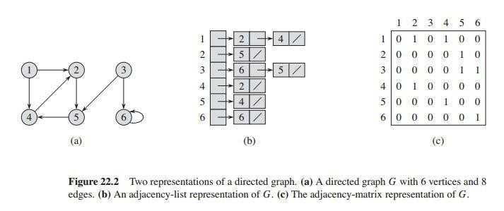

##### Graph Algorithm - BFS and DFS

|  |  |
| --- | --- |
| **BFS** | **DFS** |
| **BFS** Stands for ―**Breadth First Search**‖. | **DFS** stands for ―**Depth First Search**‖. |
| BFS starts traversal from the root node and then explore the search in the level by level manner i.e. as close as possible from the root node. | DFS starts the traversal from the root node and explore the search as far as possible from the root node i.e. depth wise. |
| Breadth First Search can be done with the help of **queue** i.e. **FIFO** implementation. | Depth First Search can be done with the help of **Stack** i.e. **LIFO** implementations. |
| This algorithm works in single stage. The visited vertices are removed from the queue and then displayed at once. | This algorithm works in two stages – in the first stage the visited vertices are pushed onto the stack and later on when there is no vertex further to visit those are popped-off. |
| BFS is **slower** than DFS. | DFS is more **faster** than BFS. |
| BFS requires **more** memory compare to DFS. | DFS require **less** memory compare to BFS. |
| **Applications of BFS** > To find Shortest path | **Applications of DFS**  > useful in finding spanning trees & forest. |
| **Example :** | **Example :** |

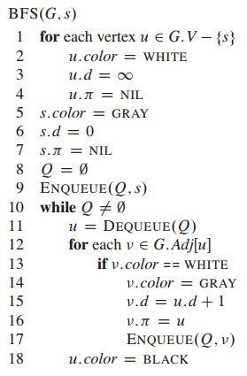The procedure BFS works as follows. With the exception of the source vertex s, lines 1–4 paint every vertex white, set u.d to be infinity for each vertex u, and set the parent of every vertex to be NIL. Line 5 paints s gray, since we consider it to be discovered as the procedure begins. Line 6 initializes s.d to 0, and line 7 sets the predecessor of the source to be NIL.

Lines 8–9 initialize Q to the queue containing just the vertex s. The while loop of lines 10–18 iterates as long as there remain gray vertices, which are discovered vertices that have not yet had their adjacency lists fully examined.

Line 11 determines the gray vertex u at the head of the queue Q and removes it from Q. The for loop of lines 12–17 considers each vertex in the adjacency list of u. If is white, then it has not yet been discovered, and the procedure discovers it by executing lines 14–17. The procedure paints vertex gray, sets its distance v.d to u.d+1, records u as its parent v.π, and places it at the tail of the queue Q. Once the procedure has examined all the vertices on u’s adjacency list, it blackens u in line 18. The loop invariant is maintained because whenever a vertex is painted gray (in line 14) it is also enqueued (in line 17), and whenever a vertex is dequeued (in line 11) it is also painted

black (in line 18).

#### Analysis of BFS

The operations of enqueuing and dequeuing take O(1) time, and so the total time devoted to queue operations is O(V). Because the procedure scans the adjacency list of each vertex only when the vertex is dequeued, it scans each adjacency list at most once. The total time spent in scanning adjacency lists is O(E). The total running time of the BFS procedure is **O(V + E).**

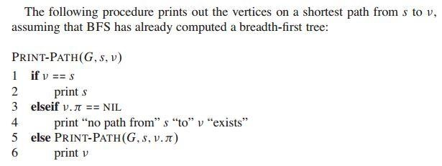

**Example**

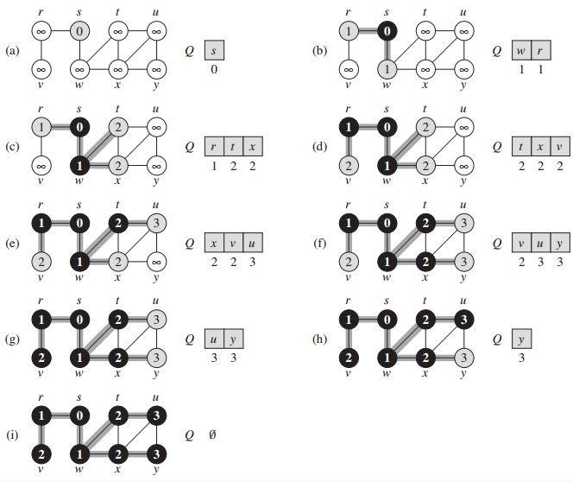

Figure: The operation of BFS on an undirected graph. Tree edges are shown shaded as they are produced by BFS. The value of u.d appears within each vertex u. The queue Q is shown at the beginning of each iteration of the while loop of lines 10–18. Vertex distances appear below vertices in the queue.

#### Depth-first search

The strategy followed by depth-first search is, as its name implies, to search ―deeper‖ in the graph whenever possible. Depth-first search explores edges out of the most recently discovered vertex that still has unexplored edges leaving it. Once all of v’s edges have been explored, the search ―backtracks‖ to explore edges leaving the vertex from which was discovered. This process continues until we have discovered all the vertices that are reachable from the original source vertex. If any undiscovered vertices remain, then depth-first search selects one of them as a new source, and it repeats the search from that source. The algorithm repeats this entire process until it has discovered every vertex.

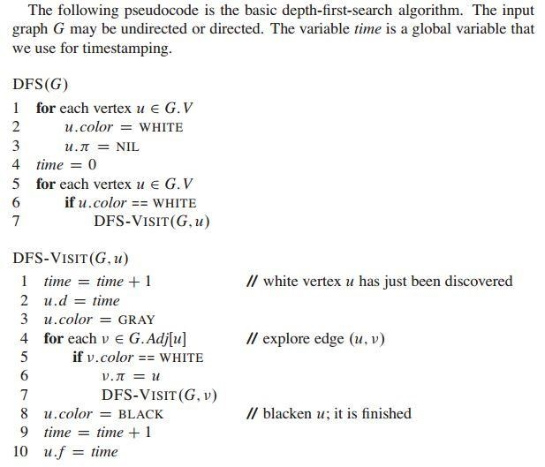

Procedure DFS works as follows. Lines 1–3 paint all vertices white and initialize their π attributes to NIL. Line 4 resets the global time counter. Lines 5–7 check each vertex in V in turn and, when a white vertex is found, visit it using DFS-VISIT. Every time DFS-VISIT(G, u) is called in line 7, vertex u becomes the root of a new tree in the depth-first forest. When DFS returns, every vertex u has been assigned a discovery time u.d and a finishing time u.f . In each call DFS-VISIT(G, u), vertex u is initially white. Line 1 increments the global variable time, line 2 records the new value of time as the discovery time u.d, and line 3 paints u gray. Lines 4–7 examine each vertex v adjacent to u and recursively visit if it is white. As each vertex v ε Adj[u] is considered in line 4, we say that edge (u, v) is explored by the depth-first search. Finally, after every edge leaving u has been explored, lines 8–10 paint u black, increment time, and record the finishing time in u.f .

**Analysis of BFS:** The total running time of the BFS procedure is O(V + E).

**Example:**

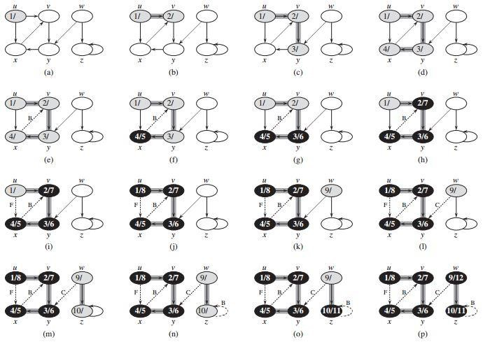

Figure: The progress of the depth-first-search algorithm DFS on a directed graph. As edges are explored by the algorithm, they are shown as either shaded (if they are tree edges) or dashed (otherwise). Nontree edges are labeled B, C, or F according to whether they are back, cross, or forward edges. Timestamps within vertices indicate discovery time/finishing times.

#### Minimum Spanning Trees

Given an undirected and connected graph G= (V,E), a spanning tree of the graph G is a tree that spans G (that is, it includes every vertex of G) and is a subgraph of G(every edge in the tree belongs to G).

The cost of the spanning tree is the sum of the weights of all the edges in the tree. There can be many spanning trees. Minimum spanning tree is the spanning tree where the cost is minimum among all the spanning trees. There also can be many minimum spanning trees. Minimum spanning tree has direct application in the design of networks.

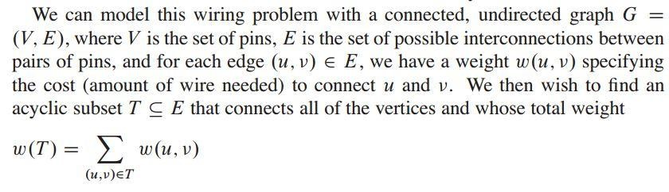

is minimized. Since T is acyclic and connects all of the vertices, it must form a tree, which we call a spanning tree since it ―spans‖ the graph G. We call the problem of determining the tree T the minimumspanning-tree problem.

Electronic circuit designs often need to make the pins of several components electrically equivalent by wiring them together. To interconnect a set of n pins, we can use an arrangement of n-1 wires, each connecting two pins. Of all such arrangements, the one that uses the least amount of wire is usually the most desirable.

In this chapter, we shall examine two algorithms for solving the minimumspanning-tree problem:

Kruskal’s algorithm and Prim’s algorithm.

#### Kruskal’s Algorithm

Kruskal’s Algorithm builds the spanning tree by adding edges one by one into a growing spanning tree. Kruskal's algorithm follows greedy approach as in each iteration it finds an edge which has least weight and adds it to the growing spanning tree.

**Algorithm Steps:**

* Sort the graph edges with respect to their weights.
* Start adding edges to the MST from the edge with the smallest weight until the edge of the largest weight.
* Only add edges which doesn't form a cycle, edges which connect only disconnected components. Example:

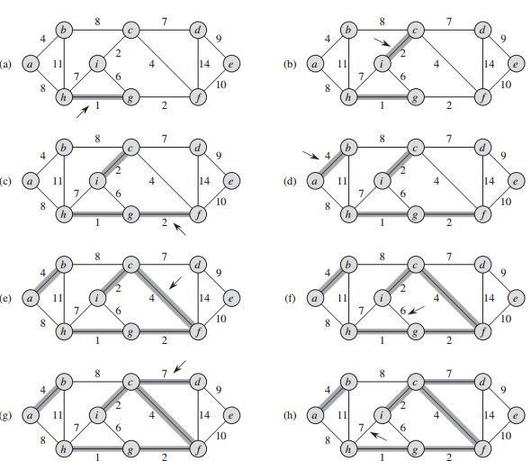

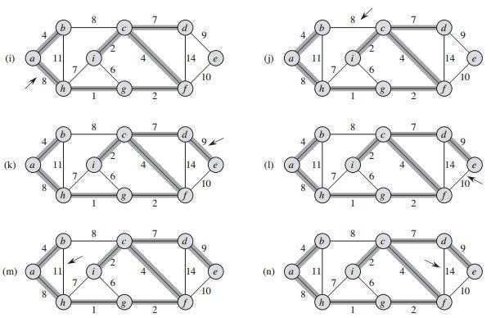

*Figure: The execution of Kruskal’s algorithm on the graph from Shaded edges belong to the forest A being grown. The algorithm considers each edge in sorted order by weight. An arrow points to the edge under consideration at each step of the algorithm. If the edge joins two distinct trees in the forest, it is added to the forest, thereby merging the two trees.*

Kruskal’s uses a disjoint-set data structure to maintain several disjoint sets of elements. Each set contains the vertices in one tree of the current forest. The operation FIND-SET(u) returns a representative element from the set that contains u. Thus, we can determine whether two vertices u and v belong to the same tree by testing whether FIND-SET(u) equals FIND-SET(v). To combine trees, Kruskal’s algorithm calls the UNION procedure.

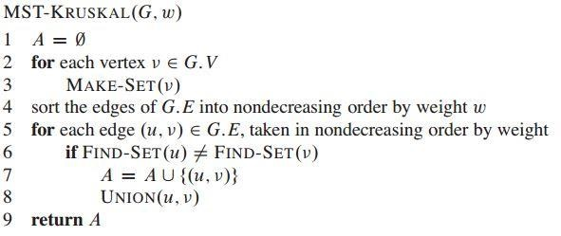

Lines 1–3 initialize the set A to the empty set and create |V| trees, one containing each vertex. The for loop in lines 5–8 examines edges in order of weight, from lowest to highest. The loop checks, for each edge(u, v), whether the endpoints u and v belong to the same tree. If they do, then the edge (u, v) cannot be added to the forest without creating a cycle, and the edge is discarded. Otherwise, the two vertices belong to different trees. In this case, line 7 adds the edge (u, v) to A, and line 8 merges the vertices in the two trees.

**Time Complexity:**

In Kruskal’s algorithm, most time consuming operation is sorting because the total complexity of the Disjoint-Set operations will be O(E lg V ), which is the overall Time Complexity of the algorithm.

#### Prim’s Algorithm

Prim’s Algorithm also uses Greedy approach to find the minimum spanning tree. In Prim’s Algorithm we grow the spanning tree from a starting position. Unlike an edge in Kruskal's, we add vertex to the growing spanning tree in Prim's.

Algorithm Steps:

1. Maintain two disjoint sets of vertices. One is containing vertices that are in the growing spanning tree and other that are not in the growing spanning tree.
2. Select the cheapest vertex that is connected to the growing spanning tree and is not in the growing spanning tree and add it into the growing spanning tree. This can be done using Priority Queues. Insert the vertices that are connected to growing spanning tree, into the Priority Queue.
3. Check for cycles. To do that, mark the nodes which have been already selected and insert only those nodes in the Priority Queue that are not marked.

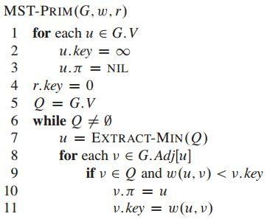In the pseudocode, the connected graph G and the root r of the minimum spanning tree to be grown are inputs to the algorithm. During execution of the algorithm, all vertices that are not in the tree reside in a min-priority queue Q based on a key attribute. For each vertex v, the attribute v.key is the minimum weight of any edge connecting v to a vertex in the tree; by convention, v.key = ∞ if there is no such edge. The attribute v.π names the parent of v in the tree.

Lines 1–5 set the key of each vertex to ∞ (except for the root r, whose key is set to 0 so that it will be the first vertex processed), set the parent of each vertex to NIL, and initialize the minpriority queue Q to contain all the vertices. Line 7 identifies a vertex u ε Q incident on a light edge that crosses the cut (V – Q, Q) (with the exception of the first iteration, in which u = r due to line 4). Removing u from the set Q adds it to the set V - Q of vertices in the tree, thus adding (u, u.π) to A. The for loop of lines 8–11 updates the key and π attributes of every vertex v adjacent to u but not in the tree.

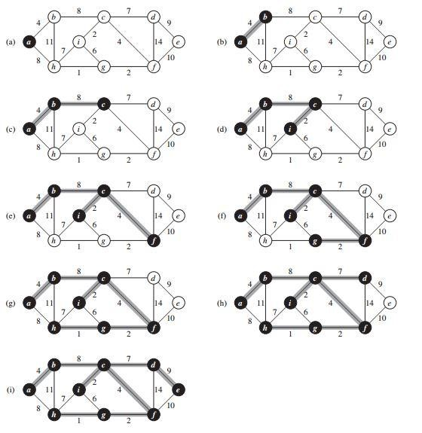

*Figure: The execution of Prim’s algorithm on the graph. The root vertex is a. Shaded edges are in the tree being grown, and black vertices are in the tree. At each step of the algorithm, the vertices in the tree determine a cut of the graph, and a light edge crossing the cut is added to the tree. In the second step, for example, the algorithm has a choice of adding either edge (b, c) or edge (a, h) to the tree since both are light edges crossing the cut.*

**Time Complexity:**

A binary min-heap supports in O(lg V) time.

Thus, the total time for Prim’s algorithm is O(V lg V + E lg V) = O(E lg V ), which is asymptotically the same as for our implementation of Kruskal’s algorithm. If we use a Fibonacci heap to implement the min-priority queue Q, the running time of Prim’s algorithm improves to O(E + V lg V ). **Single-Source Shortest Paths:**

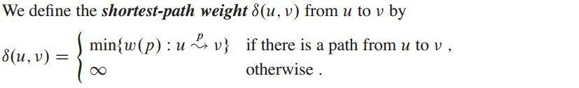

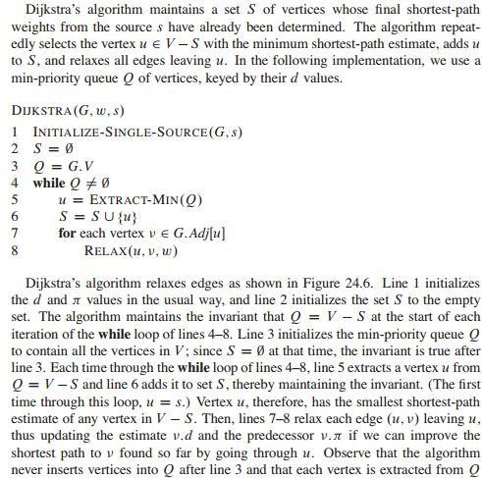

INITIALIZE-SINGLE-SOURCE(G, s)

1

. for each vertex v

∈

G.v

2

. v.d =

∞

3

. v.

π

= NIL

4

. s.d =

0

RELAX(u, v, w)

1

if v.d > u.d + w(u, v

)

2

v.d = u.d + w(u, v

)

3

v.

π

= u

and added to S exactly once, so that the while loop of lines 4–8 iterates exactly |V| times.

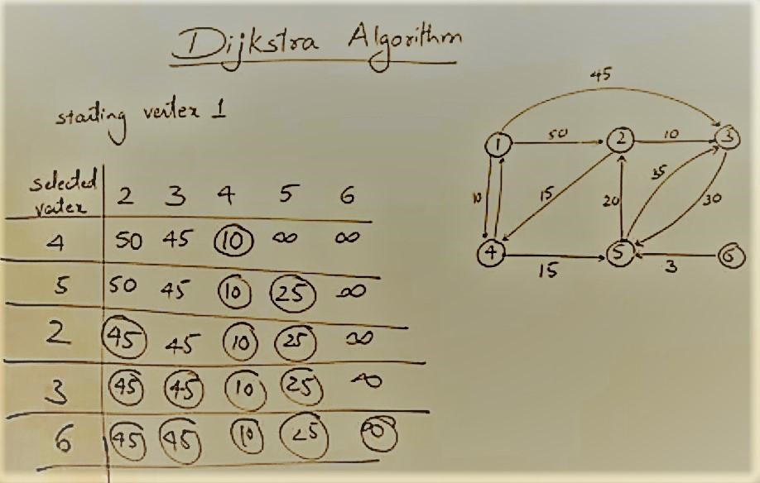

**Example:**

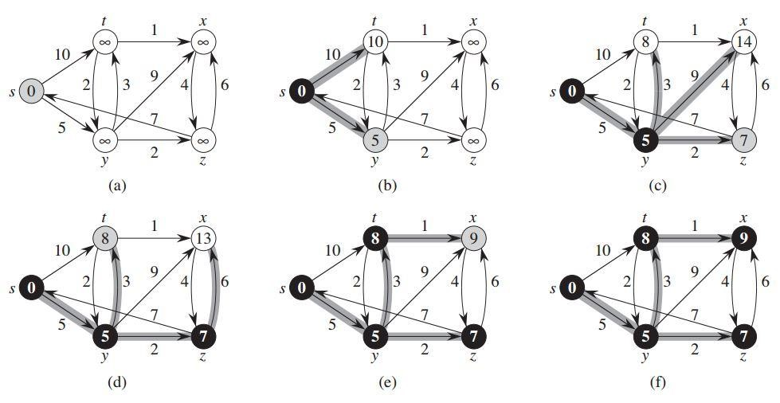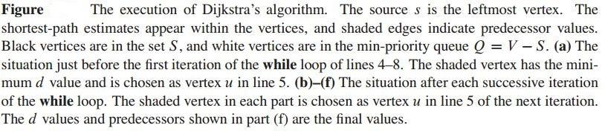

**Time Complexity:**

Time Complexity of the implementation is O(V2). If the input graph is represented using adjacency list, it can be reduced to O(E log V) with the help of binary heap.

**Note:** Dijkstra’s algorithm doesn’t work for graphs with negative weight edges. For graphs with negative weight edges, Bellman–Ford algorithm can be used.

##### Bellman–Ford algorithm The Bellman-Ford algorithm

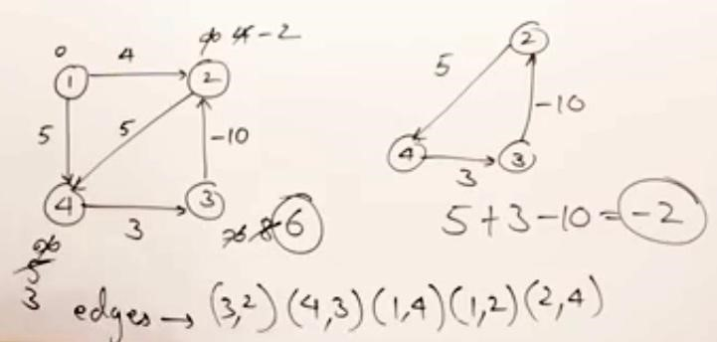solves the single-source shortest-paths problem in which edge weights may be negative. It returns a boolean value indicating whether or not there is a negative-weight cycle that is reachable from the source. If there is such a cycle, the algorithm indicates that no solution exists. If there is no such cycle, it produces the shortest paths and their weights.

*24.1 The Bellman-Ford algorithm 651*



##### 24.1 The Bellman-Ford algorithm

The ***Bellman-Ford algorithm*** solves the single-source shortest-paths problem in the general case in which edge weights may be negative. Given a weighted, directed graph G D .V;E/ with source s and weight function w W E ! R, the

Bellman-Ford algorithm returns a boolean value indicating whether or not there is a negative-weight cycle that is reachable from the source. If there is such a cycle, the algorithm indicates that no solution exists. If there is no such cycle, the algorithm produces the shortest paths and their weights.

The algorithm relaxes edges, progressively decreasing an estimate :*d* on the weight of a shortest path from the source s to each vertex 2 V until it achieves the actual shortest-path weight ı.s;/. The algorithm returns TRUE if and only if the graph contains no negative-weight cycles that are reachable from the source.

BELLMAN-FORD.G;w;s/

Time Complexity O(V.E)

1. INITIALIZE-SINGLE-SOURCE.G;s/
2. **for** i D 1 **to** jG:*V*j 1
3. **for** each edge .u;/ 2 G:*E*
4. RELAX.u;;w/
5. **for** each edge .u;/ 2 G:*E*
6. **if** :*d* > u:*d* C w.u;/
7. **return** FALSE
8. **return** TRUE

Figure 24.4 shows the execution of the Bellman-Ford algorithm on a graph with 5 vertices. After initializing the d and values of all vertices in line 1, the algorithm makes jV j 1 passes over the edges of the graph. Each pass is one iteration of the **for** loop of lines 2–4 and consists of relaxing each edge of the graph once. Figures 24.4(b)–(e) show the state of the algorithm after each of the four passes over the edges. After making jV j 1 passes, lines 5–8 check for a negative-weight cycle and return the appropriate boolean value. (We’ll see a little later why this check works.)

The Bellman-Ford algorithm runs in time O.VE/, since the initialization in line 1 takes ‚.V / time, each of the jV j 1 passes over the edges in lines 2–4 takes ‚.E/ time, and the **for** loop of lines 5–7 takes O.E/ time.

To prove the correctness of the Bellman-Ford algorithm, we start by showing that if there are no negative-weight cycles, the algorithm computes correct shortest-path weights for all vertices reachable from the source.

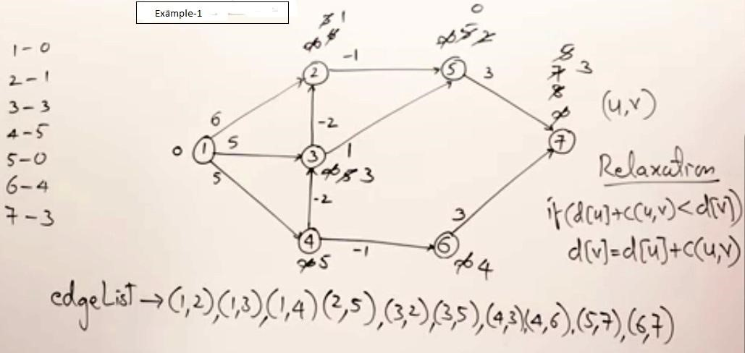

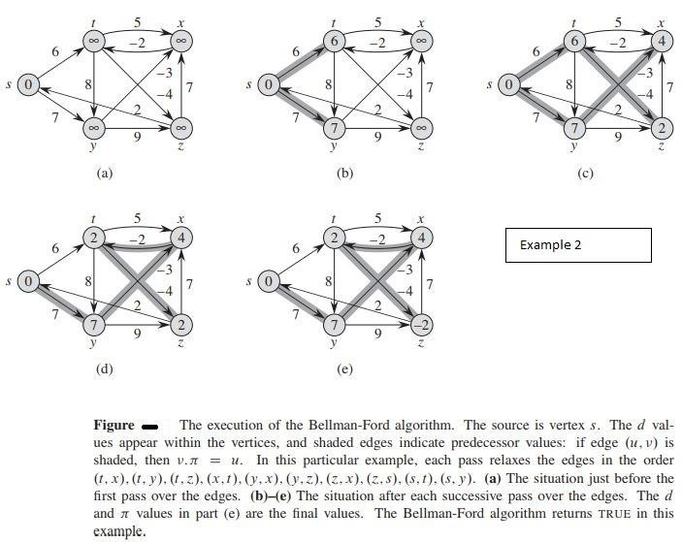

**The Floyd-Warshall algorithm**

The problem is to find shortest distances between every pair of vertices in a given edge weighted directed Graph.

We initialize the solution matrix same as the input graph matrix as a first step. Then we update the solution matrix by considering all vertices as an intermediate vertex. The idea is to one by one pick all vertices and updates all shortest paths which include the picked vertex as an intermediate vertex in the shortest path. When we pick vertex number k as an intermediate vertex, we already have considered vertices {0, 1, 2, ... k-1} as intermediate vertices. For every pair (i, j) of the source and destination vertices respectively, there are two possible cases. **1)** k is not an intermediate vertex in shortest path from i to j. We keep the value of dist[i][j] as it is.

**2)** k is an intermediate vertex in shortest path from i to j. We update the value of dist[i][j] as dist[i][k] + dist[k][j] if dist[i][j] > dist[i][k] + dist[k][j]

The following figure shows the above optimal substructure property in the all-pairs shortest path problem.

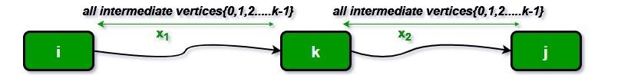

#### Example 1

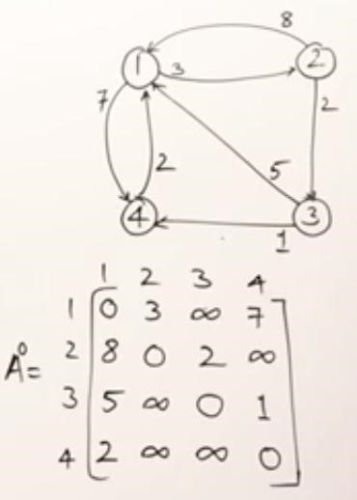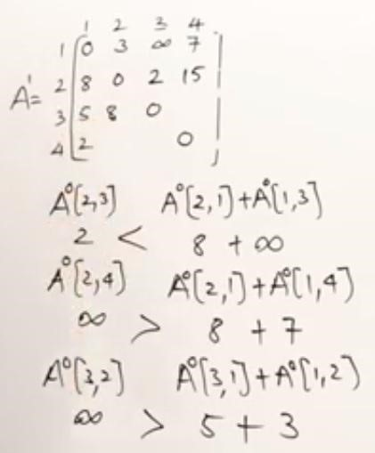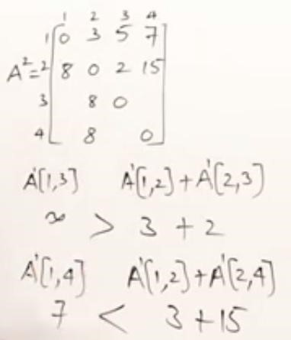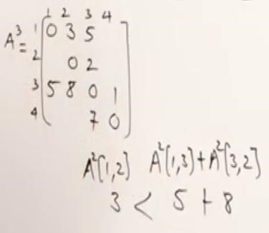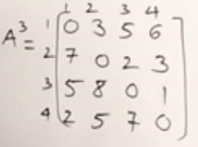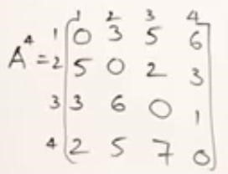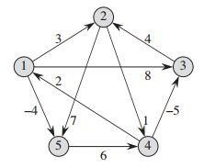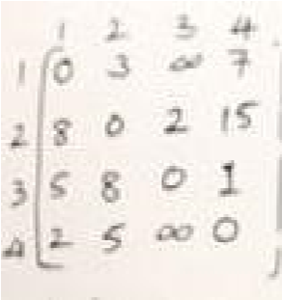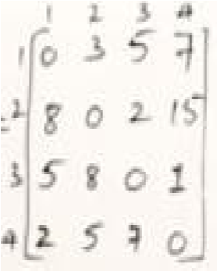

**Figure 25.1**

**Example 2**

5

|  |  |
| --- | --- |
| *25.2 The Floyd-Warshall algorithm* | *695* |
| FLOYD-WARSHALL.W /   1. n D W:*rows* 2. D.0/ D W 3. **for** k D 1 **to** n | PRINT-ALL-PAIRS-SHORTEST-PATH (π,i,j) if i == j  print i  elseif πij == NIL  print “no path from” i “to” j “exists”  else PRINT-ALL-PAIRS-SHORTEST-PATH (π,i, πij) print j |

1. let D.k/ D dij.k/ be a new n n matrix
2. **for** i D 1 **to** n
3. **for** j D 1 **to** n
4. dij.k/ D mindij.k1/;dik.k1/ C dkj.k1/
5. **return** D.n/

Figure 25.4 shows the matrices D.k/ computed by the Floyd-Warshall algorithm for the graph in Figure 25.1.

The running time of the Floyd-Warshall algorithm is determined by the triply nested **for** loops of lines 3–7. Because each execution of line 7 takes O.1/ time, the algorithm runs in time ‚.n3/. As in the final algorithm in Section 25.1, the code is tight, with no elaborate data structures, and so the constant hidden in the ‚-notation is small. Thus, the Floyd-Warshall algorithm is quite practical for even moderate-sized input graphs.

**Constructing a shortest path**

There are a variety of different methods for constructing shortest paths in the FloydWarshall algorithm. One way is to compute the matrix D of shortest-path weights and then construct the predecessor matrix … from the D matrix. Exercise 25.1-6 asks you to implement this method so that it runs in O.n3/ time. Given the predecessor matrix …, the PRINT-ALL-PAIRS-SHORTEST-PATH procedure will print the vertices on a given shortest path.

Alternatively, we can compute the predecessor matrix … while the algorithm computes the matrices D.k/. Specifically, we compute a sequence of matrices ….0/;….1/;:::;….n/, where … D ….n/ and we define ij.k/ as the predecessor of vertex j on a shortest path from vertex i with all intermediate vertices in the set f1;2;::: ;kg.

We can give a recursive formulation of ij.k/. When k D 0, a shortest path from i to j has no intermediate vertices at all. Thus,

ij.0/ D ( NIL if i D j or wij D 1 ; (25.6) i if i ¤ j and wij < 1 :

For k 1, if we take the path i k j, where k ¤ j, then the predecessor of j we choose is the same as the predecessor of j we chose on a shortest path from k with all intermediate vertices in the set f1;2;::: ;k 1g. Otherwise, we

choose the same predecessor of j that we chose on a shortest path from i with all intermediate vertices in the set {1, 2,.., k-1}.

*696 Chapter 25 All-Pairs Shortest Paths*

* 1. 3 8 1 4 ˘
  2. 0 1 1 7

D.0/ D1 4 0 1 1

* 1. 1 5 0 1 1 1 1 6 0

NIL 1 1 NIL 1 ˘

NIL NIL NIL 2 2

….0/ DNIL 3 NIL NIL NIL

4 NIL 4 NIL NIL NIL NIL NIL 5 NIL

# 0 3 8 1 4 ˘NIL 1 1 NIL 1 ˘

1. 0 1 1 7NIL NIL NIL 2 2

D.1/ D1 4 0 1 1 ….1/ DNIL 3 NIL NIL NIL

1. 5 5 0 24 1 4 NIL 1

1 1 1 6 0NIL NIL NIL 5 NIL

1. 3 8 4 4 ˘NIL 1 1 2 1 ˘
2. 0 1 1 7NIL NIL NIL 2 2

D.2/ D1 4 0 5 11 ….2/ DNIL 3 NIL 2 2 2 5 5 0 24 1 4 NIL 1

1 1 1 6 0NIL NIL NIL 5 NIL

1. 3 8 4 4 ˘NIL 1 1 2 1 ˘
2. 0 1 1 7NIL NIL NIL 2 2

D.3/ D1 4 0 5 11 ….3/ DNIL 3 NIL 2 2 2 1 5 0 24 3 4 NIL 1

1 1 1 6 0NIL NIL NIL 5 NIL

0 3 1 4 4NIL 1 4 2 1 2 1 5 0 2 ˘4 3 4 NIL 1 ˘ 3 0 4 1 14 NIL 4 2 1 D.4/ D7 4 0 5 3 ….4/ D4 3 NIL 2 1

8 5 1 6 04 3 4 5 NIL

0 1 3 2 4NIL 3 4 5 1 2 1 5 0 2 ˘4 3 4 NIL 1 ˘ 3 0 4 1 14 NIL 4 2 1 D.5/ D7 4 0 5 3 ….5/ D4 3 NIL 2 1

# 8 5 1 6 04 3 4 5 NIL

**Figure 25.4** The sequence of matrices D.k/ and ….k/ computed by the Floyd-Warshall algorithm for the graph in Figure 25.1.

UNIT: 4

## Difference between Backtracking & Branch and Bound

***Backtracking:***

* It is used to find all possible solution available to the problem

*It traverse tree by DFS (Depth first Search)

*It realizes that it has made a bad choice & undoes the last choice by tracking up.

*It search the state space tree until it found a solution

Some Problem Solved with Backtracking Technique

– N- Queens Problem, Sum of Subset, Sudoku Puzzle, Hamiltonian Cycle ***Branch-and-Bound (BB):***

*It is used to solve optimization problem *It may traverse the tree by BFS or DFS.

*It realizes that is already has a better optional solution that the pre-solution leads to so it abandons that pre-solution.

*It completely searches the ***state space solution tree*** to get optional solution.

Some Problem Solved with Branch and Bound Technique

- Traveling Salesman Problem, Vertex Cover Problem

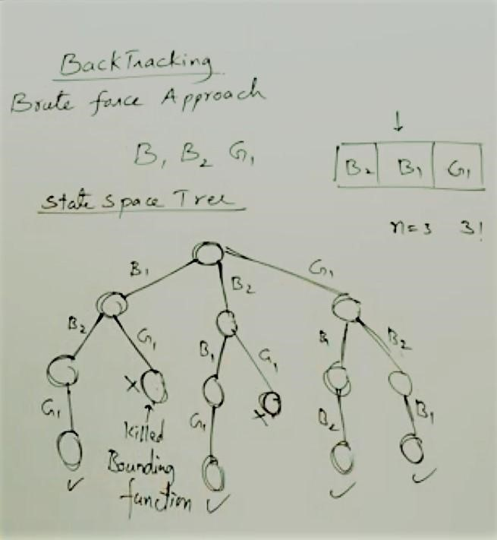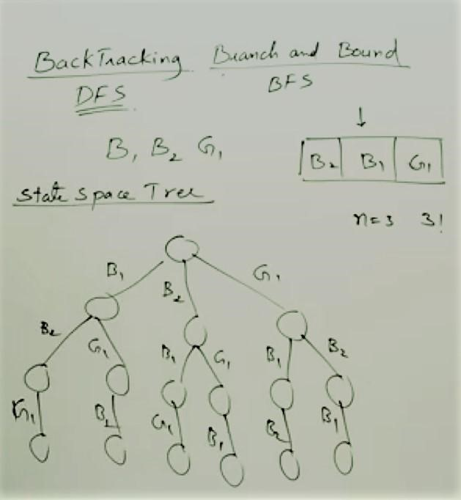

In the above figure ->***Bounding Function:*** No girl sit in the middle of two boys

Types of Branch and Bound

***1. FIFO Branch and Bound Search:*** This leads to a breadth-first search.

For this we will use a data structure called Queue. Initially Queue is empty. ***2. LIFO Branch and Bound Search:*** This leads to a depth-first searchFor this we will use a data structure called stack. Initially stack is empty.

***3. LC (lowest/least cost)*** ***Branch and Bound Search:*** the branch is extended by the node which adds the lowest additional costs, according to a given cost function.

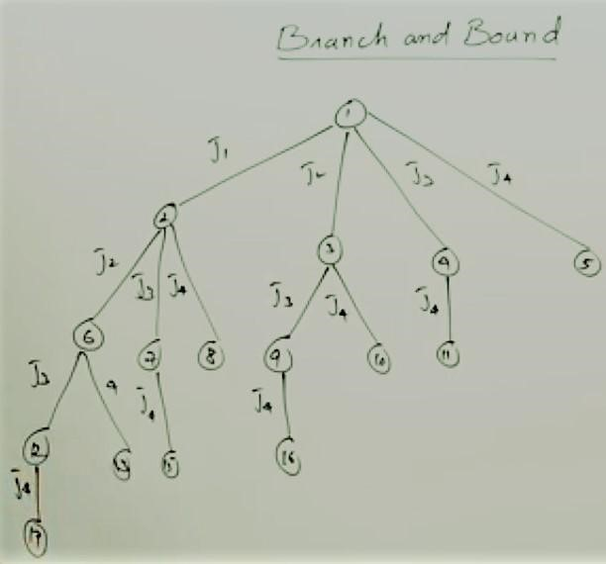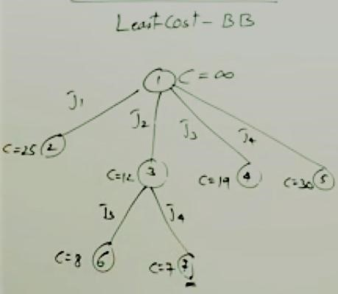

## N-Queens Problem

Nauck made an 8X8 Chessboard to find the first Feasible Solution. In a NxN square board N – number of queens need to be placed considering three Condition ---

• No two Queens can be placed in same row, same column, and same diagonal. **Time Complexity of N-Queen Problem is O (n!)**

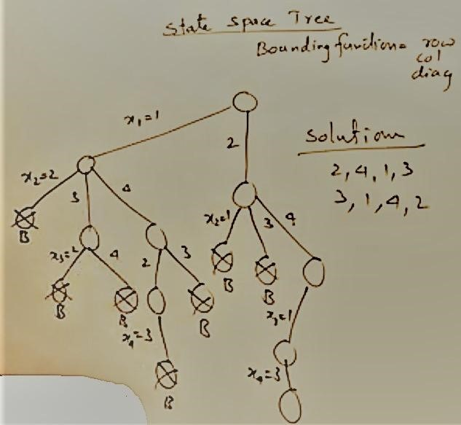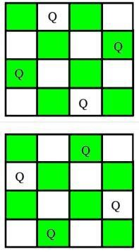

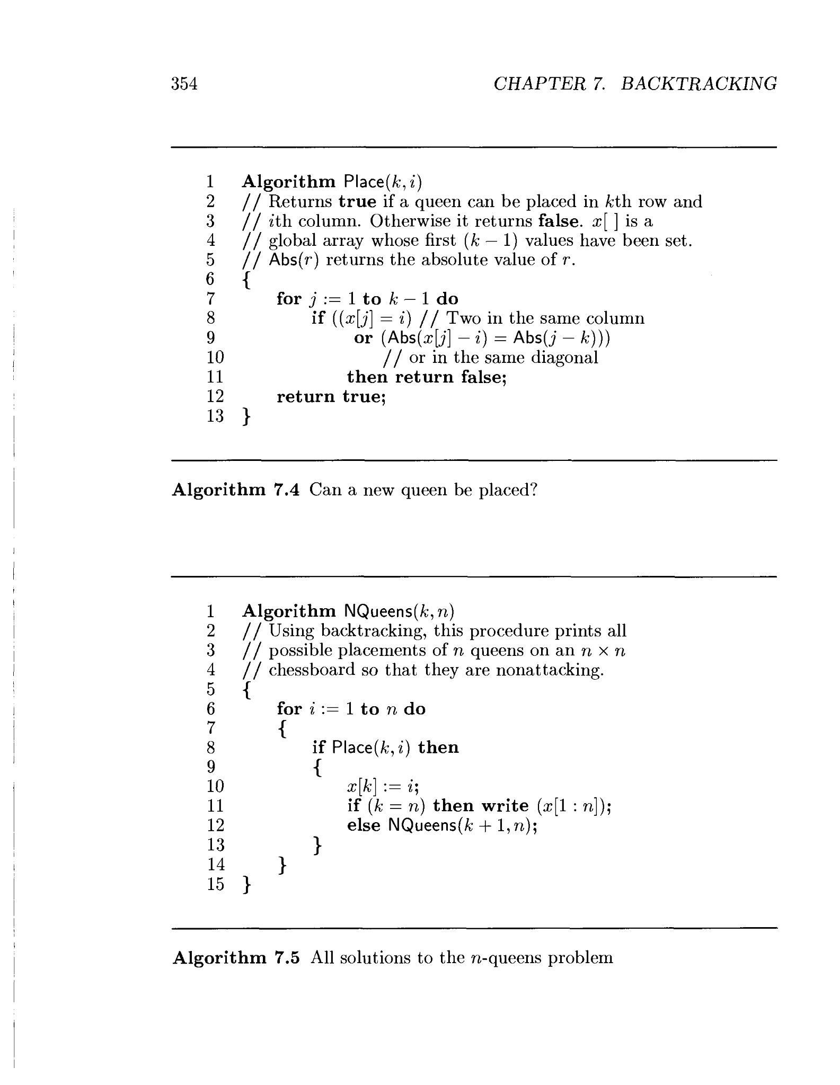

***Backtracking Algorithm***

The idea is to place queens one by one in different columns, starting from the leftmost column. When we place a queen in a column, we check for clashes with already placed queens. In the current column, if we find a row for which there is no clash, we mark this row and column as part of the solution. If we do not find such a row due to clashes then we backtrack and return false.

1. Start in the leftmost column
2. If all queens are placed return true
3. Try all rows in the current column. Do following for every tried row.

a) If the queen can be placed safely in this row then mark this [row, column] as part of the solution and recursively check if placing queen here leads to a solution. b) If placing queen in [row, column] leads to a solution then return true.

c) If placing queen doesn't lead to a solution then unmark this [row, column] (Backtrack) and go to step (a) to try other rows.

3) If all rows have been tried and nothing worked, return false to trigger backtracking.

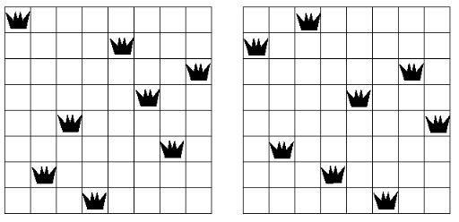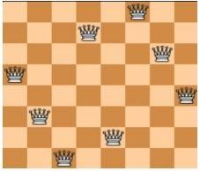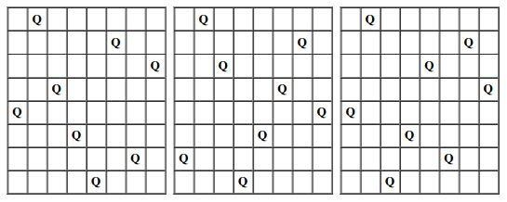

Altogether, ***92*** solutions to the problem of ***EIGHT QUEENS.***

## Sub Set Sum Problem/ Sum of Subset Problem

The Sum of Subset Problem is, there will be a set of distinct positive Numbers X and a given Number N. Now, we have to find all the combination of numbers from X that sum up to N. Make a Set of that Number. ***Backtracking Approach:***

First, organize the numbers in non decreasing order. Then generating a tree, we can find the solution by adding the weight of the nodes. Note that, here more than necessary nodes can be generated. The algorithm will search for the weighted amount of the nodes. If it goes beyond given Number N, then it stops generating nodes and move to other parent nodes for finding solution.

***Example 1:***

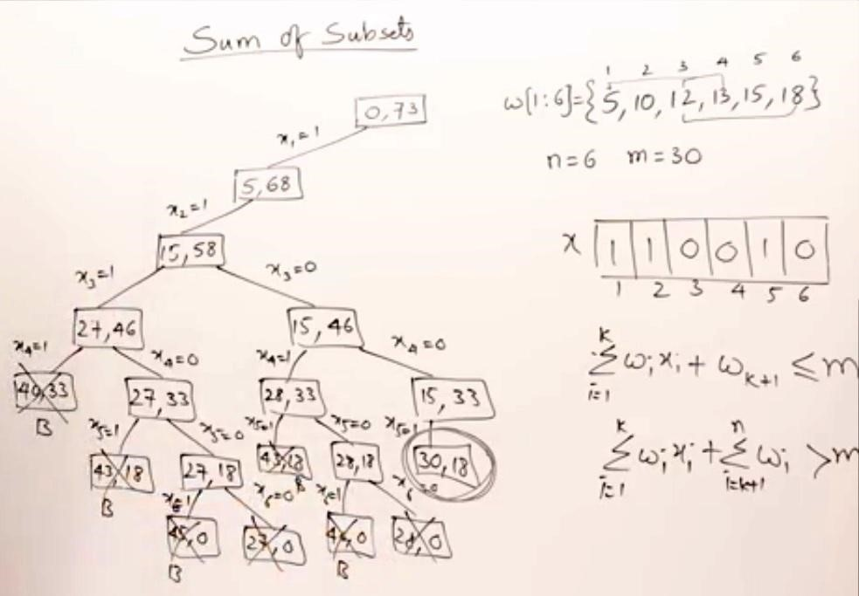

### BOUNDING FUNCTION Time Complexity of Sum of Subset Problem: O (2n)

***Example: 2***

W = {4, 5, 6, 3} and M = 13

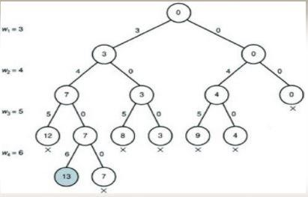

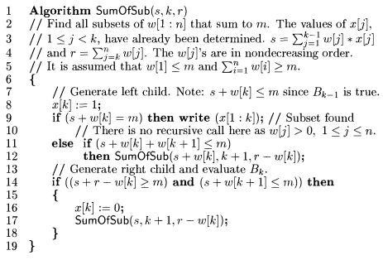

**Recursive backtracking algorithm for Sum of Subset Problem**



## 32 String Matching

Text-editing programs frequently need to find all occurrences of a pattern in the text. Typically, the text is a document being edited, and the pattern searched for is a particular word supplied by the user. Efficient algorithms for this problem—called “string matching”—can greatly aid the responsiveness of the text-editing program. Among their many other applications, string-matching algorithms search for particular patterns in DNA sequences. Internet search engines also use them to find Web pages relevant to queries.

We formalize the string-matching problem as follows. We assume that the text is an array TŒ1::n of length n and that the pattern is an array PŒ1::m of length m n. We further assume that the elements of P and T are characters drawn from a finite alphabet †. For example, we may have † D f0,1g or † D fa;b;:::;zg. The character arrays P and T are often called ***strings*** of characters.

Referring to Figure 32.1, we say that pattern P ***occurs with shift*** s in text T

(or, equivalently, that pattern P ***occurs beginning at position*** sC1 in text T ) if

0 s nm and TŒs C1::s Cm D PŒ1::m (that is, if TŒs Cj D PŒj, for 1 j m). If P occurs with shift s in T , then we call s a ***valid shift***; otherwise, we call s an ***invalid shift***. The ***string-matching problem*** is the problem of finding all valid shifts with which a given pattern P occurs in a given text T .

text *T*

abcabaabcaba

c

abaa

*s*

= 3

pattern *P*

**Figure 32.1** An example of the string-matching problem, where we want to find all occurrences of the pattern P Dabaa in the text T Dabcabaabcabac. The pattern occurs only once in the text, at shift s D 3, which we call a valid shift. A vertical line connects each character of the pattern to its matching character in the text, and all matched characters are shaded.

*988 Chapter 32 String Matching*



### 32.1 The naive string-matching algorithm

The naive algorithm finds all valid shifts using a loop that checks the condition PŒ1::m D TŒs C 1::s C m for each of the n m C 1 possible values of s.

NAIVE-STRING-MATCHER.T;P/

1. n D T:*length*
2. m D P:*length*
3. **for** s D 0 **to** n m
4. **if** PŒ1::m == TŒs C 1::s C m
5. print “Pattern occurs with shift” s

Figure 32.4 portrays the naive string-matching procedure as sliding a “template” containing the pattern over the text, noting for which shifts all of the characters on the template equal the corresponding characters in the text. The **for** loop of lines 3–5 considers each possible shift explicitly. The test in line 4 determines whether the current shift is valid; this test implicitly loops to check corresponding character positions until all positions match successfully or a mismatch is found. Line 5 prints out each valid shift s.

Procedure NAIVE-STRING-MATCHER takes time O..n m C 1/m/, and this bound is tight in the worst case. For example, consider the text string an (a string of n a’s) and the pattern am. For each of the nmC1 possible values of the shift s, the implicit loop on line 4 to compare corresponding characters must execute m times to validate the shift. The worst-case running time is thus ‚..n m C 1/m/, which is ‚.n2/ if m D bn=2c. Because it requires no preprocessing, NAIVESTRING-MATCHER’s running time equals its matching time.

*s* = 0

a

c

a

a

b

c

a

a

b

a

c

a

a

b

c

a

a

b

*s*

= 1

a

c

a

a

b

c

a

a

b

*s*

= 2

a

c

a

a

b

c

a

a

b

*s*

= 3

(a) (b) (c) (d)

**Figure 32.4** The operation of the naive string matcher for the pattern P D aab and the text T Dacaabc. We can imagine the pattern P as a template that we slide next to the text. **(a)–(d)** The four successive alignments tried by the naive string matcher. In each part, vertical lines connect corresponding regions found to match (shown shaded), and a jagged line connects the first mismatched character found, if any. The algorithm finds one occurrence of the pattern, at shift s D 2, shown in part (c).

**KMP (Knuth Morris Pratt) Pattern Searching**

The

Naive pattern searching algorithm

doesn’t work well in cases where we see many matching characters

followed by a mismatching character. Following are some examples.

txt[] = "AAAAAAAAAAAAAAAAAB"

pat[] = "AAAAB"

txt[] = "ABABABCABABABCABABABC"

pat[] = "ABABAC" (not a worst case, but a bad case for Naive)

The KMP matching algorithm uses degenerating property (pattern having same sub-patterns appearing more

than once in the pattern) of the pattern and improves the worst case complexity to O(n). The basic idea

behind KMP’s algorithm is: whenever we detect a mismatch (after some matches), we already know some of

the characters in the text of the next window. We take advantage of this information to avoid matching the

characters that we know will anyway match.

Let us consider below example to understand this.

**Matching Overview**

txt = "AAAAABAAABA"

pat = "AAAA"

We compare first window of

**txt**

with

**pat**

txt = "

**AAAA**

ABAAABA"

pat = "

**AAAA**

" [Initial position]

We find a match. This is same as

Naive String Matching

.

In the next step, we compare next window of

**txt**

with

**pat**

.

txt = "

**AAAA**

**A**

BAAABA"

pat = "

**AAA**

**A**

" [Pattern shifted one position]

This is where KMP does optimization over Naive. In this

second window, we only compare fourth

A

of pattern

with fourth character of current window of text to decide

whether current window matches or not. Since we know

first three characters will anyway match, we skipped

matching first three characters.

**Need of Preprocessing?**

An important question arises from the above explanation,

how to know how many characters to be skipped. To know this,

we pre-process pattern and prepare an integer array

lps[] that tells us the count of characters to be skipped.

**Preprocessing Overview:**

KMP algorithm preprocesses pat[] and constructs an auxiliary

**lps[]**

of size m (same as size of pattern)

which is used to skip characters while matching.

**name**

**lps**

**indicates longest proper prefix which is also suffix.**

. A proper prefix is prefix with whole

string

**not**

allowed. For example, prefixes of “ABC” are “”, “A”, “AB” and “ABC”. Proper prefixes are “”, “A”

and “AB”. Suffixes of the string are “”, “C”, “BC” and “ABC”.

We search for lps in sub-patterns. More clearly we focus on sub-strings of patterns that are either prefix

and suffix.

For each sub-pattern pat[0..i] where i = 0 to m-1, lps[i] stores length of the maximum matching proper

prefix which is also a suffix of the sub-pattern pat[0..i].

lps[i] = the longest proper prefix of pat[0..i]

which is also a suffix of pat[0..i].

**Note :**

lps[i] could also be defined as longest prefix which is also proper suffix. We need to use properly at one

place to make sure that the whole substring is not considered.

Examples of lps[] construction:

For the pattern “AAAA”,

lps[] is [0, 1, 2, 3]

For the pattern “ABCDE”,

lps[] is [0, 0, 0, 0, 0]

For the pattern “AABAACAABAA”,

lps[] is [0, 1, 0, 1, 2, 0, 1, 2, 3, 4, 5]

For the pattern “AAACAAAAAC”,

lps[] is [0, 1, 2, 0, 1, 2, 3, 3, 3, 4]

For the pattern “AAABAAA”,

lps[] is [0, 1, 2, 0, 1, 2, 3]

**Searching Algorithm:**

Unlike

Naive algorithm

, where we slide the pattern by one and compare all characters at each shift, we use a

value from lps[] to decide the next characters to be matched. The idea is to not match a character that we

know will anyway match.

How to use lps[] to decide next positions (or to know a number of characters to be skipped)?

We start comparison of pat[j] with j = 0 with characters of current window of text.

We keep matching characters txt[i] and pat[j] and keep incrementing i and j while pat[j] and txt[i] keep

**matching**

.

When we see a

**mismatch**

We know that characters pat[0..j-1] match with txt[i-j+1…i-1] (Note that j starts with 0 and increment

it only when there is a match).

We also know (from above definition) that lps[j-1] is count of characters of pat[0…j-1] that are both

proper prefix and suffix.

From above two points, we can conclude that

we do not need to match these lps[j-1] characters

with txt[i-j…i-1] because we know that these characters will anyway match. Let us consider above

example to understand this.

txt[] = "

**AAAA**

ABAAABA"

pat[] = "

**AAAA**

"

lps[] = {0, 1, 2, 3}

i = 0, j = 0

txt[] = "

**A**

**AAA**

ABAAABA"

pat[] = "

**A**

**AAA**

"

txt[i] and pat[j] match, do i++, j++

i = 1, j = 1

txt[] = "

**A**

**A**

**AA**

ABAAABA"

pat[] = "

**A**

**A**

**AA**

"

txt[i] and pat[j] match, do i++, j++

i = 2, j = 2 txt[] = "**AAAA**ABAAABA" pat[] = "**AAAA**"

pat[i] and pat[j] match, do i++, j++ i = 3, j = 3 txt[] = "**AAAA**ABAAABA" pat[] = "**AAAA**" txt[i] and pat[j] match, do i++, j++ i = 4, j = 4

Since j == M, print **pattern found** and reset j, j = lps[j-1] = lps[3] = 3

Here unlike Naive algorithm, we do not match first three characters of this window. Value of lps[j-1] (in above step) gave us index of next character to match.

i = 4, j = 3 txt[] = "A**AAAA**BAAABA" pat[] = "**AAAA**" txt[i] and pat[j] match, do i++, j++ i = 5, j = 4

Since j == M, print **pattern found** and reset j, j = lps[j-1] = lps[3] = 3

Again unlike Naive algorithm, we do not match first three characters of this window. Value of lps[j-1] (in above step) gave us index of next character to match.

i = 5, j = 3 txt[] = "AA**AAAB**AAABA" pat[] = "**AAAA**" txt[i] and pat[j] do NOT match and j > 0, change only j j = lps[j-1] = lps[2] = 2

i = 5, j = 2 txt[] = "AAA**AABA**AABA" pat[] = "**AAAA**"

txt[i] and pat[j] do NOT match and j > 0, change only j j = lps[j-1] = lps[1] = 1

i = 5, j = 1 txt[] = "AAAA**ABAA**ABA" pat[] = "**AAAA**"

txt[i] and pat[j] do NOT match and j > 0, change only j j = lps[j-1] = lps[0] = 0

i = 5, j = 0 txt[] = "AAAAA**BAAA**BA" pat[] = "**AAAA**" txt[i] and pat[j] do NOT match and j is 0, we do i++.

i = 6, j = 0 txt[] = "AAAAAB**AAABA**" pat[] = "**AAAA**"

txt[i] and pat[j] match, do i++ and j++

i = 7, j = 1 txt[] = "AAAAAB**AAAB**A" pat[] = "**AAAA**" txt[i] and pat[j] match, do i++ and j++ We continue this way...

Knuth–Morris–Pratt algorithm { Worst case Time complexity to O(n)}

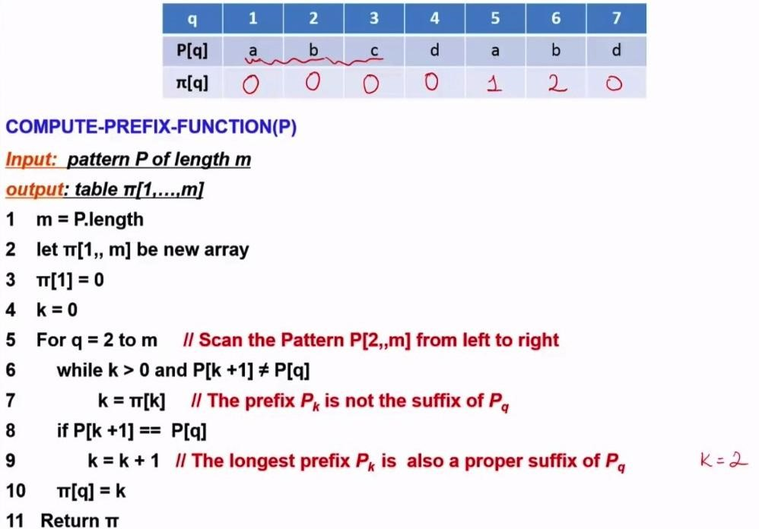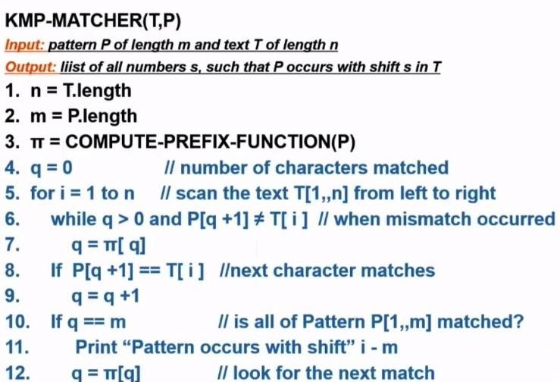

### The Rabin-Karp algorithm

Rabin-Karp is another pattern searching algorithm to find the pattern in a more efficient way. It also checks the pattern by moving window one by one, but without checking all characters for all cases, it finds the hash value. When the hash value is matched, then only it tries to check each character. This procedure makes the algorithm more efficient.

The Rabin-Karp algorithm makes use of hash functions and the rolling hash technique. A hash function is essentially a function that maps one thing to a value. In particular, hashing can map data of arbitrary size to a value of fixed size.

**Hashing**: Hashing is a way to associate values using a hash function to map an input to an output. The purpose of a hash is to take a large piece of data and be able to be represented by a smaller form. Example 1:

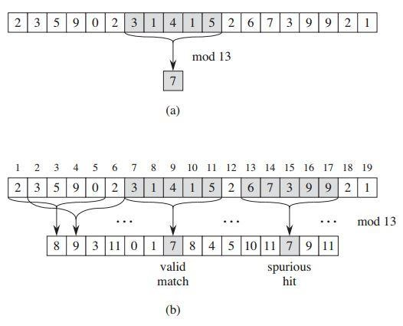

The Rabin-Karp algorithm. Each character is a decimal digit, and we compute values modulo 13. (a) A text string. A window of length 5 is shown shaded. The numerical value of the shaded number, computed modulo 13, yields the value 7. (b) The same text string with values computed modulo 13 for each possible position of a length-5 window. Assuming the pattern P = 31415, we look for windows whose value modulo 13 is 7, since 31415 7 (mod 13). The algorithm finds two such windows, shown shaded in the figure. The first, beginning at text position 7, is indeed an occurrence of the pattern, while the second, beginning at text position 13, is a spurious hit.

**Time complexity:**

***The time complexity is O(m+n)[Non Spurious hit], but for the worst case, it is O(mn) [Spurious hit]***

***Example 2:***

***Text=31415926535 Pattern=26***

Hash function= 26 mod 13=0

Window of length 2 taken

31 mod 13=5 Slide Window

14 mod 13=1

41 mod 13=2

15 mod 13=2

59 mod 13=7

92 mod 13=1

26 mod 13=0[Non Spurious hit][valid match]

65 mod 13=0[Spurious hit][not valid match]

53 mod 13=1

35 mod 13=9

**Example 3:**

Text= cadba {Take ASCII Value}

Text= 99971009897

Pattern= db

Pattern= 10098

Hash Function=10098 mod 13=10

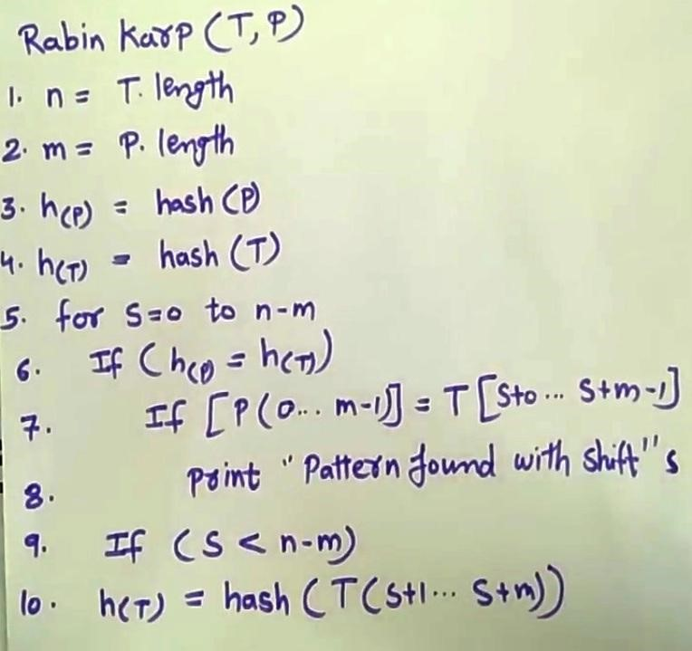

**

## NP-Completeness | Set 1 (Introduction)

We have been writing about e cient algorithms to solve complex problems, like shortest path, Euler graph, minimum spanning tree, etc. Those were all success stories of algorithm designers. In this post, failure stories of computer science are discussed.

**Can all computational problems be solved by a computer?** There are computational problems that can not be solved by algorithms even with unlimited time. For example Turing Halting problem (Given a program and an input, whether the program will eventually halt when run with that input, or will run forever). Alan Turing proved that general algorithm to solve the halting problem for all possible program-input pairs cannot exist. A key part of the proof is, Turing machine was used as a mathematical de nition of a computer and program (Source Halting Problem).

Status of NP Complete problems is another failure story, NP complete problems are problems whose status is unknown. No polynomial time algorithm has yet been discovered for any NP complete problem, nor has anybody yet been able to prove that no polynomialtime algorithm exist for any of them. The interesting part is, if any one of the NP complete problems can be solved in polynomial time, then all of them can be solved.

**What are NP, P, NP-complete and NP-Hard problems?**

P is set of problems that can be solved by a deterministic Turing machine in **P**olynomial time.

NP is set of decision problems that can be solved by a **N**on-deterministic Turing Machine in **P**olynomial time. P is subset of NP (any problem that can be solved by deterministic machine in polynomial time can also be solved by non-deterministic machine in polynomial time).

Informally, NP is set of decision problems which can be solved by a polynomial time via a “Lucky Algorithm”, a magical algorithm that always makes a right guess among the given set of choices (Source Ref 1).

NP-complete problems are the hardest problems in NP set. A decision problem L is NP-complete if: **1)** L is in NP (Any given solution for NP-complete problems can be veri ed quickly, but there is no e cient known solution).

**2)** Every problem in NP is reducible to L in polynomial time (Reduction is de ned below).

A problem is

NP-Hard

if it follows property 2 mentioned above, doesn’t need to follow

property 1. Therefore, NP-Complete set is also a subset of NP-Hard set.

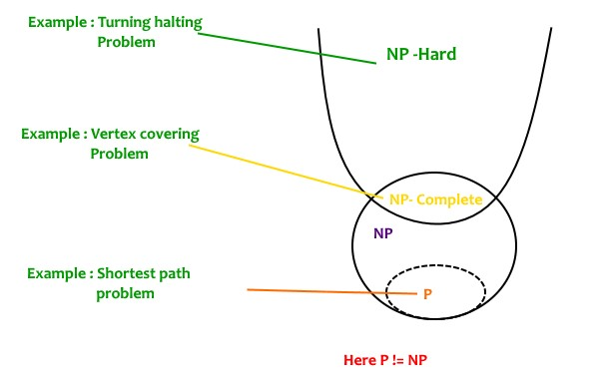

**Decision vs Optimization Problems**

NP-completeness applies to the realm of decision problems. It was set up this way

because it’s easier to compare the di

culty of decision problems than that of optimization

problems. In reality, though, being able to solve a decision problem in polynomial time will

often permit us to solve the corresponding optimization problem in polynomial time (using a

polynomial number of calls to the decision problem). So, discussing the di

culty of

decision problems is often really equivalent to discussing the di

culty of optimization

problems. (Source

Ref 2

).

For example, consider the

vertex cover problem

(Given a graph, nd out the minimum sized

vertex set that covers all edges). It is an optimization problem. Corresponding decision

problem is, given undirected graph G and k, is there a vertex cover of size k?

**What is Reduction?**

Let L

and L

be two decision problems. Suppose algorithm A

solves L

. That is, if y is an

input for L

then algorithm A

will answer Yes or No depending upon whether y belongs to

L

or not.

The idea is to nd a transformation from L

to L

so that the algorithm A

can be part of an

algorithm A

to solve L

.

1

2

2

2

2

2

2

1

2

2

1

1

Learning reduction in general is very important. For example, if we have library functions to solve certain problem and if we can reduce a new problem to one of the solved problems, we save a lot of time. Consider the example of a problem where we have to nd minimum product path in a given directed graph where product of path is multiplication of weights of edges along the path. If we have code for Dijkstra’s algorithm to nd shortest path, we can take log of all weights and use Dijkstra’s algorithm to nd the minimum product path rather than writing a fresh code for this new problem.

**How to prove that a given problem is NP complete?**

From the de nition of NP-complete, it appears impossible to prove that a problem L is NPComplete. By de nition, it requires us to that show every problem in NP is polynomial time reducible to L. Fortunately, there is an alternate way to prove it. The idea is to take a known NP-Complete problem and reduce it to L. If polynomial time reduction is possible, we can prove that L is NP-Complete by transitivity of reduction (If a NP-Complete problem is reducible to L in polynomial time, then all problems are reducible to L in polynomial time).

**What was the rst problem proved as NP-Complete?**

There must be some rst NP-Complete problem proved by de nition of NP-Complete problems. SAT (Boolean satis ability problem) is the rst NP-Complete problem proved by Cook (See CLRS book for proof).

It is always useful to know about NP-Completeness even for engineers. Suppose you are asked to write an e cient algorithm to solve an extremely important problem for your company. After a lot of thinking, you can only come up exponential time approach which is impractical. If you don’t know about NP-Completeness, you can only say that I could not come with an e cient algorithm. If you know about NP-Completeness and prove that the problem as NP-complete, you can proudly say that the polynomial time solution is unlikely to exist. If there is a polynomial time solution possible, then that solution solves a big problem of computer science many scientists have been trying for years.

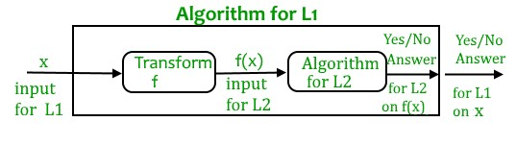

We will soon be discussing more NP-Complete problems and their proof for NPCompleteness.

**References:**

MIT Video Lecture on Computational Complexity

Introduction to Algorithms 3rd Edition by Clifford Stein, Thomas H. Cormen, Charles E.

### P, NP-Complete, NP, and NP-Hard (in Short)

NP problems have their own significance in programming, but the discussion becomes quite hot when we deal with differences between NP, P, NP-Complete and NP-hard.

P- Polynomial time solving: Problems which can be solved in polynomial time, which take time like O(n), O(n2), O(n3). E.g.: finding maximum element in an array or to check whether a string is palindrome or not. So there are many problems which can be solved in polynomial time. NP- Non deterministic Polynomial time solving: Problem which can't be solved in polynomial time like TSP (travelling salesman problem) or an easy example of this is subset sum problem: given a set of numbers, does there exist a subset whose sum is zero? But NP problems are checkable in polynomial time means that given a solution of a problem, we can check that whether the solution is correct or not in polynomial time.

***Now we will discuss about NP-Complete and NP-hard.***

Take two problems A and B both are NP problems.

***Reducibility-*** If we can convert one instance of a problem A into problem B (NP problem) then it means that A is reducible to B.

***NP-hard--*** Now suppose we found that A is reducible to B, then it means that B is at least as hard as A.

***NP-Complete --*** The group of problems which are both in NP and NP-hard are known as NPComplete problem.

Now suppose we have a NP-Complete problem R and it is reducible to Q then Q is at least as hard as R and since R is an NP-hard problem. Therefore Q will also be at least NP-hard, it may be NP-complete also.

### Approximation Algorithm

Given an optimization problem P, an algorithm A is said to be an approximation algorithm for P, if for any given instance I, it returns an approximate solution that is a feasible solution.

Approximation algorithms

1. Guaranteed to run in polynomial time.
2. Guaranteed to get a solution which is close to the optimal solution.
3. Obstacle: need to prove a solution’s value is close to optimum value, without even knowing what the optimum value is!

### Types of approximation

P -An optimization problem, A -An approximation algorithm, I -An instance of P,

A(I) -Optimal value for the instance I, A(I) -Value for the instance I generated by A

1. ***Absolute approximation:*** A is an absolute approximation algorithm if there exists a constant k such that, for every instance I of P, A(I) − A(I) ≤ k. Example: Planar graph coloring.
2. ***Relative approximation:*** A is an relative approximation algorithm if there exists a constant k such that, for every instance I of P, max{ A(I) /A(I) , A(I) /A (I) } ≤ k. Example: Vertex cover.

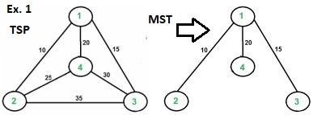The full walk of above tree would be 1-2-1-4-1-3-1. Apply Hamiltonian

cycle so that the output is 1-2-4-3-1

Cost=10+25+30+15=80

In this case, the approximate algorithm produces the optimal tour, but it may not produce optimal tour in all cases.

A full walk is lists all vertices when they are first visited in preorder, it also list vertices when they are returned after a subtree is visited in preorder. The full walk of above tree would be 1-21-4-1-3-1.

Following are some important facts that prove the 2-approximateness.

1. The cost of best possible Travelling Salesman tour is never less than the cost of MST.

(The definition of MST says, it is a minimum cost tree that connects all vertices).

1. The total cost of full walk is at most twice the cost of MST (Every edge of MST is visited atmost twice)
2. The output of the above algorithm is less than the cost of full walk. In above algorithm, we print preorder walk as output. In preorder walk, two or more edges of full walk are replaced with a single edge. For example, 2-1 and 1-4 are replaced by 1 edge 2-4. So if the graph follows triangle inequality, then this is always true.

From the above three statements, we can conclude that the cost of output produced by the approximate algorithm is never more than twice the cost of best possible solution.

**A Hamiltonian cycle,** also called a Hamiltonian circuit, Hamilton cycle, or Hamilton circuit, is a graph cycle (i.e., closed loop) through a graph that visits each node exactly once. Determining whether such paths and cycles exist in graphs is the Hamiltonian path problem, which is NPcomplete.

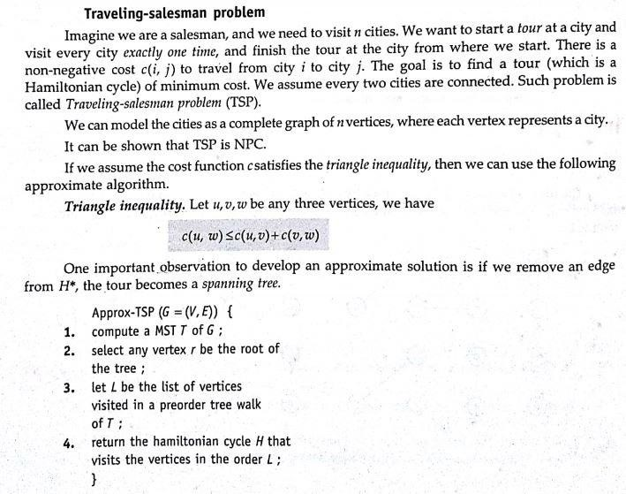

*35.2 The traveling-salesman problem 1113*

Example:2

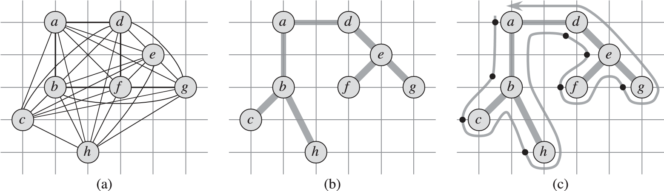

*a*

*d*

*e*

*c*

*h*

(

d

)

*a*

*d*

*b*

*f*

*e*

*g*

*c*

*h*

(

e

)

*b*

*f*

*g*

Time Complexity of

APPROX-TSP-TOUR

ϴ

(

V ²

)

**Figure 35.2** The operation of APPROX-TSP-TOUR. **(a)** A complete undirected graph. Vertices lie on intersections of integer grid lines. For example, f is one unit to the right and two units up from h. The cost function between two points is the ordinary euclidean distance. **(b)** A minimum spanning tree T of the complete graph, as computed by MST-PRIM. Vertex a is the root vertex. Only edges in the minimum spanning tree are shown. The vertices happen to be labeled in such a way that they are added to the main tree by MST-PRIM in alphabetical order. **(c)** A walk of T , starting at a. A full walk of the tree visits the vertices in the order a;b;c;b;h;b;a;d;e;f;e;g;e;d;a. A preorder walk of T lists a vertex just when it is first encountered, as indicated by the dot next to each vertex, yielding the ordering a;b;c;h;d;e;f;g. **(d)** A tour obtained by visiting the vertices in the order given by the preorder walk, which is the tour H returned by APPROX-TSP-TOUR. Its total cost is approximately 19:074. **(e)** An optimal tour Hfor the original complete graph. Its total cost is approximately 14:715.

Recall from Section 12.1 that a preorder tree walk recursively visits every vertex in the tree, listing a vertex when it is first encountered, before visiting any of its children.

Figure 35.2 illustrates the operation of APPROX-TSP-TOUR. Part (a) of the figure shows a complete undirected graph, and part (b) shows the minimum spanning tree T grown from root vertex a by MST-PRIM. Part (c) shows how a preorder walk of T visits the vertices, and part (d) displays the corresponding tour, which is the tour returned by APPROX-TSP-TOUR. Part (e) displays an optimal tour, which is about 23% shorter.

### Vertex Cover Problem

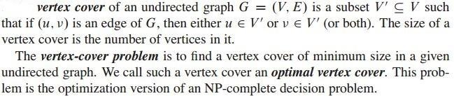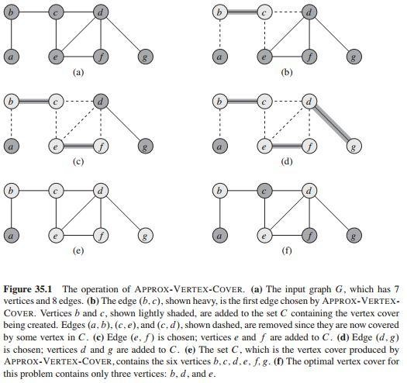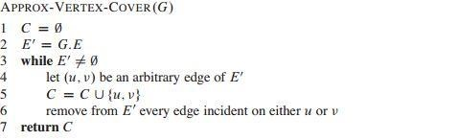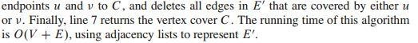

[https://www.linkedin.com/in/bhabanishankarpradhan07/](DAA_CompleteNotes_Edited.docx)